North Carolina Child Passenger Safety Technical Update and Recertification Overview

2011

INSTRUCTOR MANUAL



Revised March 2011

Developed by the NC Child Passenger Safety Training Committee

 |  | 

Table of Contents

Module 1: Introduction to the North Carolina Child Passenger Safety Technical Update 2010 1
Introduction 1
Acknowledgments 1
Objectives of this Update/Refresher 1
Module 2: Recertification Overview 3
Re-certification Overview 3
Re-certification Overview 3
Community Event/Education Requirements 6
Continuing Education Requirements 6
Auditing of CEUs 7
Recertification Reminders 8
Recertification Log 8
Module 3: NC Occupant Restraint Laws 9
Introduction to NC Occupant Restraint Laws 9
NC Occupant Restraint Laws 9
NC CPS Law 9
North Carolina Seat Belt Law 11
NC Children in Back of Pickup Trucks Law 13
The North Carolina CPS Technician Liability Protection Law 14
Module 4: Current CPS Certification Curriculum 16
Current Curriculum Introduction 16
Current Curriculum – Teaching Philosophy 17
Review Seat Belt Systems 18
Current Curriculum Content 19
NHTSA’s 4 Steps for Kids 19
Module 5: Technical Review and Update 21
Technical Review Introduction 21
The Role of a CPS Technician 21
Federal Standards and Non-Regulated Products Introduction 26
FMVSS 213 Changes 26
NHTSA Ease of Use Ratings 27
Restraint Use on Aircraft 28
Non-regulated (Aftermarket) Products 29
Seat Replacement 30
Air bags Introduction 31
Air Bag Suppression Systems 31
Side Impact Air Bags 33
Ford Inflatable Seat Belts 35
Installation Introduction 35
The Back Is Where It’s At 35
Installation Class Exercises 36
How Tight Is Tight Enough? 37
Tightening Devices 37
Recline Angle Indicators 37
Seat Belt Locking Mechanisms 38
Review of locking clip 39
Lock-Offs 39
Review of Belt Shortening Clip 40
Installing with LATCH 40
Best Practice Recommendations Introduction 49
Restraint Selection 49
Using rear-facing CRs 51
Using Forward-facing with Harness CRs 55
Using booster seats 57
Using seat belts 59
Module 6: Resources 61
National CPS Resources 61
NC CPS Resources 63
Module 7: New Products/Products with Interesting Features 66
New Products/Products with Interesting Features Listed by Manufacturer 66
Overall Considerations 66
Baby Trend 66
Britax 68
Britax Convertible Seat Redesign 71
Chicco 72
Clek 73
Columbia Medical 75
Combi 76
Cybex/Regal Lager 78
Dorel/Safety 1st 78
Dorel/Cosco 82
Dorel/Eddie Bauer 83
Evenflo 84
E-Z-ON 88
Graco 89
Learning Curve The First Years 92
Maxi Cosi 94
Mia Moda 96
Orbit Baby 97
Peg Perego: 98
Recaro 99
Safe Traffic System 100
Safety Angel 100
Sunshine Kids 101
Snug Seat 104
Teutonia 105
Module 8: Fact or Fiction 107

Module 1: Introduction to the North Carolina Child Passenger Safety Technical Update 2011

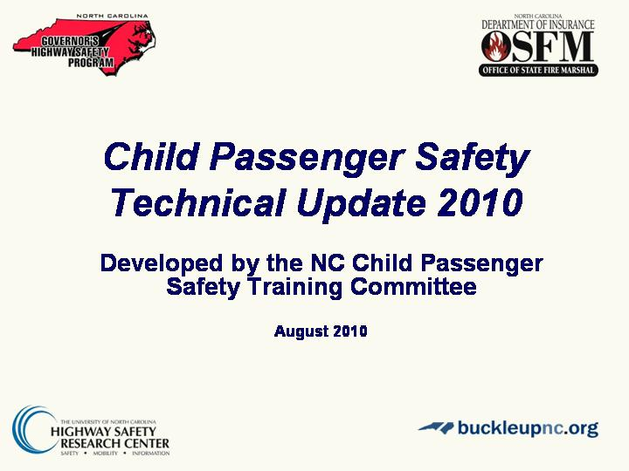
Slide 1

Introduction
- Child Passenger Safety Technical Update 2011
- Developed by the NC Child Passenger Safety Training
Committee

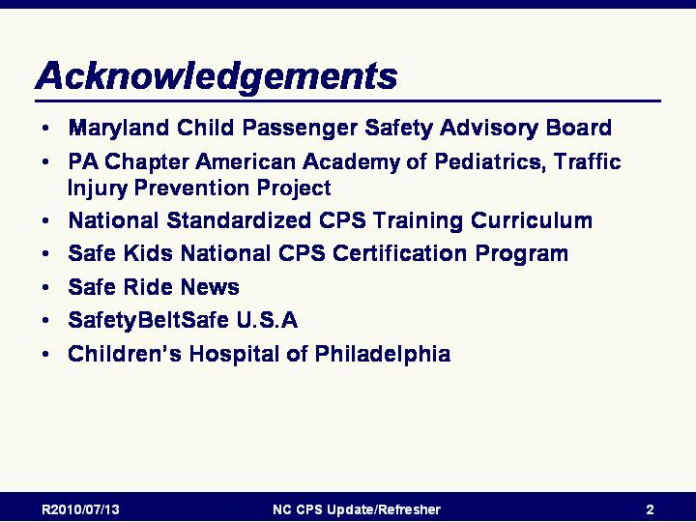
Slide 2

Acknowledgments
- Maryland Child Passenger Safety Advisory Board
- PA Chapter American Academy of Pediatrics, Traffic
Injury Prevention Project
- National Standardized CPS Training Curriculum
- Safe Kids National CPS Certification Program
- Safe Ride News
- SafetyBeltSafe U.S.A
- Children’s Hospital of Philadelphia

Slide 3

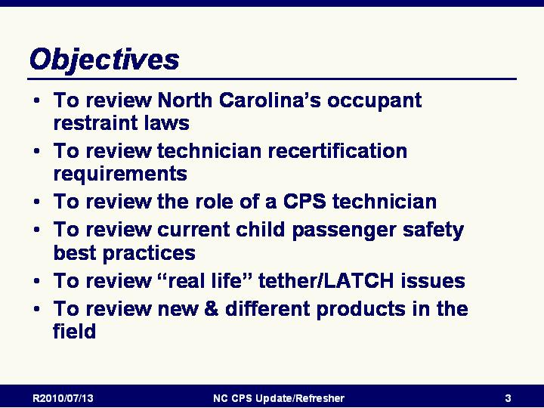
Objectives of this Update/Refresher
- Review objectives
  - To review North Carolina’s Occupant Restraint Laws
  - To review Technician recertification requirements
  - To define the role of a CPS technician
  - To review current child passenger safety best practices
  - To become familiar with “real life” Tether/LATCH issues
  - To recognize new products in the field

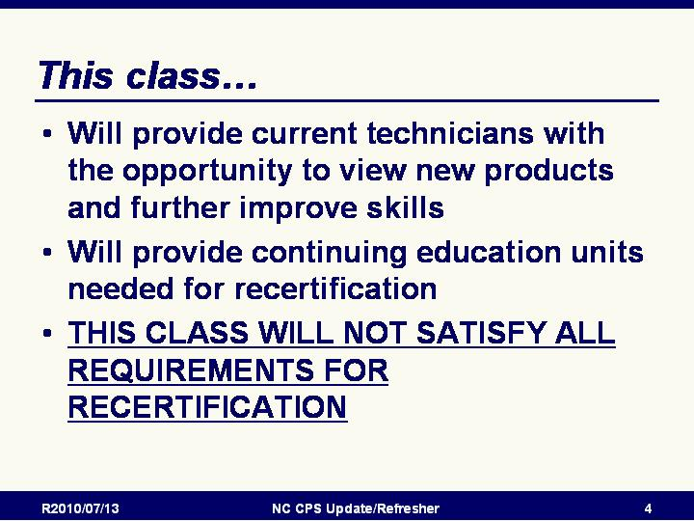
Slide 4

Emphasize that what this class will do is that it will:
This class will
- Provide current technicians with the opportunity to view
new products and further improve skills
- Will provide continuing education units needed for
recertification

THIS CLASS WILL NOT SATISFY ALL REQUIREMENTS FOR RECERTIFICATION

Note: Recertification requirements will be covered in the following section.

Module 2: Recertification Overview
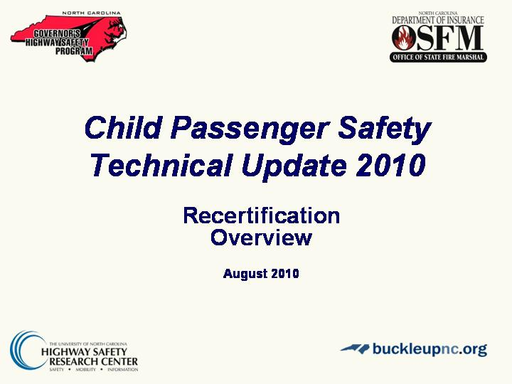

Slide 5
Re-certification Overview

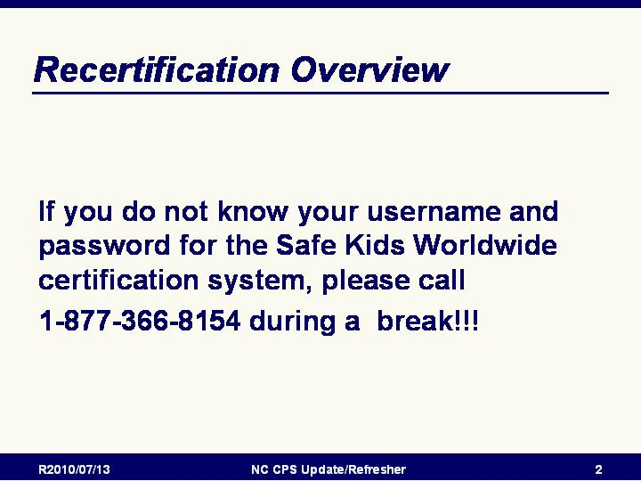
Slide 1
Re-certification Overview
- Emphasize that being familiar with the SK online
system is extremely important:
- If you do not know your username and password for the
Safe Kids Worldwide certification system, please call
1-877-366-8154 during a break!!!.

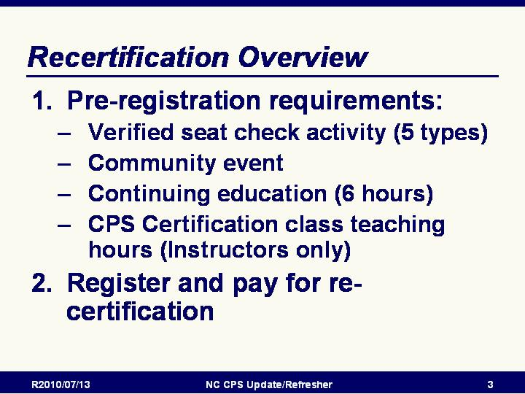
Slide 2

Re-certification Overview
- The certification cycle for both technicians and instructors is two years.
- In order to retain their certifications, Techs must meet all of the requirements for and successfully complete the
re-certification process.
- There are two general steps to successful re-certification:
  - 1. Meet all pre-registration requirements, including:
    - Verified seat check activity (5 types).
    - Community event (one check up or community workshop)
    - Continuing education (6 hours)
    - If applicable, teaching hours
  - 2. Register and pay for re-certification.
    - Registering and paying for re-certification may be done up to four months prior to the individual’s certification cycle end date.
    - The re-certification fee is $50 for technicians and instructor candidates and $60 for instructors.

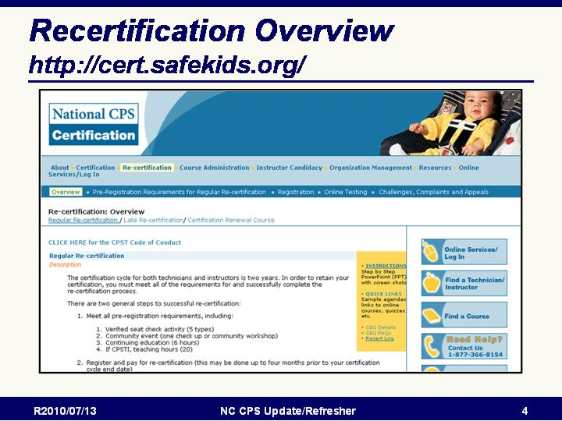
Slide 4

Recertification Overview (continued)
Screen shot of Safe Kids CPS Certification website information
on recertification requirements.

Certification website: http://cert.safekids.org
Instructor Note: If the computer this presentation is running on has internet access, clicking on the links on the slides will open the website pages. If not, the next two slides show screen shots of the listed websites.

Note that the website URL has recently changed. Be sure to update any bookmarks.
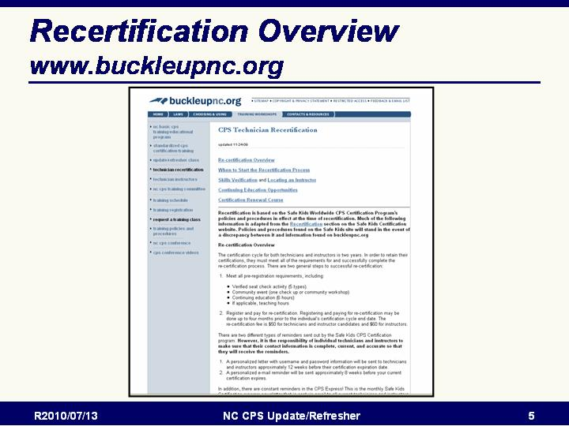
Slide 5

Recertification Overview (continued)
Screen shot of buckleupnc.org website information on
recertification requirements.

Certification information: www.buckleupnc.org/training_recertification.cfm

Slide 6

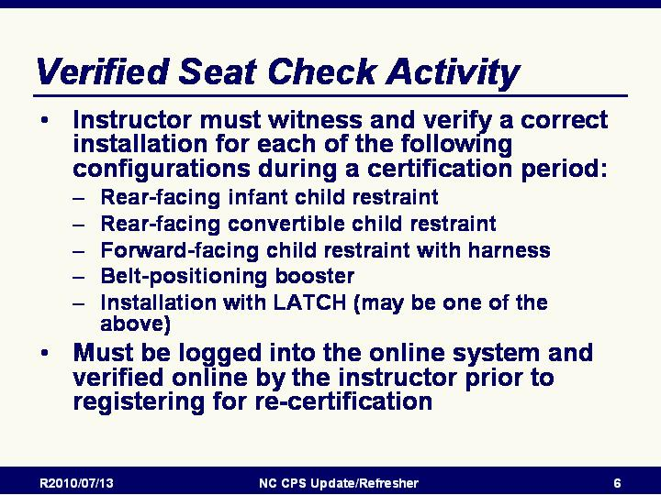
Verified Seat Check Activity
As a part of the re-certification process, all technicians and instructors are required to have a currently certified instructor or technician-proxy witness and verify (instructors only) a correct installation for each of the following configurations during that particular certification period:
            - Rear-facing only child restraint
            - Rear-facing convertible child restraint
            - Forward-facing child restraint with harness
            - Belt-positioning booster
            - Installation with LATCH: LATCH requires a harnessed CR must be used following manufacturer instructions. A RF CR secured correctly using the lower anchors only would count. A tether must be used if it is required for a correct LATCH installation.

All seat checks are for the way the child restraint left. If the child arrives in a rear-facing only CR, and leaves in a RF convertible, it may be used as a RF convertible seat check.

Once a seat check is entered for verification, the instructor will be sent an email notification. As this email notification is provided as a courtesy, it is the responsibility of the instructor to review the requests. The email is not required to access the seat check verification request.

Slide 7
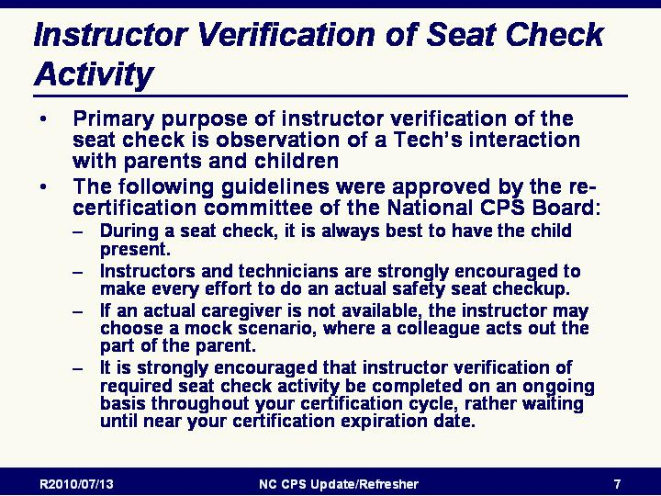
Instructor Verification of Seat Check Activity
The primary purpose of instructor verification of the seat check activity required for re-certification is observation of your interaction with parents and children. The verifying instructor or their technician-proxy should feel confident in your ability to communicate accurate information to a parent or caregiver and should double-check that the installation and paperwork are appropriate and correct.

Direct observation helps ensure that communication with parents is accurate and consistent with the information and methodologies detailed in the standardized curriculum. The ideal has always been instructor observation of seat checks, and was strongly recommended by the National CPS Board.

The following guidelines were approved by the re-certification committee of the National CPS Board:

            - During a seat check, it is always best to have the child present.
            - Instructors and technicians are strongly encouraged to make every effort to do an actual safety seat checkup.
            - If an actual caregiver is not available, the instructor may choose a mock scenario, where a colleague acts out the part of the parent.
            - It is strongly encouraged that instructor verification of required seat check activity be completed on an ongoing basis throughout your certification cycle, rather waiting until near your certification expiration date.

Once a seat check is entered for verification, the instructor will be sent an email notification. As this email notification is provided as a courtesy, it is the responsibility of the instructor to review the requests. The email is not required to access the seat check verification request.
PLEASE NOTE: If no action is taken, seat checks are NO LONGER automatically approved after 14 days. If no action is taken, they remain pending (ungraded). If you are waiting for a seat check to be reviewed and it is pending, please follow up with the instructor directly.

Slide 8
Instructor Verification of Seat Check Activity
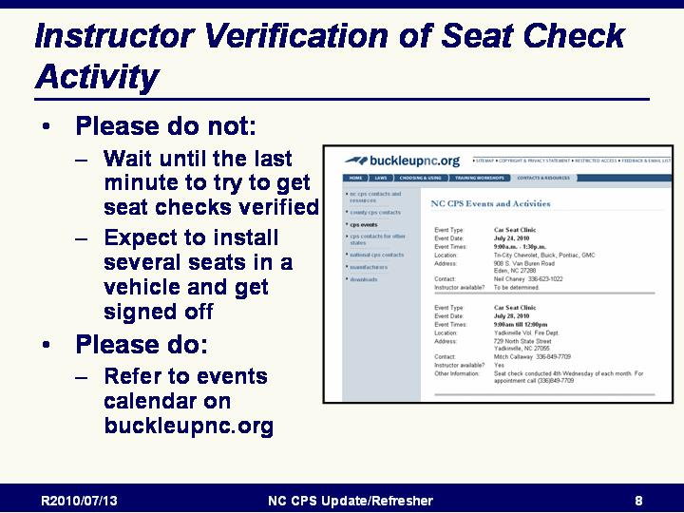
Verification of seat check activities can be completed at any point throughout the certification cycle. Please do not wait until the last minute. Refer to the events calendar on www.buckleupnc.org for clinics and other events where you might be able to complete your skills verification.

Slide 6

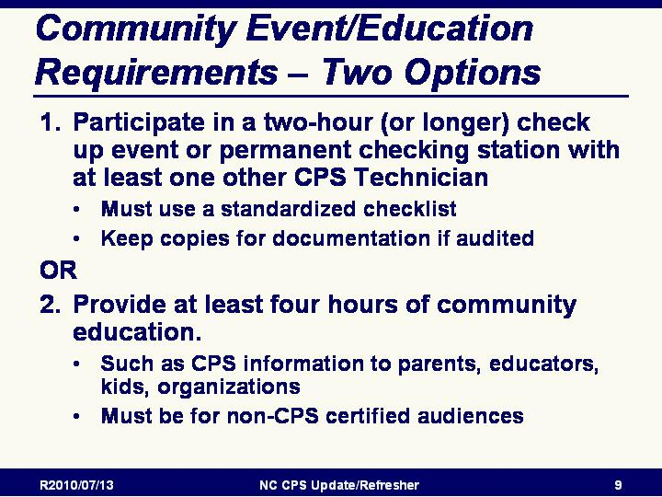
Community Event/Education Requirements
All technicians and instructors are required to participate in at
least one community event and the event must be logged into
the online system. There are two options for satisfying the
“community event” requirement:

- Participate in a two-hour (or longer) check up event with at
least one other *CPS Technician at which you serve families
using any standardized checklist. Copies of the checklists should be kept to provide documentation for possible audit. Providing education and installation assistance through Permanent Checking Stations will satisfy this requirement as long as the other criteria (at least 2 hours, with another certified Technician, and with documentation) are met.
OR
- Provide at least four hours of community education. Examples of community education include presenting CPS information to parents, educators, kids, organizations (PTAs, law enforcement) and civic clubs. These are presentations must be made to non-CPS certified audiences.
*Clarification: A Technician must work with at least one other CPS technician for a two hour check-up event. (For example: A fire station that has one technician and several participants with Basic Awareness training, will not qualify under this requirement.)

HELPFUL HINT: Inviting an instructor to your event will provide an opportunity to verify installation skills and to meet this requirement.

Individuals need to maintain a file with recertification documentation in order to have needed information available for recertification and possible audit.

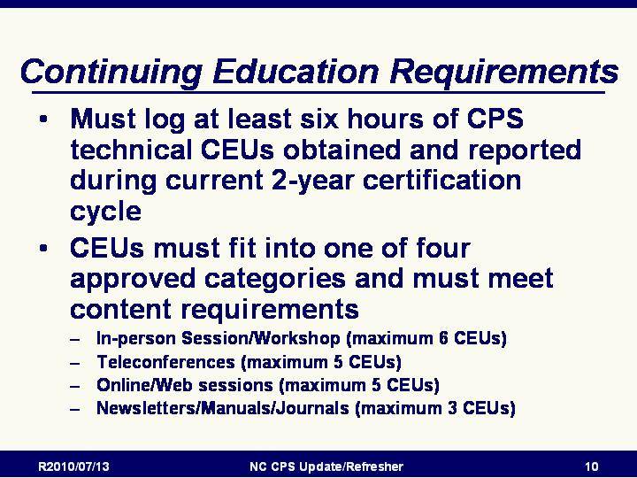
Slide 7

Continuing Education Requirements
All technicians and instructors are required to log at least six hours of CPS technical continuing education (CEUs) into the system. The CEUs must be obtained and reported during one’s current certification cycle (two years). There is no carry-over from one period to the next, even when more than the required CEUs have been accumulated. CEUs must fit into one of the five approved categories and meet content requirements. A 45 or 50-minute session may be rounded up and counted as 1 hour of continuing education. Sessions shorter than 45 minutes may not be included.

Categories of CEUs
In-person Session/Workshop (maximum 6 CEUs)
Teleconferences (maximum 5 CEUs)
Online/Web sessions (maximum 5 CEUs)
Newsletters/Manuals/Journals (maximum 3 CEUs)

Since the intent of CEUs is to get updated information, the option to observe a CPS certification course is no longer available. Please choose an alternative CEU Category.

Technicians and instructors may mix and match categories to meet the six required hours of continuing education. All categories of CEUs must meet the content requirements of improving CPS technical knowledge such as LATCH, a child restraint manufacturer workshop or CPS technical update. Non-technical CPS sessions, such as how to get funding or run an inspection station, do not qualify.

Slide 8

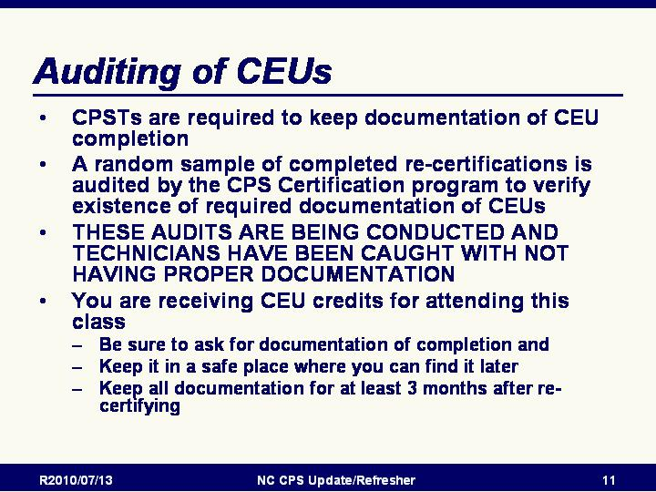
Auditing of CEUs
- IMPORTANT NOTES regarding CEU auditing:
  - CEUs are self-certified, like child restraints are certified by the manufacturer.
  - CPSTs are required to keep personal written proof of the types and content of their CEU achievements.
  - A random sample of completed re-certifications will be audited by the CPS Certification program. This is much the same manner that child restraints are selected for compliance testing by NHTSA.
  - Each category has specific written documentation requirements.
  - The purpose of the audit is to verify existence of documentation of CEUs being completed and in accordance with policies and procedures of the certifying body.
- STRESS: These audits are being conducted and technicians have been caught with not having proper documentation. There have been technicians in North Carolina who have lost their certifications as a result of the auditing process.
- STRESS: You are receiving CEU credits for attending this class. Be sure to ask for documentation of completion and keep it in a safe place where you can find it later.
- STRESS: Keep CEU documentation for at least 3 months after recertifying.

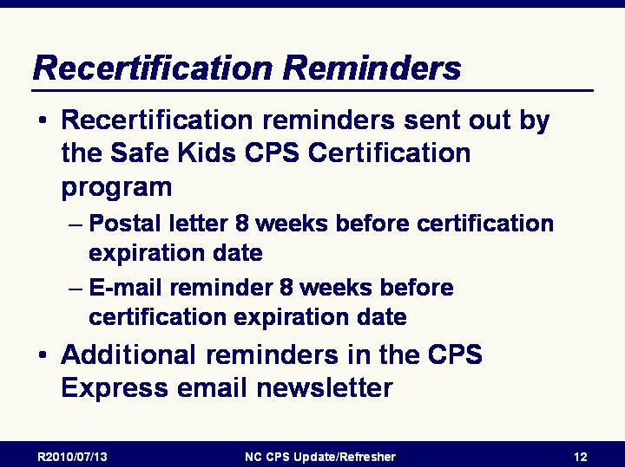
Slide 9

Recertification Reminders
- There are two different types of reminders sent out by the Safe Kids CPS Certification program.
  - A personalized letter with username and password information will be sent to technicians and instructors approximately 8 weeks before their certification expiration date.
  - A personalized e-mail reminder will be sent approximately 8 weeks before your current certification expires.
- In addition, there are constant reminders in the CPS Express! This is the monthly Safe Kids Certification program newsletter that is sent via email to all current technicians and instructors with valid email addresses listed in their online profiles. Back issues of CPS Express are available through the Certification website.

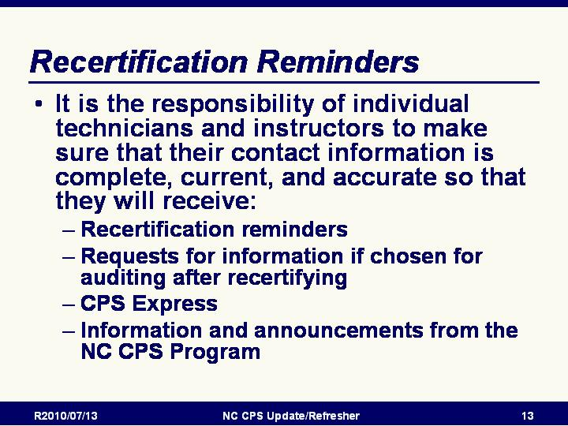
Slide 10
- EMPHASIZE: It is the responsibility of individual technicians and instructors to make sure that their contact information is complete, current, and accurate so that they will receive:
  - Recertification reminders
  - Requests for information if chosen for auditing after recertifying
  - CPS Express
  - Information and announcements from the NC CPS Program

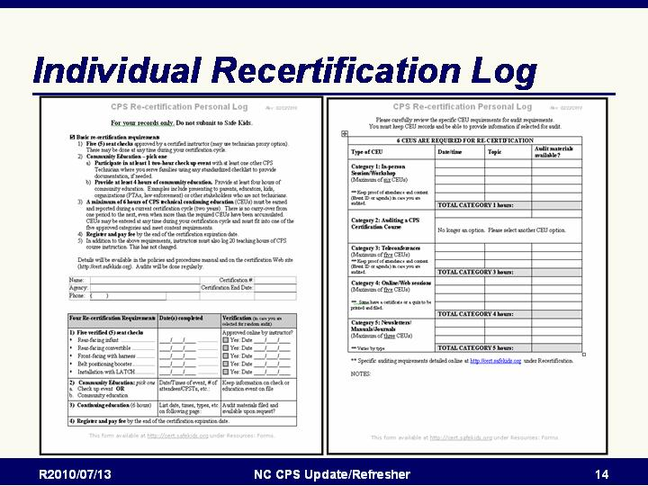
Slide 11

Recertification Log
- Downloadable from the Safe Kids Certification website.
- Helps keep track of requirements and status

INSTRUCTOR NOTE: All participants in the Update/Refresher should receive a copy of the Individual Recertification Log - Included as a handout on the NC Update/Refresher Instructor CD

Module 3: NC Occupant Restraint Laws
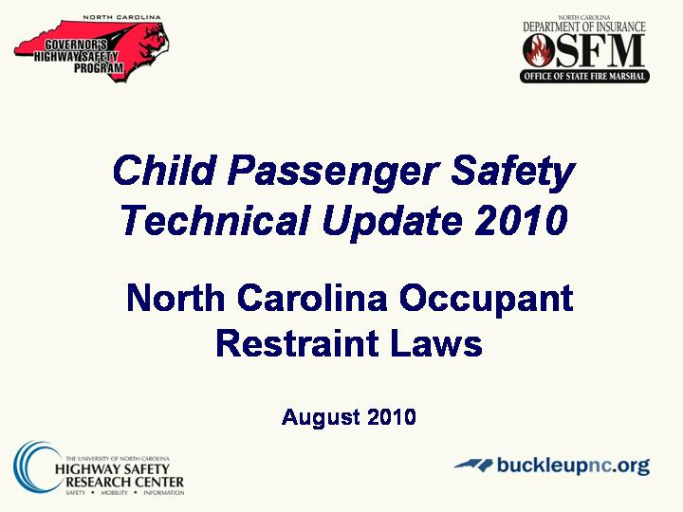
Slide 1

Introduction to NC Occupant Restraint Laws
This section will be a review of NC’s 3 occupant restraint laws:
- CPS Law
- Seat Belt Law
- Children in Back of Pickup Trucks

Slide 2

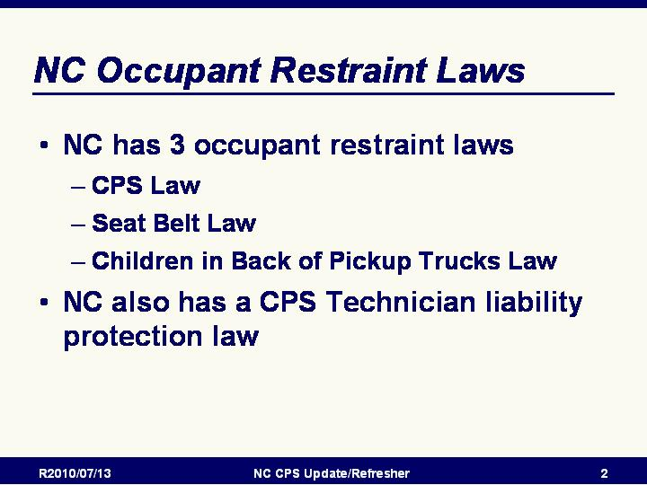
NC Occupant Restraint Laws
- NC has 3 occupant restraint laws
  - CPS Law
  - Seat Belt Law
  - Children in Back of Pickup Trucks Law
- NC also has a CPS Technician liability protection law

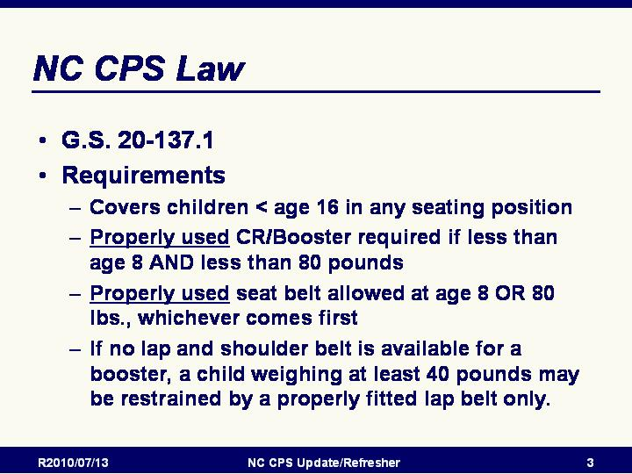
Slide 2

NC CPS Law
- NC General Statute Chapter 20, Section 137.1 (G.S. 20-137.1)
- Effective as of June 1, 2007
- Requirements:
  - All children less than 16 years of age must be properly restrained in all vehicle seating positions. Drivers and occupants 16 and older are covered by the NC Seat Belt Law.
  - Children younger than age 8 AND who weigh less than 80 pounds must be properly secured in child passenger restraint systems appropriate for their weight. Most drivers are able to comply with the changes by using belt-positioning booster seats for children over 40 pounds.
  - Any type of child restraint (infant only, convertible, forward facing only, booster seat, harness or vest) that meets federal standards in effect at the time of its manufacture may be used.
  - When a child reaches age 8 (regardless of weight) OR 80 pounds (regardless of age), a properly fitted seat belt may be used to restrain the child. Shoulder belts behind the back or under the arm are not allowed.
  - If there is no lap and shoulder belt equipped seating position available for using a belt-positioning booster, a child less than 8 years of age and at least 40 pounds may be restrained by a properly fitted lap belt only.

REMINDER/WARNING: Belt-positioning booster seats can only be used with lap and shoulder combination seat belts. Belt-positioning booster seats must NEVER be used with just a lap belt.

Slide 3

NC CPS Law Requirements Continued
- The NC CPS law requires that a child restraint (CR) be properly installed in the rear seat if
  - the child is less than 5 years of age and
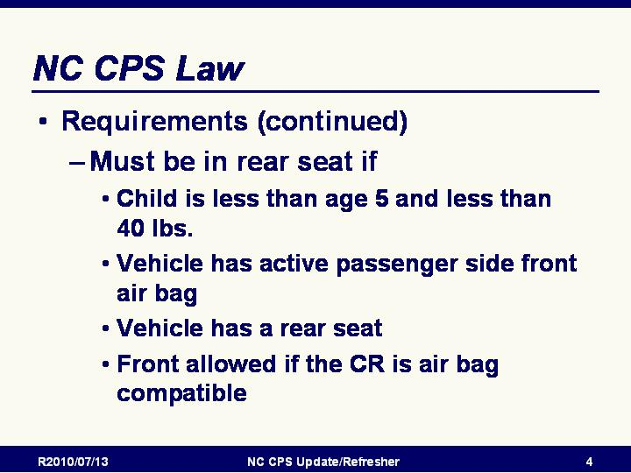
  - less than 40 pounds in weight and
  - the vehicle has an active passenger side air bag.

- The CR may be installed in the front seat if:
  - it is designed for use with air bags, or
  - the vehicle has an air bag on-off switch that is turned off, or
  - the vehicle has no air bag at all, or
  - the vehicle has no rear seat.

REMINDER: Regardless of what is legal, it is strongly recommended that all children age 12 and under should ride buckled up in a rear seat in restraints appropriate for their ages and sizes.

Slide 4

NC CPS Law Exemptions:
- Current Exemptions:
  - Ambulances or other emergency vehicles
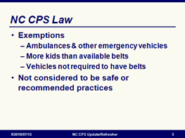
  - If all seating positions equipped with child passenger restraint systems or seat belts are occupied
  - Vehicles that are not required by federal law or regulation to be equipped with seat belts
- Exemptions were included in earliest version of the law
  - Helped get a law enacted
  - Not considered to be safe or recommended practices
- NOTE: The “Personal Needs” exemption was removed as of June 1, 2007

Slide 5

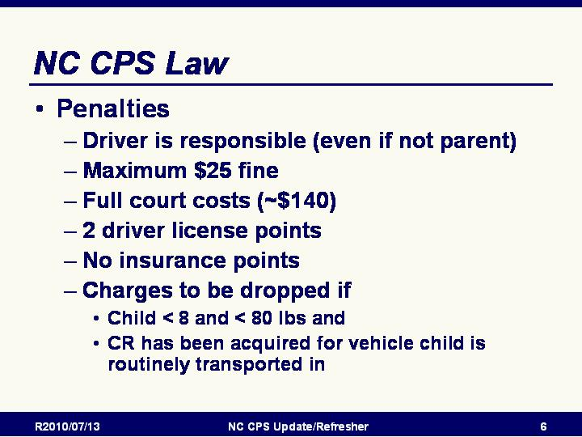
NC CPS Law Penalties:
- Fine not to exceed $25.00.
- Full court costs apply. Cost of court is currently around $140 ($136 as of July 1, 2010 and $141 as of October 1, 2010).
- Two driver's license points are assessed.
- No insurance points can be assessed.
- Charges are to be dropped if the child is under 8 years of age and the driver produces proof satisfactory to the court that he has subsequently acquired an approved child passenger restraint system for a vehicle in which the child is normally transported

Slide 6

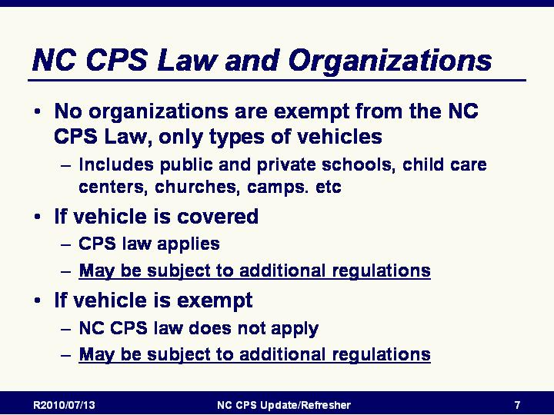
NC CPS Law and Organizations
- No organizations are exempt from the NC CPS Law, only types of vehicles
- This includes public and private schools, child care centers, churches, camps. etc
- If the vehicle is covered, the CPS law applies, but the organization may be subject to additional regulations
- If the vehicle is exempt, the NC CPS law does not apply, but the organization may still be subject to additional regulations

Slide 7

North Carolina Seat Belt Law
G.S. 20-135.2A
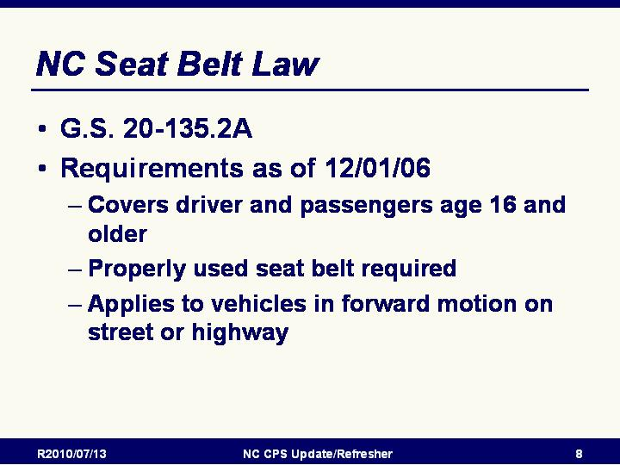
Requirements
- The seat belt law requires all drivers and passengers ages 16 and older to have a seat belt properly fastened about his or her body at all times when the vehicle is in forward motion on a street or highway.
- "Properly fastened" means that the occupant is secured within the full seat belt in the manner specified by the vehicle manufacturer's instructions.
- Children less than age 16 are covered under the North Carolina Child Passenger Safety (CPS) Law.

NOTE: Rear seat passenger older than 15 became covered by the NC Seat Belt Law as of December 1, 2006.
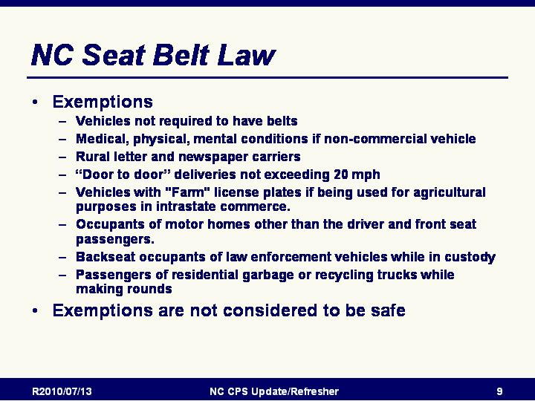
Slide 8

North Carolina Seat Belt Law Exemptions
Exemptions as of December 1, 2006:
- Motor vehicles not required to be equipped with seat belts under federal law
- A driver or occupant with a medical or physical condition that prevents appropriate restraint by a seat belt or with a professionally certified mental phobia against the wearing of vehicle restraints;
- A motor vehicle operated by a rural letter carrier of the United States Postal Service while performing duties as a rural letter carrier and a motor vehicle operated by a newspaper delivery person while actually engaged in delivery of newspapers along the person's specified route;
- A driver or passenger frequently stopping and leaving the vehicle or delivering property from the vehicle if the speed of the vehicle between stops does not exceed 20 miles per hour;
- Vehicles with "Farm" license plates while being used for agricultural purposes in intrastate commerce; or
- Occupants of motor homes other than the driver and front seat passengers. (NOTE: This is a new exemption added when the “adults in rear seat” coverage was added.)
- Passengers of residential garbage or recycling trucks while making rounds

Slide 9

North Carolina Seat Belt Law Penalties and Enforcement
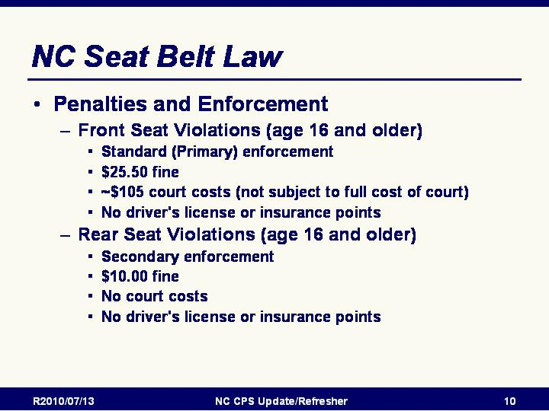
- Front seat Violations:
  - Standard (primary) enforcement
  - Penalties
  - $25.00 fine
  - ~$105 in court costs ($101.50 as of July 1, 2010 and $106.50 as of October 1, 2010)
  - No driver's license points are assessed.
  - No insurance points are assessed.

- Rear seat violations (age 16 or older):
  - Secondary enforcement
  - Penalties
  - $10.00 fine
  - No court costs
  - No driver's license points are assessed.
  - No insurance points are assessed.

Slide 10

NC Children in Back of Pickup Trucks Law
- G.S. 20-135.2B
- NOTE: Revisions Passed by 2008 Session: Increase in age covered from < 12 to <16 and removal of “rural county” exemption - Effective October 1, 2008
- Requirements
  - "The operator of a vehicle having an open bed or open cargo area shall insure that no child under 16 years of age is transported in the bed or cargo area of that vehicle. An open bed or open cargo area is a bed or cargo area without permanent overhead restraining construction."
  - "Permanent overhead restraining construction" was not specified by the legislature and has not been defined by our courts.

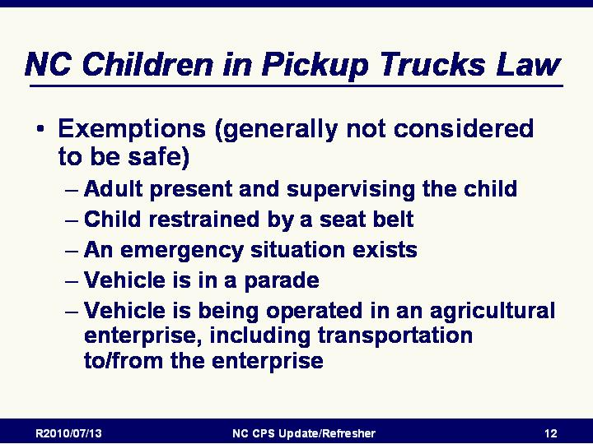
Slide 11

Children in Back of Pickup Trucks Law

Exemptions
- If an adult is present in the bed or cargo area of the vehicle and is supervising the child;
- If the child is secured or restrained by a seat belt manufactured in compliance with FMVSS 208, installed to support a load strength of not less than 5,000 pounds for each belt, and of a type approved by the Commissioner of the Division of Motor Vehicles;
- If an emergency situation exists;
- If the vehicle is being operated in a parade pursuant to a valid permit;
- If is being operated in an agricultural enterprise, including transportation to/from the enterprise

INSTRUCTOR NOTE: The “rural county” exemption was removed from the Back of Pickup Trucks law effective as of October 1, 2008

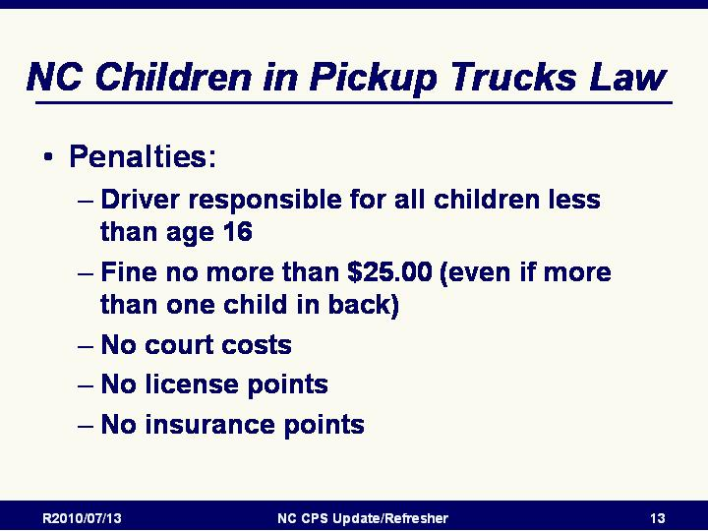
Slide 12

NC Children in PickUp Trucks Law
- Driver responsible for all children less than age 16
- Fine not to exceed $25.00 (even if more than one child in back)
- No court costs
- No driver's license points shall be assessed.
- No insurance points shall be assessed.

Slide 13

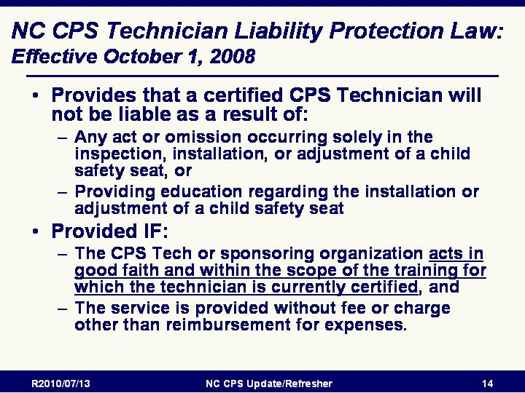
The North Carolina CPS Technician Liability Protection Law

Basic provisions
- This law provides that a certified child passenger safety technician or sponsoring organization would not be liable as a result of:
  - Any act or omission occurring solely in the inspection, installation, or adjustment of a child safety seat, or
  - Providing education regarding the installation or adjustment of a child safety seat if the certified technician or sponsoring organization:
    - Acts in good faith, and
    - Within the scope of the training for which the technician is currently certified, and
    - The service is provided without fee or charge other than reimbursement for expenses.
- “Good Samaritan” protection is needed for those volunteer CPS technicians who provide such an important service to North Carolinians but who may not be covered by liability insurance through their employer, sponsoring organization or through individual liability coverage.

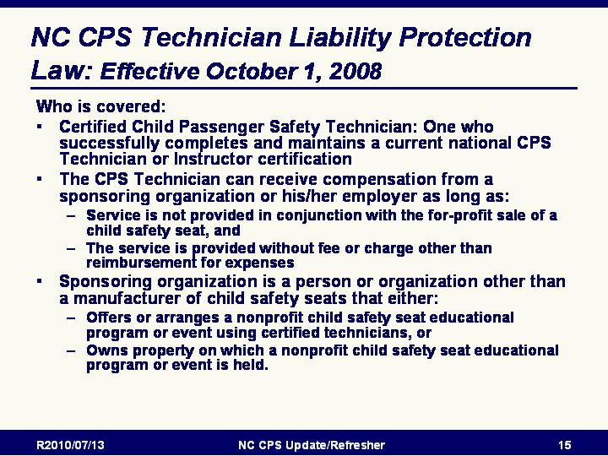
Slide 14

Who is covered by this liability protection?
- This law defines a Certified Child Passenger Safety Technician as being an individual who successfully completes and maintains a current child passenger safety technician or technician instructor certification
- A sponsoring organization is defined as a person or organization other than a manufacturer of child safety seats that either
  - Offers or arranges a nonprofit child safety seat educational program or event using certified technicians, or
  - Owns property on which a nonprofit child safety seat educational program or event is held.

Slide 15

Exceptions to this Technician liability protection
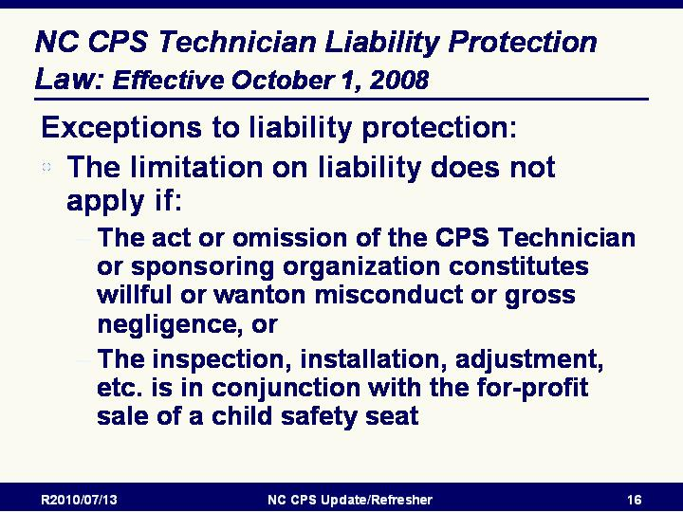
- The limitation on liability does not apply if:
  - The act or omission of the certified child passenger safety technician or sponsoring organization constitutes willful or wanton misconduct or gross negligence, or
  - The inspection, installation, or adjustment of a child safety seat or education provided regarding the installation or adjustment of a child safety seat is in conjunction with the for-profit sale of a child safety seat.

Module 4: Current CPS Certification Curriculum

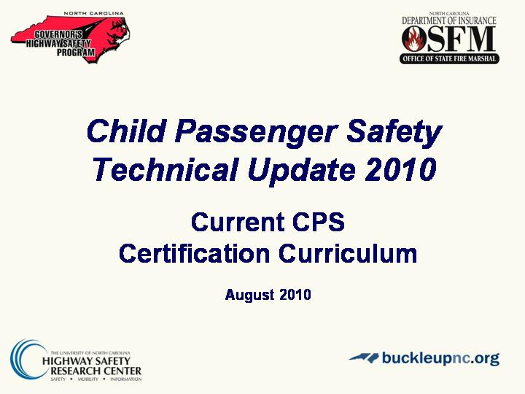
Slide 1

Current Curriculum Introduction
- In this section will be covering what is new and what is different with the most recent revision of the standardized curriculum.
- Most recent edition is April 2007 - Revised January 2008

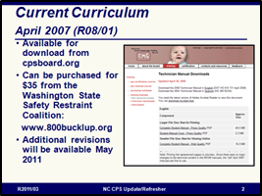
Slide 2

Current Curriculum April 2007 (R08/01)
- Available for download from cpsboard.org
  - Can be purchased from the Washington State Safety Restraint Coalition: www.800bucklup.org
  - Individual copies for $35 (includes shipping)
  - Bulk orders available
- Additional revisions will be made available May 2011 – will be announced through CPS Express

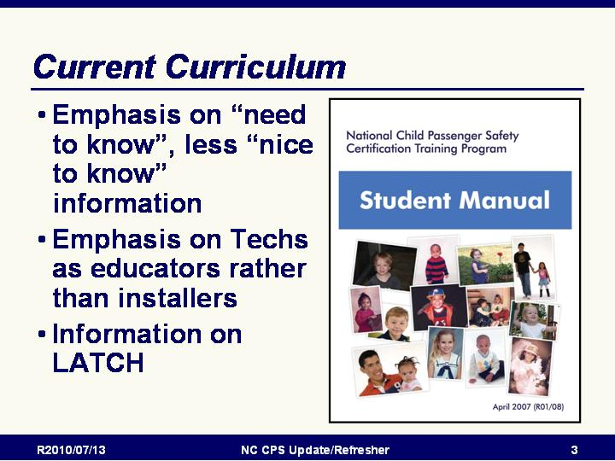
Slide 9

Current Curriculum
- More emphasis on need to know vs. nice to know
- More emphasis on education vs. installation
- More information on LATCH

Slide 10

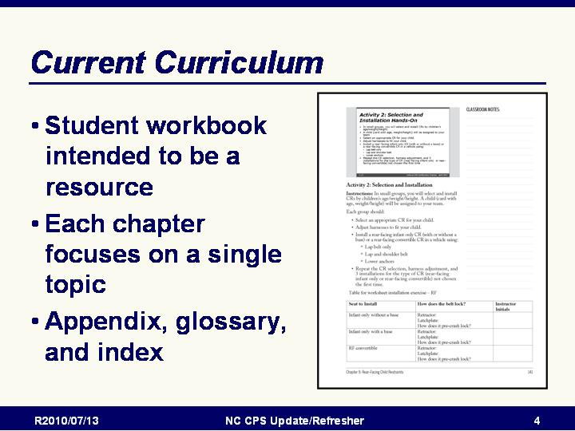
Current Curriculum
- Student workbook intended to be used as a resource during and after the course.
- New design features for this edition:
  - Based on NHTSA’s “4 Steps For Kids”
  - Includes an appendix, glossary and index.
  - Each chapter focuses on a single topic
  - Reduced duplication of information
  - Makes information easier to find

Slide 11

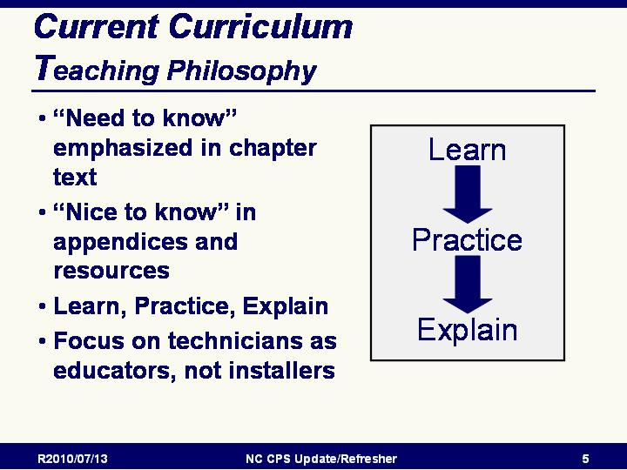
Current Curriculum – Teaching Philosophy
- Emphasis is on “Need To Know” Information
  - The current curriculum concentrates on providing CPS technicians with information and skills needed “curbside” to teach a parent/caregiver correct use of child restraints and seat belts
- “Nice to know” information is included in appendix and/or references to different resources
- Emphasis on “Learn, Practice, Explain” in which the students:
    - Learn the facts/skills/information
    - Practice the new skills/information
    - Explain what they have learned to parents/caregivers
- Emphasis on Technicians as EDUCATORS, not “installers”
  - More emphasis and focus on technicians providing education rather than providing an installation service
  - Technicians must empower parents to do it themselves
  - Ask participants to think about the question “Are You an “Educator” or an “Installer?” As an Educator, you must:
    - Show the parent(s) how to correct installation errors and let them reinstall the seat on their own
    - Check for recalls
    - Provide educational materials
    - Have other necessary materials on hand for each appointment

- STRESS TO PARTICIPANTS:
  - Ultimately, parents/caregivers are responsible for their children’s safety
  - Technician must provide pertinent information, then
    - The parent/caregiver has the final decision and final responsibility
    - The parent/caregiver should always be the last one to install the child restraint and secure the child
  - All actions should be documented — especially if advice is not followed
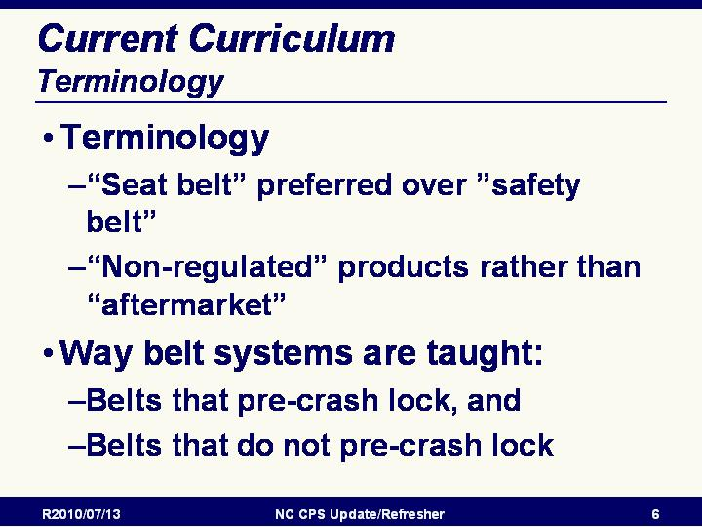
Slide 12

Current Curriculum - Terminology
- Different Terminology
  - “Seat belt” preferred over ”safety belt”
  - “Non-regulated” product has replaced “aftermarket”
- New terms for way belt systems are taught - “Belts that pre-crash lock” and “belts that don’t pre-crash lock“
  - The way in which the seat belt systems are taught is much different.
  - New technicians may discuss the belts in a way that “old-timers” are not used to including:
    - Belts that pre-crash lock, and
    - Belts that do not pre-crash lock

Slide 13

Review Seat Belt Systems

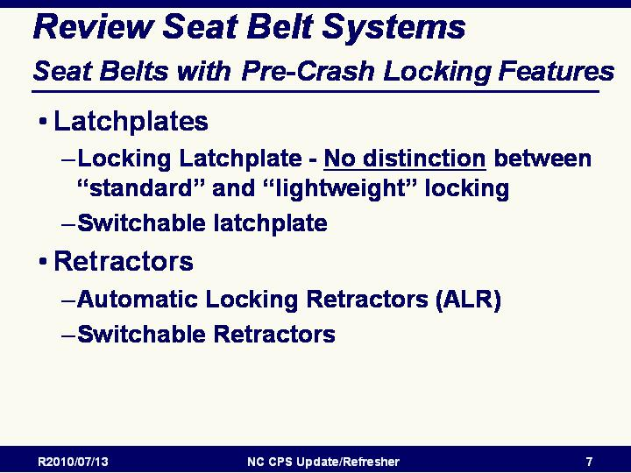
Seat Belt Systems With Pre-Crash Locking Features
- Explain connection between pre-crash locking seat belt systems and CR installation
- Discusses types of pre-crash locking seat belt systems including:
  - Latchplates
    - Locking Latchplate
      - No distinction made between “standard” and “lightweight” locking latchplates
      - Some locking latchplates have a bar; others have a sliding or rotating piece made out of either metal or plastic.
      - Often found in older model vehicles or in the center rear seat
    - Switchable latchplate
      - Has a button to manual switch latchplate from the adult pre-crash position to the child pre-crash position.
  - Retractors
    - Automatic Locking Retractors (ALR)
    - Switchable Retractors

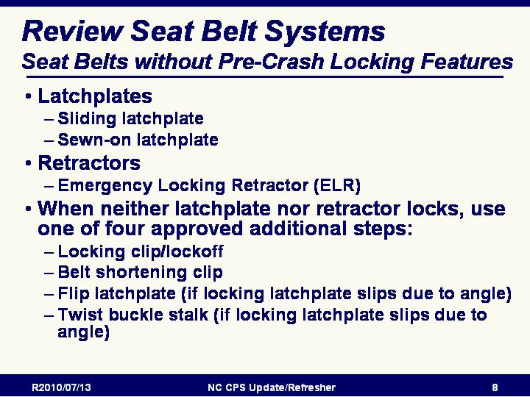
Slide 14

Review Seat Belt Systems

Seat Belt Systems Without Pre-Crash Locking Features
- Explains seat belts that do not provide that pre-crash locking feature:
- Latchplates
  - Sliding latchplate
  - Sewn-on latchplate
- Retractors
  - Emergency Locking Retractor (ELR)
- When neither the latchplate nor the retractor stays pre-crash locked, use one of the four approved additional steps to install a CR:
  - Locking clip/lockoff
  - Belt shortening clip
  - Flip latchplate (if locking latchplate slips due to angle)
  - Twist buckle stalk (if locking latchplate slips due to angle)

Slide 15

Current Curriculum Content
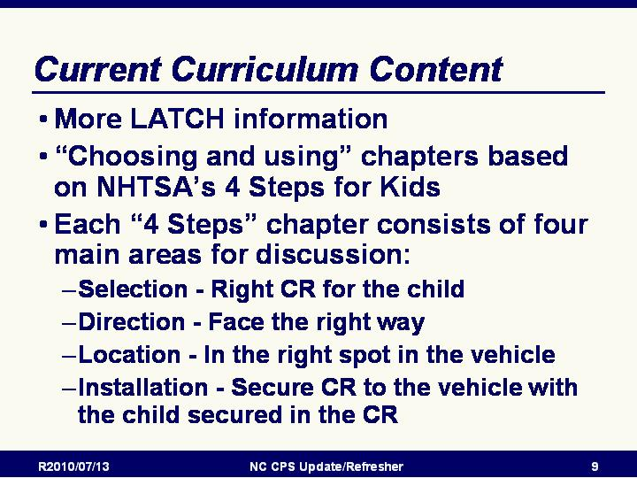
- More LATCH information is included
  - Lower Anchors and Tethers for Children (LATCH) — much more common now
  - Most passenger vehicles made after 2002 have at least three top tethers and two lower anchor sets
  - More LATCH information, including tethers without lower attachments, is included in the current curriculum
- “Choosing and Using” chapters are based on NHTSA’s 4 Steps for Kids [NOTE: the 4 Steps will be covered in more detail below]
- Discussion for each step consists of four main issues
  - Selection — Use the correct restraint
  - Direction — Face the right way
  - Location — Install in the right spot in the vehicle
  - Installation
    - Secure CR to the vehicle in the right way
    - Secure the child correctly in the CR

Slide 16

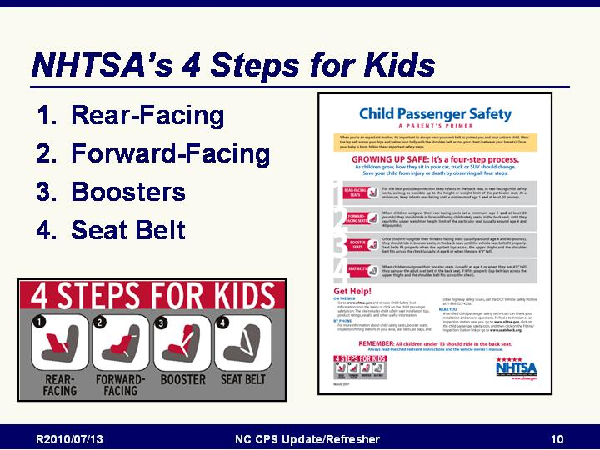
NHTSA’s 4 Steps for Kids
- “Choosing and Using” Sections of the Curriculum are based on NHTSA’s 4 Steps for Kids
- Growing up safe is a four-step process.
  - Step 1: Rear-facing seats
    - As long as possible up to the height or weight limit of the particular seat
    - At a minimum rear-facing until age 1 and at least 20 pounds
    - In the back seat
  - Step 2: Forward-facing seats
    - When rear-facing seat is outgrown (minimum age 1 and at least 20 pounds)
    - Until reaching the upper weight or height limit of the particular seat
    - Should be in the back seat
  - Step 3: Boosters
    - When forward-facing harness is outgrown (usually around age 4 and 40 pounds)
    - In the back seat
    - Until the vehicle seat belts fit properly
    - Lap belt lays across the upper thighs
    - Shoulder belt fits across the chest
  - Step 4: Seat belts
    - When both lap and shoulder belts fit properly
    - Usually at age 8 or when they are 4’9” tall
    - Should be in the back seat

Module 5: Technical Review and Update

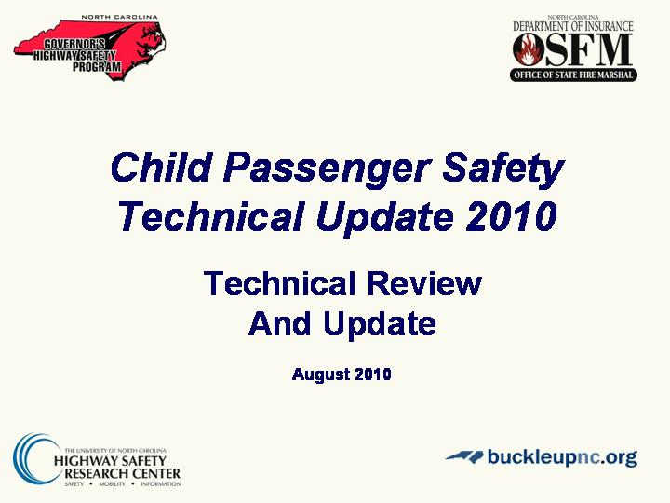
Slide 17

Technical Review Introduction
Will be covering information related to:
- The Role of a CPS Technician
- Federal Standards and Aftermarket Products
- Air bags
- Installation (with belts and with tethers and with LATCH)
- Best Practice Recommendations

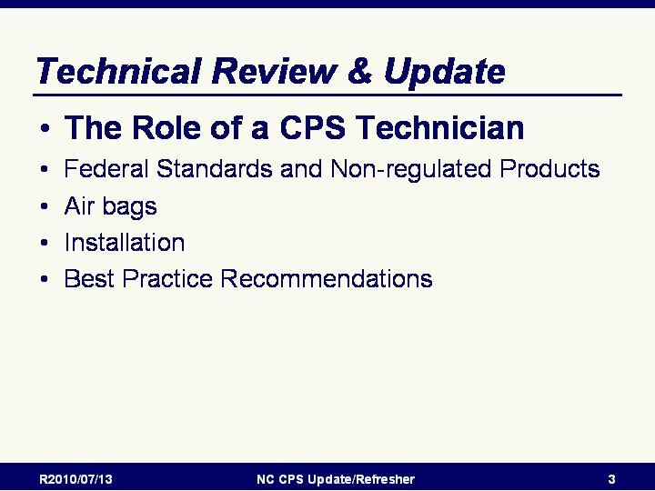
Slide 18

The Role of a CPS Technician
- Introductory slide
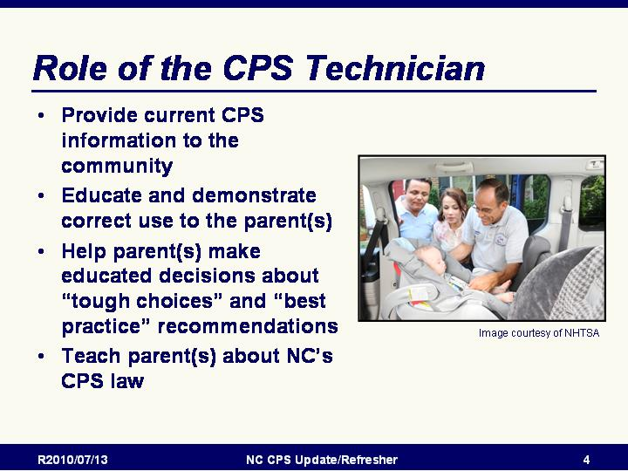
- This section will discuss the role of a CPS Technician

Slide 19

Role of the CPS Technician
- Provide current CPS information to the community
- Educate and demonstrate correct use to the parent(s)
- Help parent(s) make educated decisions about “tough choices” and “best practice” recommendations
- Teach parent(s) about NC’s CPS law

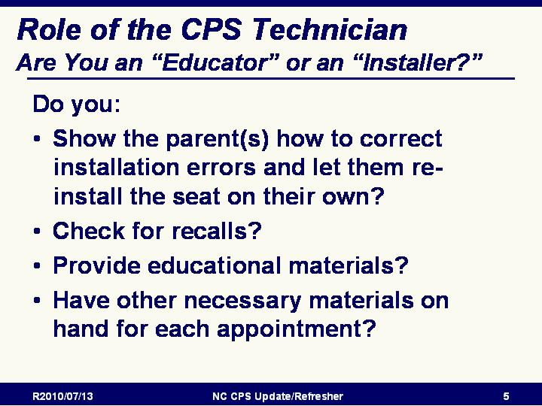
Slide 20

Are You an “Educator” or an “Installer?”
Do you:
- Show the parent(s) how to correct installation errors and let them re-install the seat on their own?
- Check for recalls?
- Provide educational materials?
- Have other necessary materials on hand for each appointment?

EMPHASIZE: If you install the CR but fail to educate the parent/caregiver on how to do it, you are not doing your job as a CPS Technician.

REMEMBER: Ultimately, parents and other caregivers are responsible for their children's safety. Once given all the pertinent information, the parent/caregiver has the final decision and final responsibility. The parent/caregiver should always be the last one to install the child restraint and secure the child. This action should be documented. If a client, recipient, or patient disregards recommended practices, ignores manufacturer's instructions, or leaves with an unrestrained child, document the behavior.

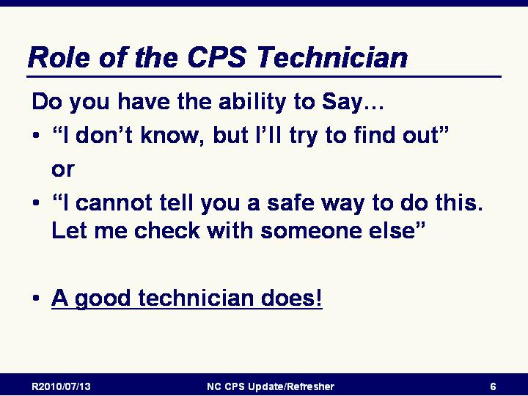
Slide 21

Practices to follow to reduce your exposure to liability include:
- Know your limitations of this and any other CPS training programs you take.
- Always be willing to say, "I don't know, but I will try to find out" when you don't know or the issue is unclear.
- Ensure that all staff involved in providing child passenger safety information are adequately trained. Follow established state and national guidelines for training and/or certification.
- Document all training activity, program content, inspection procedures, and materials distributed. Keep copies of all documentation.
- Make sure that ONLY current, accurate materials and information are distributed. Use current, dated materials from sources that are reliable in child passenger safety.
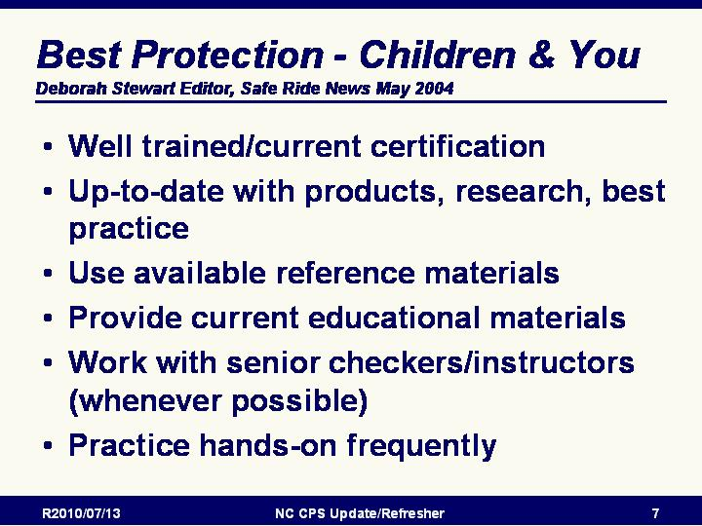
- Be cautious if you create your own promotional materials. Be sure they meet established guidelines for CPS materials and have them reviewed by specialists in the CPS field.

Slide 22

Best Protection - Children & You
Credit: Deborah Stewart Editor, Safe Ride News May 2004
To provide the best service to children and adults and to guard against possible liability issues, Technicians:
- Must be well trained and maintain a CURRENT certification
- Must be up-to-date with products, research, best practice
- Must use available reference materials
- Must provide current educational materials
- Must work with senior/more experienced Technicians/instructors (whenever possible)
- Must practice hands-on frequently

Slide 23

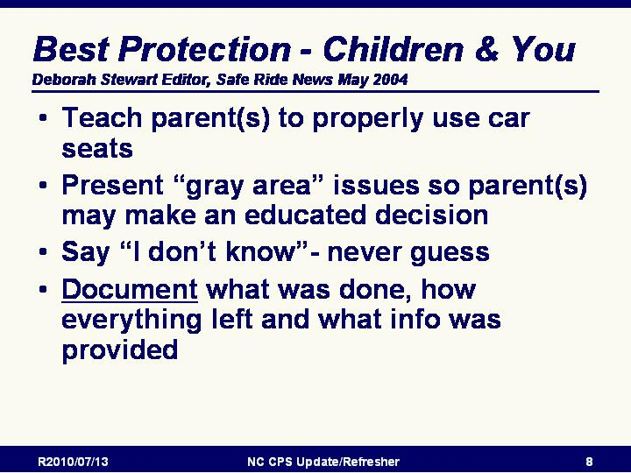
Best Protection - Children & You (continued)
To provide the best service to children and adults and to guard against possible liability issues, Technicians must:

- Teach parent(s) to properly use car seats
- Present “gray area” issues so parent(s) may make an educated decision
- Say “I don’t know”-never guess
- Document what was done, how everything left and what info was provided

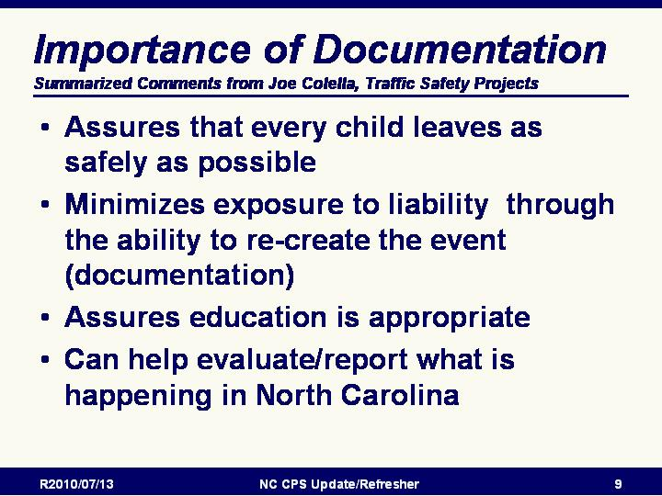
Slide 24

Importance of Documentation
Credit: Summarized Comments from Joe Colella, Traffic Safety Projects
- Documentation assures that every child leaves as safely as possible
- Documentation minimizes exposure to liability through the ability to re-create the event
- Documentation assures education is appropriate
- Documentation can help evaluate/report what is happening in North Carolina

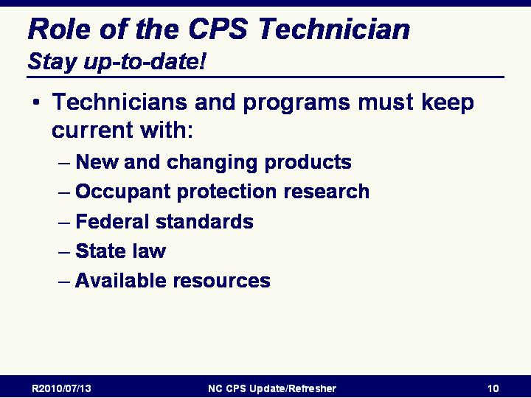
Slide 25

Stay Up-to-Date!
Individual Technicians and programs must keep current with
- New and changing products
- Occupant protection research
- Federal standards
- State law
- Available resources

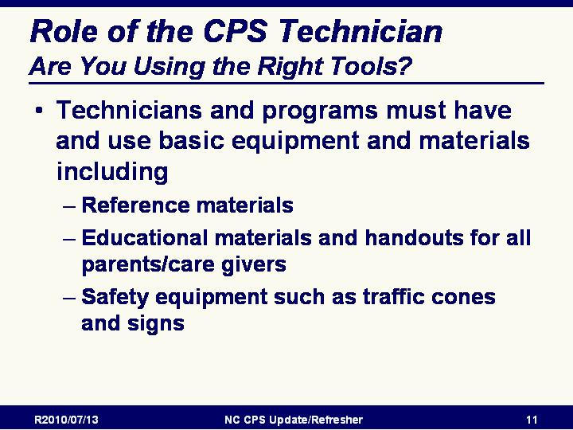
Slide 26

Are You Using the Right Tools?
Individual Technicians and programs must have and use basic reference materials, equipment and educational materials

Slide 27

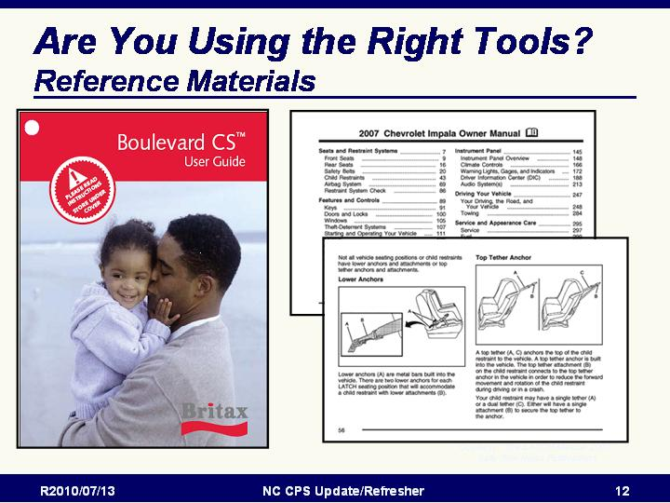
Are You Using the Right Tools? - Reference Materials
- Individual Technicians and programs must have and use basic reference materials including:
  - Child restraint instructions
  - Manufacturer contact information
  - CPS Participant/Instructor manual
  - Standard checklist
  - Updated recall list

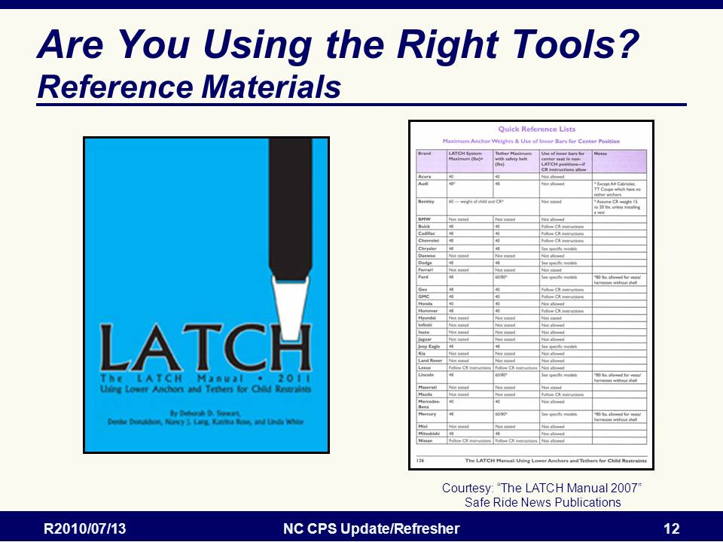
Slide 28

Are You Using the Right Tools? - Reference Materials
- Individual Technicians and programs must have and use basic reference materials including:
  - LATCH and Tether manual
  - This is an indispensable tool

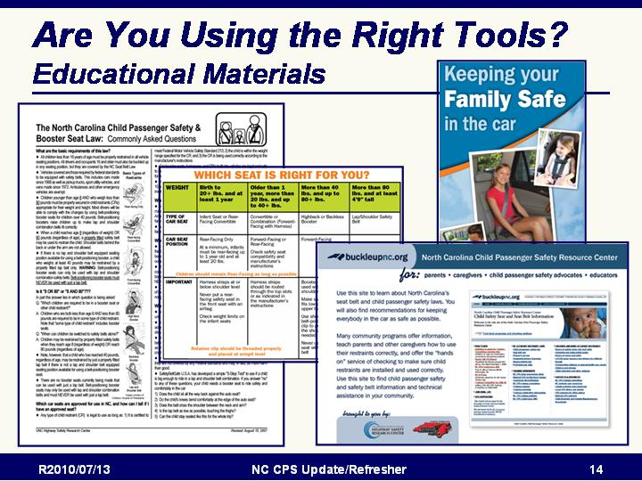
Slide 29

Are You Using the Right Tools? - Educational Materials
- Individual Technicians and programs must have and provide educational materials and handouts for all parents/care givers
- NC occupant restraint laws
- Best practice recommendations
- Available from:
  - NC Governor’s Highway Safety Program
  - NC Department of Insurance, Office of State Fire Marshal
  - UNC Highway Safety Research Center / buckleupnc.org
Slide 30

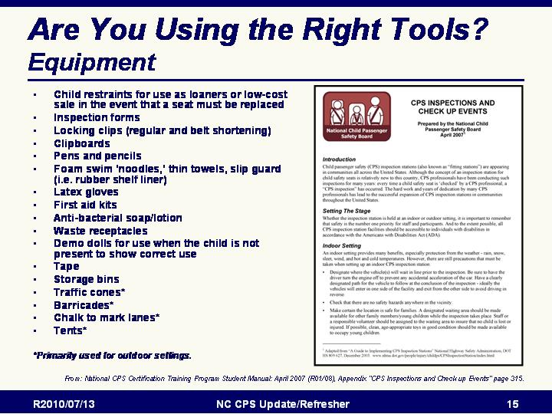
Are You Using the Right Tools? - Equipment
- Individual Technicians and programs must have and use basic equipment such as materials
  - Child restraints for use as loaners or low-cost sale in the event that a seat must be replaced
  - Inspection forms
  - Locking clips (regular and belt shortening)
  - Clipboards
  - Pens and pencils
  - Foam swim ‘noodles,’ thin towels, slip guard (i.e. rubber shelf liner)
  - Latex gloves
  - First aid kits
  - Anti-bacterial soap/lotion
  - Waste receptacles
  - Demo dolls for use when the child is not present to show correct use
  - Tape
  - Storage bins
  - Traffic cones* (Primarily used for outdoor settings)
  - Barricades* (Primarily used for outdoor settings)
  - Chalk to mark lanes* (Primarily used for outdoor settings)
  - Tents* (Primarily used for outdoor settings)
- For a more complete list and information on running and equipping programs, refer to: National CPS Certification Training Program Student Manual: April 2007 (R01/08), Appendix “CPS Inspections and Check up Events” page 315.

Slide 31

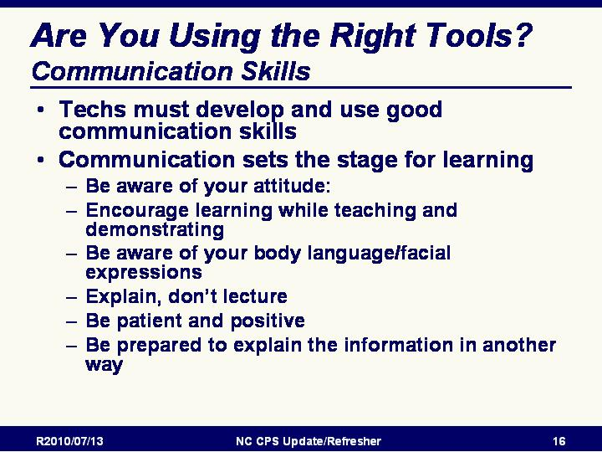
Are You Using the Right Tools? - Communication Skills
- Individual Technicians and programs must develop and use good communication skills
- Communication is important to learning. Caregivers will pick up on the tone of your voice and your body language. If you are negative toward the parent/caregiver, they may not listen to your message.
- Caregivers are trying to keep their children as safe as possible — that is why they have come to you for help.
- This is your opportunity to show the parent/caregiver that CPSTs are helpful and understanding.
- Communication sets the stage for learning
  - Be aware of your attitude:
  - Encourage learning while teaching and demonstrating
  - Be aware of your body language/facial expressions
  - Explain, don’t lecture
  - Be patient and positive
  - Be prepared to explain the information in another way

Slide 32

Best Practices and Tough Choices
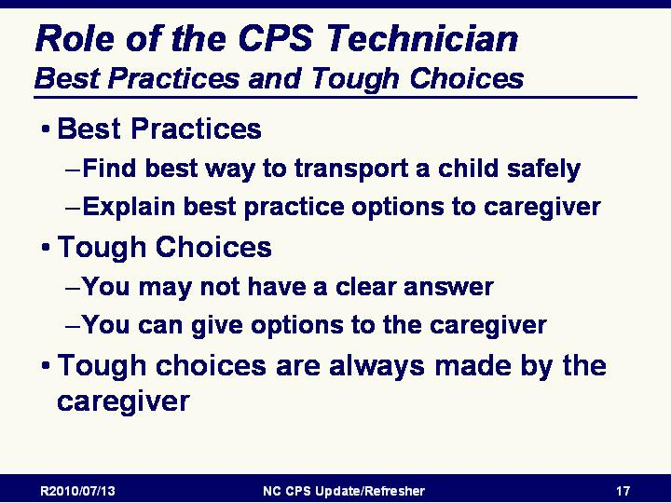
- Best practice is the gold standard of protection. It is the most acceptable way to transport a child safely on the basis of the child’s age, weight, height, and body development.
- Often, parents/caregivers do not choose the best practice because they do not understand the reason for it.
- As a technician, it is your job to understand the reason and explain it in simple, clear terms to the parent/caregiver.
- Tough choices are issues that may not have a clear answer regarding the safest way to transport a child. Parents/caregivers will then need to decide among the options.
- In many cases, there will be best practices related to the tough choices. A technician must provide caregivers with available options. Parents/caregivers are then better able to make tough choices about how best to restrain their own child.
- Tough choices are always made by the parent/caregiver, not the technician.
- As a technician,
  - You should never support a parent/ caregiver in breaking the law or going against the manufacturers’ instructions.
  - You should place the parent/caregiver’s tough choice on your checklist to prevent liability and risk.
  - Remember: Watch your attitude and body language when a parent/caregiver does not choose a best practice.

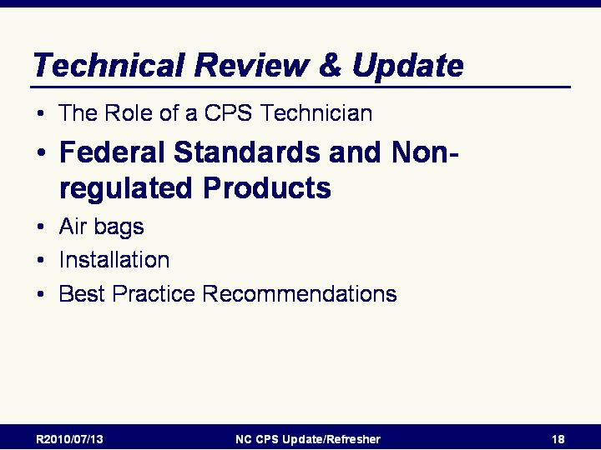
Slide 33

Federal Standards and Non-Regulated Products Introduction
Introductory slide
This section will discuss the federal standards.

Slide 34

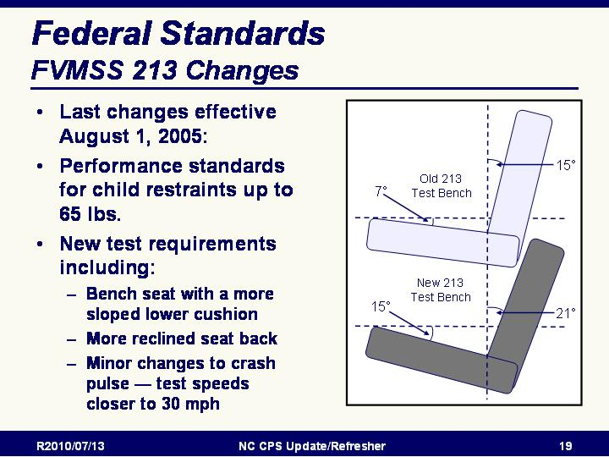
FMVSS 213 Changes
- Last changes to FMVSS 213 were as of August 1, 2005:
- Performance standards for child restraints up to 65 lbs.
- New test requirements including:
  - A bench seat with a more sloped lower cushion (now 15 degrees from the horizontal rather than 7 degrees)
  - More reclined seat back (now 21 degrees from the vertical rather than 15 degrees)
  - Minor changes to crash pulse — test speeds closer to 30 mph

Slide 35

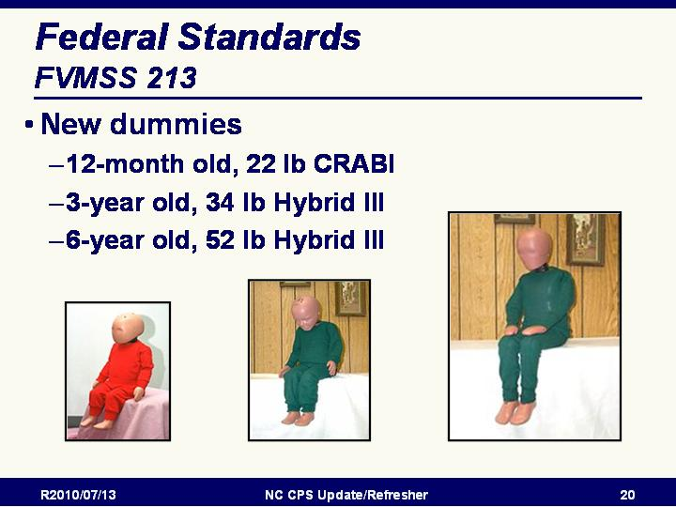
New crash test dummies used
- The 12-month old, 22 pound CRABI (Child Restraint AirBag Interaction) dummy
  - Slightly taller and heavier than the previous 9-month dummy.
  - Developed for air bag testing and accommodating a baby up to 22 pounds. It is taller than previous 9-month dummy necessitating higher backs on infant-only restraints.
- The 3-year old, 34 pound Hybrid III dummy
  - More sophisticated instrumentation than previous Hybrid II dummy,
  - Allowing what NHTSA calls a more human-like response.
- The 6-year old, 52 pound Hybrid III dummy
  - A weighted version of the 6-year dummy (weighted up to 62 pounds) will be required for tests of the structural integrity of restraints for children from 50 to 65 pounds.
  - To be used until a I0-year old dummy is ready.

NOTE: Refer students to Appendix page 235 of Student Manual for more details.
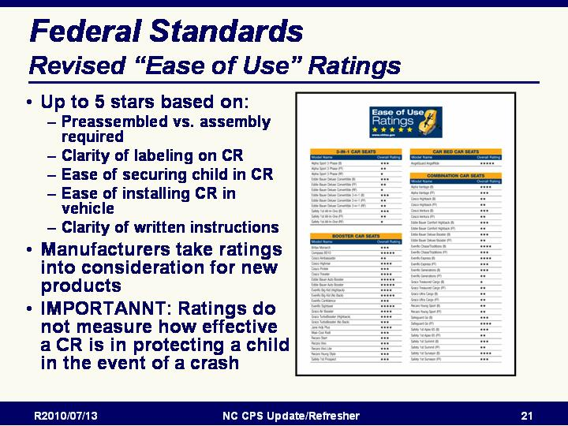

Slide 36

NHTSA Ease of Use Ratings
- “Ease of Use Ratings” revised in 2008
- A child restraint is assessed under each mode (rear-facing, forward-facing, and booster) of proper use and is awarded both an individual category 5-star rating and an overall 5-star rating.
- For each mode, child restraints are individually assessed on the following four categories:

  - Evaluation of Labels: Examines the content and clarity of the labeling attached to the child restraint.
  - Evaluation of Instructions: Examines the content and clarity of the instruction manual for the restraint.
  - Securing the Child: Examines the ease of using features that pertain to securing a child correctly in the restraint.
  - Vehicle Installation Features: Examines the ease of using features that pertain to installing the child restraint in a vehicle.

STRESS: Ratings do not measure how effective a child restraint is in protecting a child in the event of a crash

Slide 37

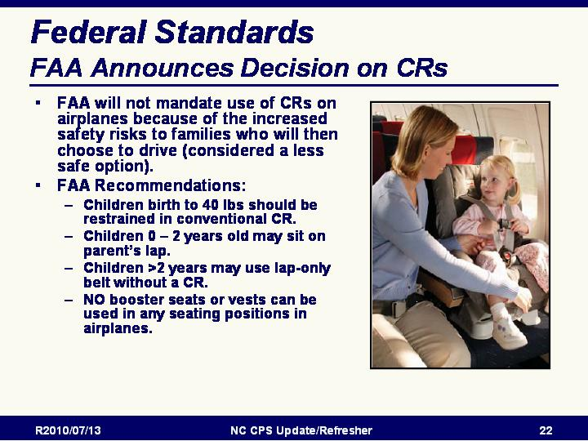
Restraint Use on Aircraft

FAA Recommendations
FAA will not mandate use of Child Restraints on airplanes because of the increased safety risks to families who will then choose to drive (driving is considered a less safe option)
FAA Recommendations:
- Children birth to 40 lbs should be restrained in conventional CR.
- Children 0 – 2 years old may sit on parent’s lap.
- Children >2 years may use lap-only belt without CR.
- NO booster seats or vests can be used in any seating positions in airplanes.

Slide 38

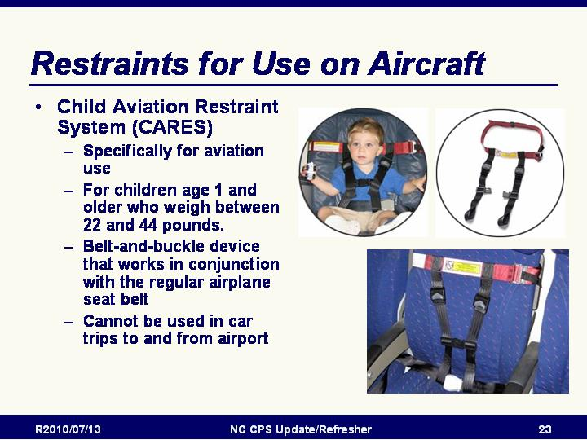
Restraints for Use on Aircraft
- CARES is designed specifically for aviation use for children age 1 and older who weigh between 22 and 44 pounds.
- CARES is the first and only aviation Child Safety Device to be certified by the Federal Aviation Administration (FAA) as an alternative to a car seat.
- CARES is an elegantly designed belt-and-buckle device that works in conjunction with the regular airplane seat belt and provides young travelers the same level of safety as a car seat.
- CARES weighs just one pound and fits into a 6" stuff sack! It is easily portable, simple to install, adjustable to nearly every size airplane seat, and usable on any seat in the airplane, except in the emergency exit rows.
- Need your car seat on the other end of the trip? Just check it through as luggage – and carry CARES on board in your pocket!
- CARES is manufactured exclusively by AmSafe Aviation, the foremost manufacturer of aviation seatbelts and pilot restraints in the world. (Turn over your airplane seat belt buckle. Chances are it says AmSafe.) CARES is made of the same industrial-strength webbing as your own seat belt and is engineered to the highest aviation-safety standards.
From: www.kidsflysafe.com/about.php

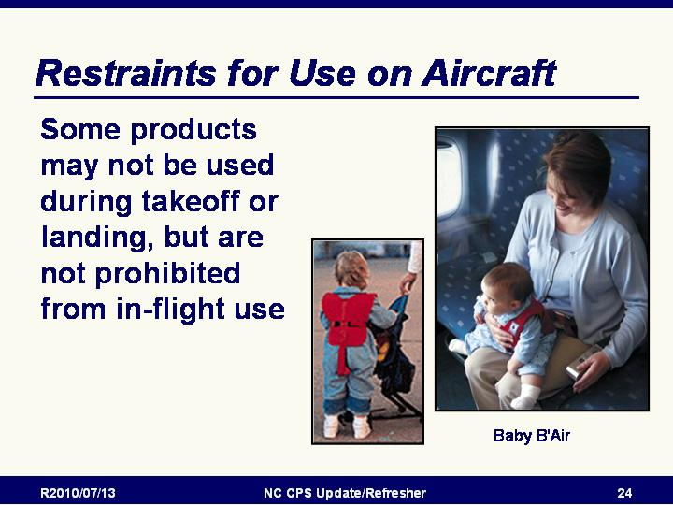
Slide 39

Restraints for Use on Aircraft
- Some products may not be used during takeoff or landing, but are not prohibited from in-flight use. The FAA changed regulations in early 1996, banning devices other than approved car seats during takeoff, taxi and landing.
- Baby B'Air is worn by the infant like a vest.
- The Baby B'Air was designed ONLY for use during air travel to prevent injuries due to severe turbulence and should NOT UNDER ANY CIRCUMSTANCE BE USED IN AN AUTOMOBILE.
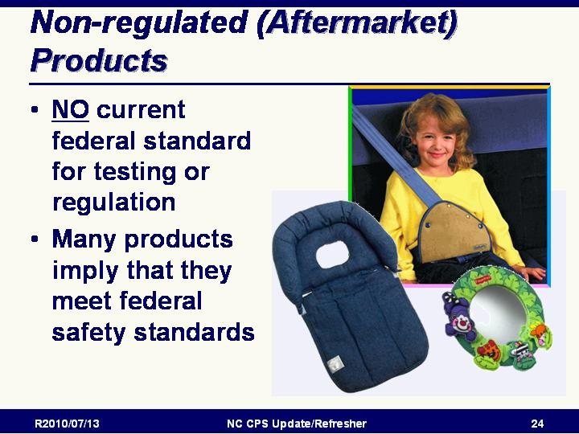

Slide 40

Non-regulated (Aftermarket) Products
Reminder:
- NO current federal standard for testing or regulation
- Many products may mislead one to believe that they meet federal safety standards

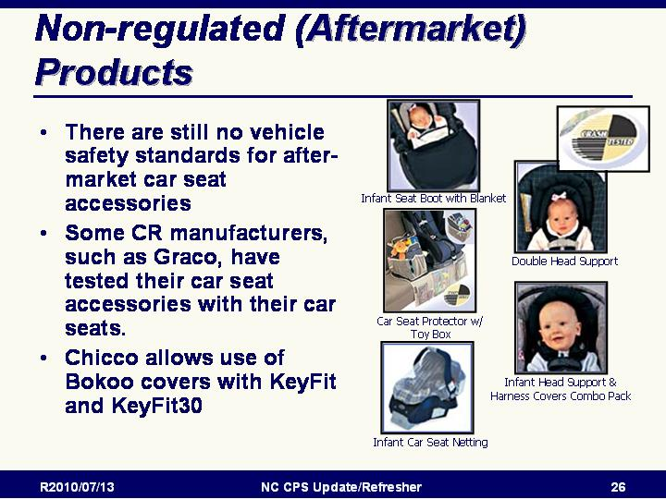
Slide 41

Non-Regulated (Aftermarket) Products
- There are still no Federal standards for after-market car seat and seat belt accessories. For example, a seat belt adjuster label may say the product “meets all applicable federal standards” when there is no Federal standard.
- Carefully read all manuals and instructions, including vehicle and CR manufacturers’ instructions and recommendations. Many warn against using “extras” with their products.
- Some devices can injure if not properly secured during a crash. Suction window shades and mirrors are two examples of objects that can harm vehicle occupants during a crash. Window shades that stick to the windows are better to use.
- Manufacturer-tested and -approved accessories such as toys for their own CRs or shoulder belt adjustable clips are fine. Some CR manufacturers, such as Graco, have tested their car seat accessories with their car seats.
- There is a difference between seat belt adjusters that come with booster seats (manufacturer-tested and endorsed) versus those that are sold independently.
- Remember: Parents/caregivers make the final decision regarding use of these products. As technicians, we advise and educate.

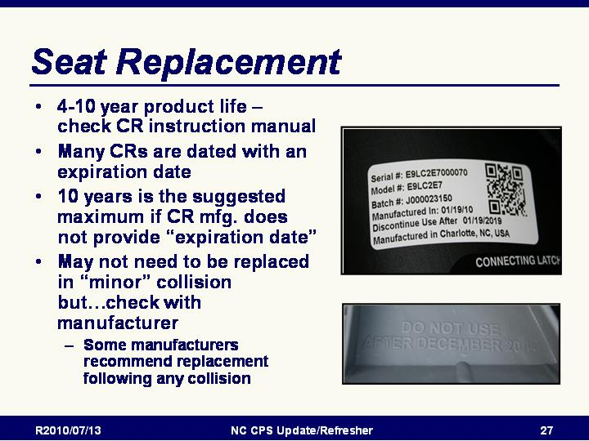
Slide 42

Seat Replacement
- 4-10 year product life – check CR instruction manual
- Many CRs are dated with an expiration date
- NC suggests 10 years as a recommended maximum if CR mfg. does not provide “expiration date”
- May not need be replaced in “minor” collision however some manufacturers recommend replacement after any collision. Check with manufacturer to be sure.

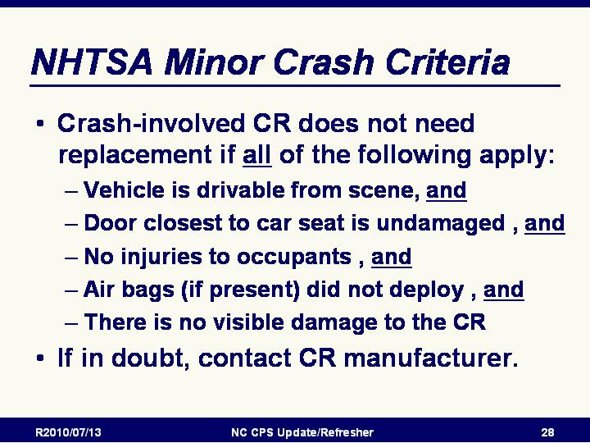
Slide 43

NHTSA Minor crash criteria
- In general, seat belts, child restraints, and air bags should all be considered "one time use" products and vehicle and child restraint manufacturers recommend replacement of their restraints after a crash.
- However, a child restraint may not need to be replaced following a minor crash. The National Highway Traffic Safety Administration (NHTSA) has established criteria to determine if a crash is severe enough to warrant child restraint system (CRS) replacement. According to these criteria, a crash is considered minor if ALL the following are met:

- A visual inspection of the CRS does not reveal any cracks or deformities;
- The vehicle with the CRS installed in it can be driven from the scene;
- The vehicle door nearest the CRS is undamaged;
- There were no injuries to any occupants; and
- The air bags did not deploy

- Parents who have been involved in a minor crash with their children in child restraints should call the child restraint manufacturer for advise on replacing it and continue to use the restraint in the meantime.
- Insurance claims should include the cost of replacing occupant restraint systems in use in other than minor crashes. In addition, some child restraint manufacturers may offer replacement restraints for those that have been involved in a crash.
- When in doubt, contact CR manufacturer.

Slide 44

Air bags Introduction

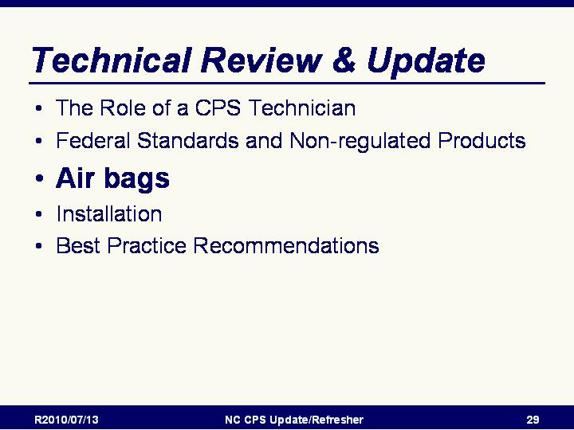

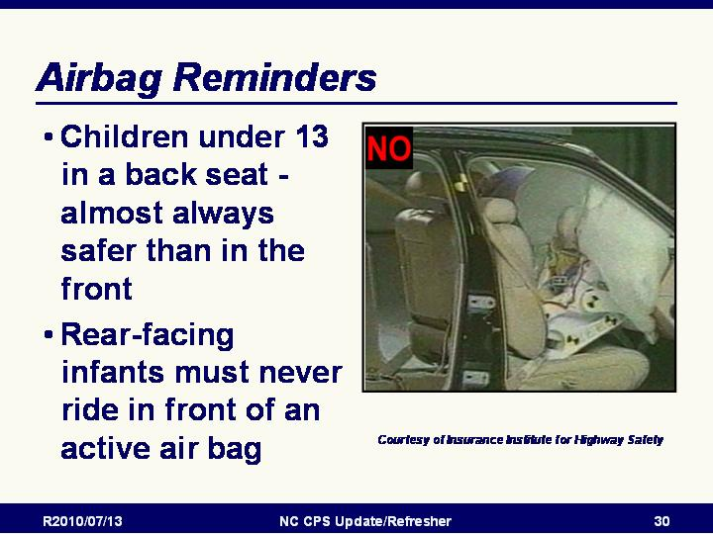
Slide 45

Airbag Reminders
- As a reminder:
  - All children under 13 should ride in a back seat — children are almost always safer in the back seat
  - Rear-facing infants must never ride in front of an active passenger air bag.

Slide 46

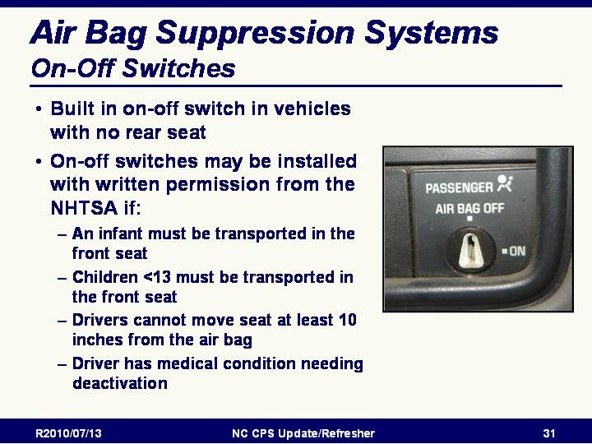
Air Bag Suppression Systems

Air Bag Active Suppression: On-Off Switches
- Some air bags can be shut off by the owner with a built in on-off switch
- May be in vehicles with no rear seat
- Check owner’s manual
- Air bag on-off switches can be installed with written permission from the NHTSA if:
  - A rear-facing infant must be transported in the front seat.
  - Children under 13 must be transported in the front seat.
  - Drivers cannot change their driving position (10 inches from the air bag).
  - There is an existing medical condition that would warrant deactivation.

Slide 47

Air Bag Suppression Systems: Passive Suppression
- Sometimes referred to as “smart air bags”
- Available in the front passenger seat of some vehicles
- Required in light duty vehicles as of MY 2006
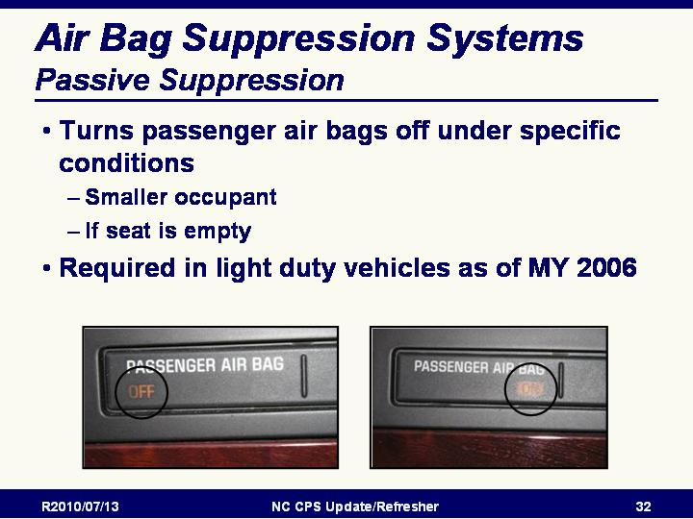
- designed primarily to minimize the risk of an air bag-related injury or death to children and small-stature adults.
- Designed to meet the needs of the occupant in a variety of specific crash situations.
- Depending on design, air bag systems automatically determine if and with what level of power the driver and passenger air bags will inflate.
- The appropriate level of power is based upon sensor inputs that can typically detect:
  - If a seat is occupied and, if so,
  - Occupant size,
  - Seat position (how close to the steering wheel or dashboard),
  - Seat belt use of the occupant, and
  - Crash severity.
- Turns front and/or side air bag off under specific conditions:
  - If a smaller occupant is present in the seat
  - If the seat is empty
- Check the vehicle owner’s manual

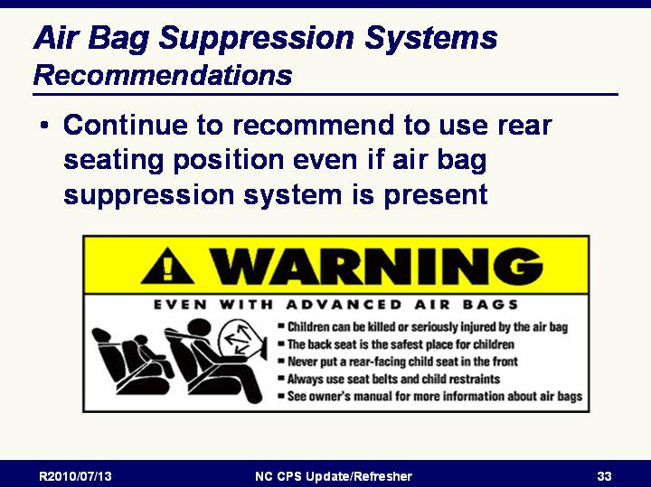
Slide 48

Advanced (Smart) Air Bags
- Still recommended to use rear seating position
- NHTSA continues to recommend that children 12 and under be transported in the rear seat in an appropriate child restraint system. Children are safer in the rear seat.
- This applies to all children 12 and under: an infant riding in a rear-facing infant seat, a child riding in a forward-facing child restraint, an older child riding in a booster seat and children large enough to wear a seat belt.

Slide 49

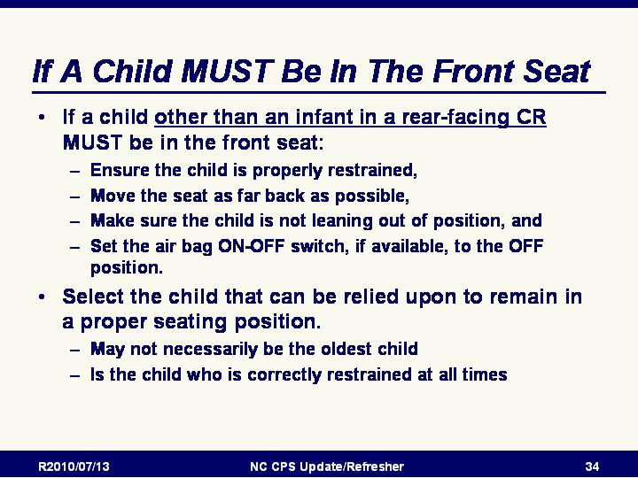
If A Child MUST Be In The Front Seat
- NHTSA also recognizes that there are occasions when a parent or caregiver has no other option than to place a child other than an infant in a rear-facing child safety seat in the right front seat (for example, in a pickup truck with insufficient or no available rear seat, or when a parent is transporting more children than available rear seating positions).
- In the event there is no available rear seat and parents have no other option than to place a child other than an infant in a rear-facing child restraint in a front passenger seating position, take these steps:
  - Ensure the child is properly restrained,
  - Move the seat as far back as possible,
  - Make sure the child is not leaning out of position, and
  - Set the air bag ON-OFF switch, if available, to the OFF position.
- This applies to all children 12 and under: an infant riding in a rear-facing infant seat, a child riding in a forward-facing child restraint, an older child riding in a booster seat and children large enough to wear a seat belt.
- *When faced with having to choose which child to place in front of an air bag in the front seat, select the child that can be relied upon to remain in a proper seating position. This may not necessarily be the oldest child, but the child who is held back (restrained) at all times.

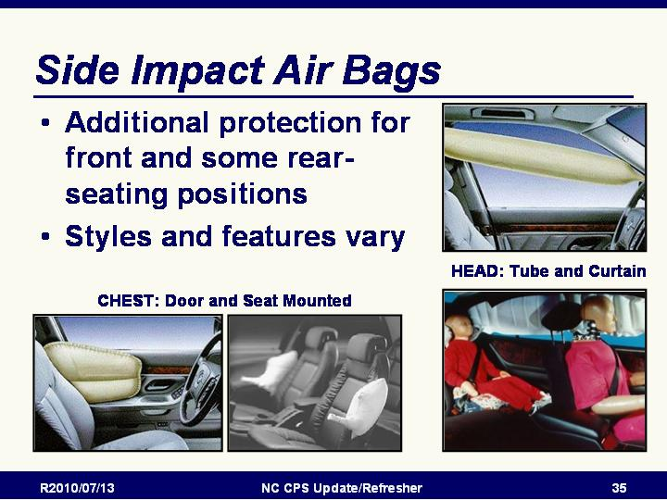
Slide 50

Side Impact Air Bags
- Additional protection for front and some rear-seating positions
- Styles and features vary
- Point out types OF SABs illustrated on the slide:
  - Chest/Torso - Door and seat mounted
  - Head - Tube and curtain
- SABs are inflatable devices that help protect your head and/or chest from being hit by hard objects in a side-impact crash.
- The first head SABs were introduced in model year 1998, but did not become widely available until recently.
- SABs, unlike frontal air bags, are not required by NHTSA. Because they are not required safety equipment, the Federal government does not mandate that vehicles be equipped with SABs. However, on September 11, 2007, NHTSA published a final rule that requires upgraded side impact protection. This rule, Federal Motor Vehicle Safety Standard (FMVSS) No. 214, Side Impact Protection, establishes new performance requirements.
- It's up to individual manufacturers to decide what type or types of protection systems - including SABs - they will use to meet the upgraded requirement.
- There are three main types of SABs: chest (torso) SABs, head SABs, and head/chest combination (combo) SABs.
  - Chest (torso) SABs are mounted in the side of the seat back or in the door and are designed to help protect an adult's chest in a serious side-impact crash.
  - Head SABs are usually mounted in the roof rail above the side windows and are designed to help protect an adult's head in a side-impact crash. There are two types of head SABs: curtain SABs and tubular SABs. Curtain SABs can provide protection to both front and rear occupants in a side-impact crash; some may also stay inflated longer to provide protection from ejection if your vehicle rolls over after being struck on the side. Some new convertibles include head SABs that deploy upwards from the window sill.
  - Head/chest combination ("combo") SABs are usually mounted in the side of the seat and are typically larger than chest (torso) SABs. Combo SABs are designed to help protect both the head and chest of an adult.
- Consult your owner's manual or vehicle manufacturer for specific information on your vehicle's side air bag system
Source: http://www.safercar.gov/

Slide 51

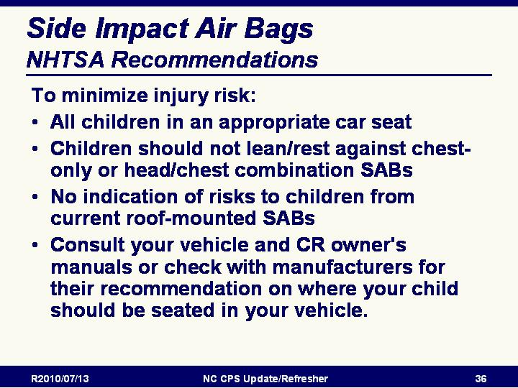
Side Impact Air bags: NHTSA Recommendations
Potential Risk & Real-World Experience
- To minimize the potential risk of SAB-related injuries to occupants - especially children - a group of automotive and insurance industry experts known as the Technical Working Group (TWG) developed voluntary SAB standards and testing procedures. Manufacturers now report to the government if the SABs in a given vehicle model have met the voluntary standards.
- To find out if your vehicle's SABs meet the TWG standards, visit and search the vehicle database by make, model, and year. Vehicles reported as meeting the TWG voluntary standards will indicate "Meets Specification" beside the "SAB Out Of Position Testing" entry under "Air Bags." These out of position testing standards were developed primarily with children in mind. TWG standards information can also be found in the annual NHTSA "Buying a Safer Car" brochures.
- Prior to the development of the recommended TWG standards, many chest (torso) and head/chest combination (combo) SABs showed a potential for serious or fatal injury to children seated too close to a deploying air bag. However, very few vehicles sold in the U.S. have these types of SABs in the rear seating positions.
- NHTSA has not seen any indication that current roof-mounted head SABs pose a risk to children. Many roof-mounted SABs now extend rearward to include the second and even the third row seating positions. You can check your owner's manual or visit and search the vehicle database to learn whether your vehicle is equipped with SABs, and if so, what type.
- As of 2008, NHTSA has investigated over 1,500 cases where SABs have deployed in crashes. Sixty of the cases have involved children (ages 13 and under). NHTSA crash investigators found no moderate or serious injuries to these children as a result of SAB deployments. NHTSA continues to closely monitor real-world SAB deployments involving both children and adults.

- What are NHTSA's recommendations regarding child passenger safety and SABs?
  - All air bags (frontal or side) are supplemental safety devices and are intended to work best in combination with seat belts. Therefore, even with SABs that meet TWG testing procedures (see #6 above), make sure that:
  - ALL children use a safety restraint appropriate for their age and size (this could be a safety seat, booster seat or adult safety belt).
  - Children aged 12 and younger are safest sitting in the rear seat properly restrained.
  - NEVER place a rear-facing infant seat in the front seat of a vehicle with a front passenger air bag.
  - To minimize injury risks, NHTSA recommends that children not lean or rest against chest-only or head/chest combination SABs.
  - NHTSA has not seen any indication of risks to children from current roof-mounted head SABs.

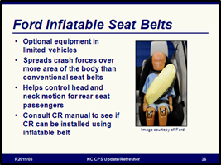
Slide 52

Ford Inflatable Seat Belts
- Optional equipment in limited vehicles – introduced in 2011 Ford Explorer
- Spreads crash forces over five times more area of the body than conventional seat belts
- Helps control head and neck motion for rear seat passengers
- Consult CR manual to see if CR can be installed using inflatable belt

From: http://media.ford.com/article_display.cfm?article_id=31360

“WASHINGTON, D.C., Jan. 26, 2011 – Ford Motor Company has brought to market the world’s first automotive inflatable seat belts, combining attributes of traditional seat belts and airbags to provide an added level of crash safety protection for rear seat occupants….
Ford introduced inflatable rear seat belts on the 2011 Ford Explorer. Over time, Ford plans to offer the technology in vehicles globally…
Advances in airbag inflation and seat belt construction methods have enabled Ford and its suppliers to develop inflatable seat belts that are designed to deploy over a vehicle occupant’s torso and shoulder in 40 milliseconds in the event of a crash…
Vehicle safety sensors determine the severity of the collision in the blink of an eye and deploy the inflatable belts’ airbags. Each belt’s tubular airbag inflates with cold compressed gas, which flows through a specially designed buckle from a cylinder housed below the seat…
The inflatable belt’s accordion-folded bag breaks through the belt fabric as it fills with air, expanding sideways across the occupant’s body in about the same amount of time it takes a car traveling at highway speed to cover a yard of distance.
The use of cold compressed gas instead of a heat-generating chemical reaction – which is typical of traditional airbag systems – means the inflated belts feel no warmer on the wearer’s body than the ambient temperature. The inflatable belts also fill at a lower pressure and a slower rate than traditional airbags, because the device does not need to close a gap between the belt and the occupant…
The inflated belt helps distribute crash force energy across five times more of the occupant’s torso than a traditional belt, which expands its range of protection and reduces risk of injury by diffusing crash pressure over a larger area, while providing additional support to the head and neck. After deployment, the belt remains inflated for several seconds before dispersing its air through the pores of the airbag.”

NOTE: Some CR manufacturers have taken the position that their CR’s are not to be installed using inflatable seat belts. Example from Britax:
Q. Can I use an inflatable seat belt to install my BRITAX car seat?
A. Currently, BRITAX does not permit the use of inflatable seat belts with any BRITAX product – old and newly manufactured products. This has been added to the Incompatible Seat Belt section in current convertible user guides and it will be added to user guides of other models as they are revised and updated. BRITAX continues to review inflatable seat belt compatibility and may modify its position dependent upon test results.

http://www.britaxusa.com/customer-service/faq/installation-questions

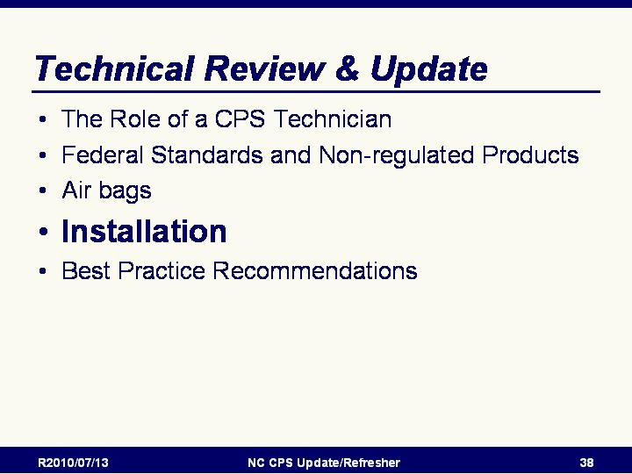
Slide 53

Installation Introduction

Slide 54

The Back Is Where It’s At
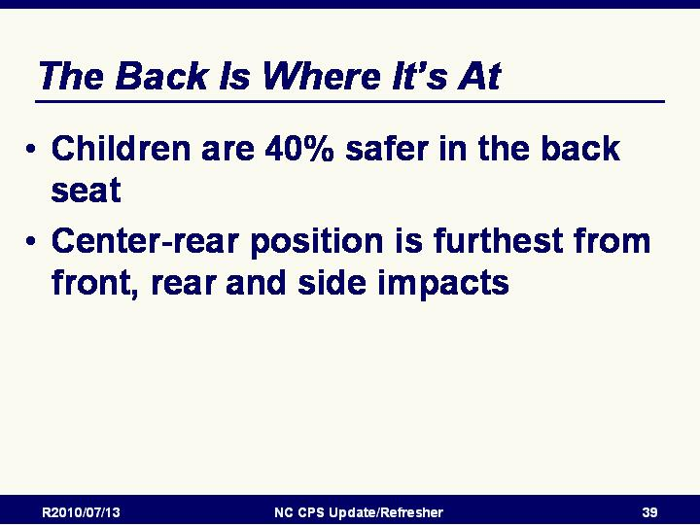
- Reminder that best practice recommendation is for children less than age 13 should not ride in the front seat.
  - Children are 40% safer in the back seat
  - The center-rear position is furthest from front, rear and side impacts

Slide 55

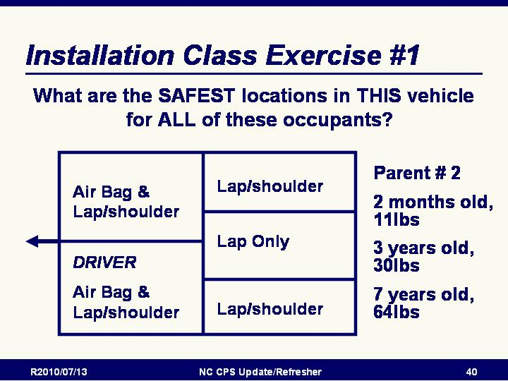
Installation Class Exercises

Safe Location Exercise #1
- Using the sizes and vehicle configuration on the overheads ask the participants to select the safest place in the vehicle for ALL of the occupants.
- Solicit responses from class and place on flip chart. Take this opportunity to discuss the complicated issues that arise for parents when real world vehicle and occupant needs conflict with best practice recommendations.
- Discuss possible solutions including:
  - Front Passenger side: Parent # 2
  - Rear passenger side: 3 year old or 2 month old
  - Rear Center: 2 month old or 3 year old
  - Rear driver side: 3 year old or 7 year old

Slide 56

Installation Class Exercise #2
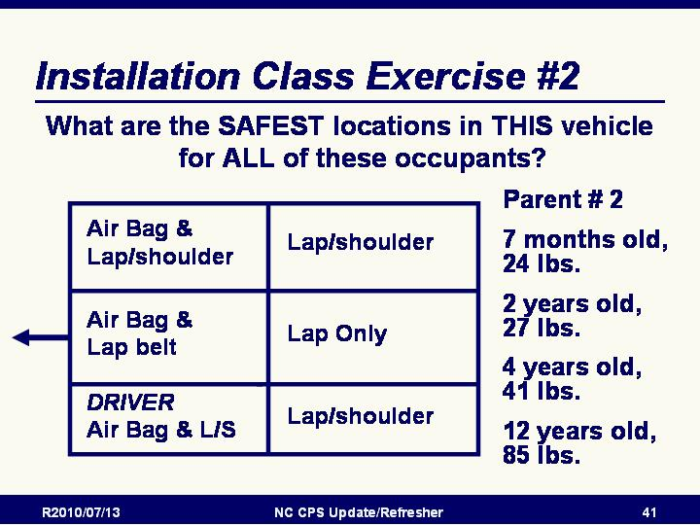
- Using the sizes and vehicle configuration on the overheads ask the participants to select the safest place in the vehicle for ALL of the occupants.
- Solicit responses from class and place on flip chart. Take this opportunity to discuss the complicated issues that arise for parents when real world vehicle and occupant needs conflict with best practice recommendations. Discuss possible solutions including:
  - Front Passenger side: Parent # 2
  - Front center: 2 year old in FF CR with harness*
  - Rear passenger side: 4 year old in BPB or high weight harness or 7 month old in RF CR**
  - Rear Center: 7 month old in RF CR or 4 year old In a forward-facing CR with harness and a higher weight limit
  - Rear driver side: 12 year old in lap and shoulder belt or 4 year old in BPB or high weight harness

* When faced with having to choose which passenger to put in front of an air bag, the person who is held back at all times is the best choice, the child in a properly used CR with a harness cannot lean forward. If a child will be transported in the front seat with an active air bag on a regular basis, an on/off switch should be installed.
** 7 month old in the outboard seating position is acceptable. Many safety experts believe the rear-facing CR, like in front crashes, provides greater protection in side impacts than a forward-facing CR.

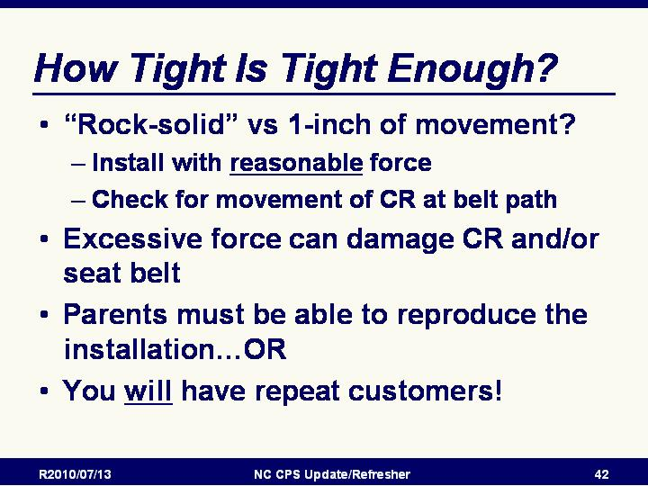
Slide 57

How Tight Is Tight Enough?
- “Rock” solid vs. 1” of movement?
  - Install as tightly as possible with reasonable force
  - Pull CRS at belt path with reasonable force to test
- Parents must be able to reproduce the installation…OR
- You will have repeat customers! AND THIS IS NOT A GOOD THING!

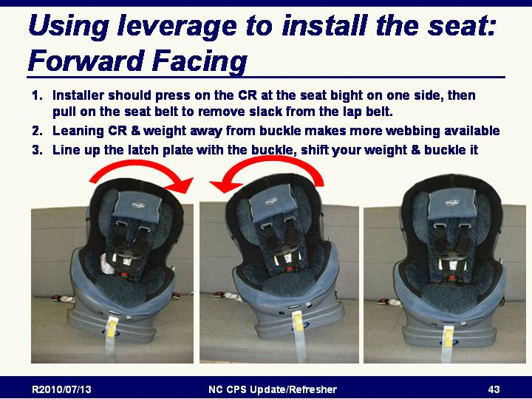
Slide 58

Using leverage to install the seat: Forward Facing
- Installer should press on the CR at the seat bight on one side pull on the seat belt to remove slack from the lap belt.
- Leaning CR & weight away from buckle makes more webbing available
- Line up the latch plate with the buckle, shift your weight & buckle it

Slide 59

Tightening Devices

Installation Tools: Non-Regulated Tightening Devices
- There are still no regulations or recommended testing procedures for tightening tools
- Concerns about possible stress on CR due to over-tightening
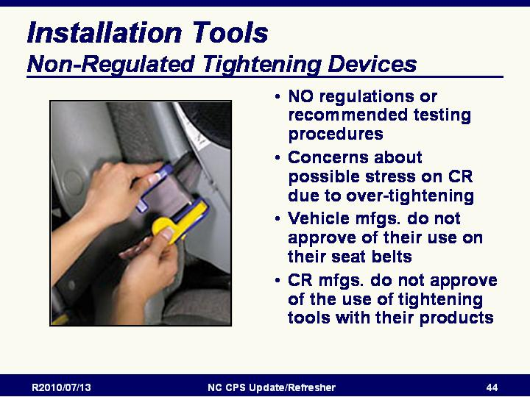
- Vehicle manufacturers do not approve of their use on their seat belts
- CRS manufacturers do not approve of their use with their products

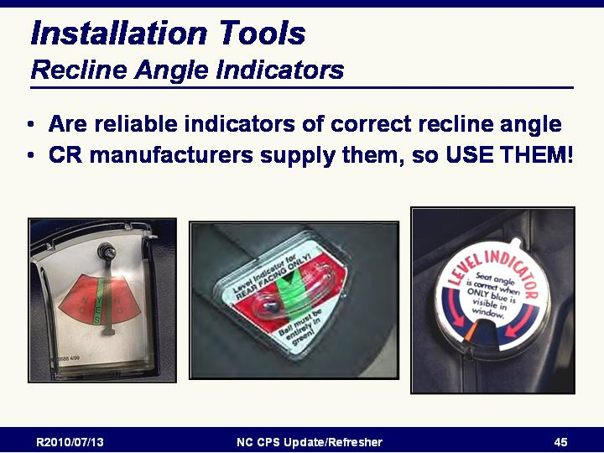
Slide 60

Recline Angle Indicators

Installation Tools: Recline Angle Indicators
- Generally, these are reliable indicators of correct recline angle
- CR manufacturer supplies them, so USE THEM!

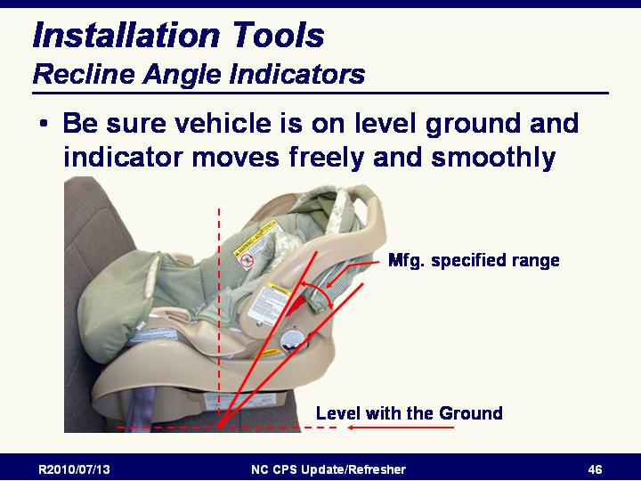
Slide 61

Installation Tools: Recline Angle Indicators
- If using a “bubble” or other indicator that relies on gravity to determine/indicate correct angle, Be sure the vehicle is on level ground and indicator moves freely and smoothly.

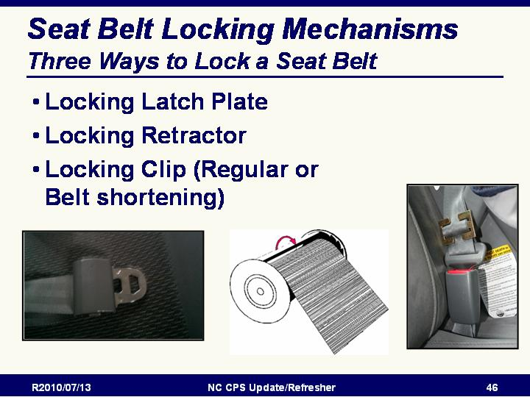

Slide 62

Seat Belt Locking Mechanisms

Three Ways to Lock a Seat Belt:
- Locking Latch Plate
- Locking Retractor
- Locking Clip (Regular or Belt shortening)

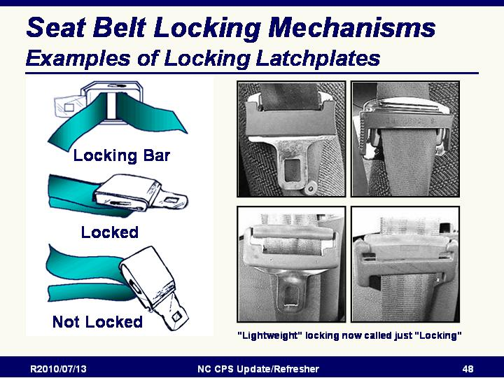
Slide 63

Seat Belt Locking Mechanisms
Examples of Locking Latchplates
- No longer any distinction between “standard and “lightweight” locking latchplates
- All are treated the same

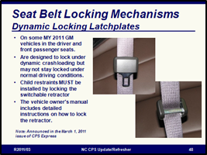
Slide 64

Seat Belt Locking Mechanisms

Dynamic Locking Latchplates
- Some 2011 model year GM vehicles are equipped with dynamic locking latch plates in the front driver and passenger seats.
- These are different from the more familiar cinching latch plates that are used for child restraint installation as the dynamic locking latch plates are designed to lock under dynamic crash loading but they may not stay locked under normal driving conditions.
- Child restraints MUST be installed by locking the switchable retractor, even when there is a dynamic locking latch plate in the front passenger seat.
- The vehicle owner's manual instructs that the retractor must be locked for child restraint installation in the front passenger seat along with detailed instructions on how to lock the retractor.

Note: This was announced in the March 1, 2011 issue of CPS Express

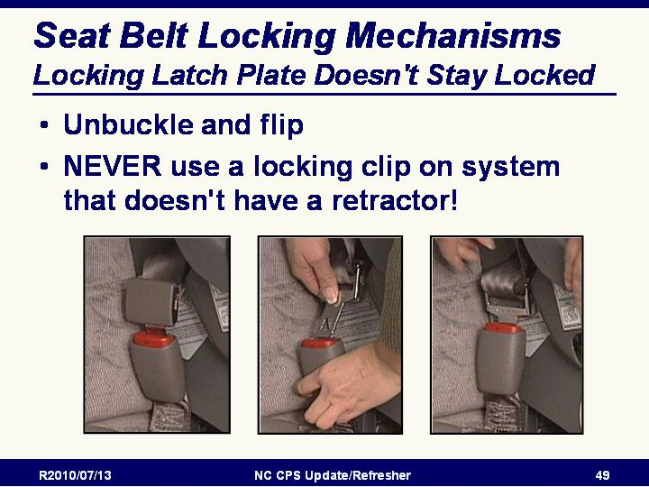
Slide 65

Seat Belt Locking Mechanisms

Locking Latch Plate Doesn't Stay Locked
- Unbuckle and flip
- NEVER use a locking clip on system that doesn't have a retractor!

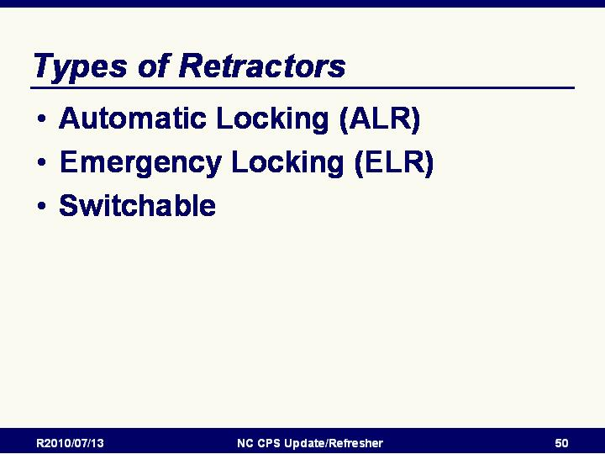
Slide 66

Review of types of Retractors
- Automatic Locking (ALR)
- Emergency Locking (ELR)
- Switchable

Slide 67

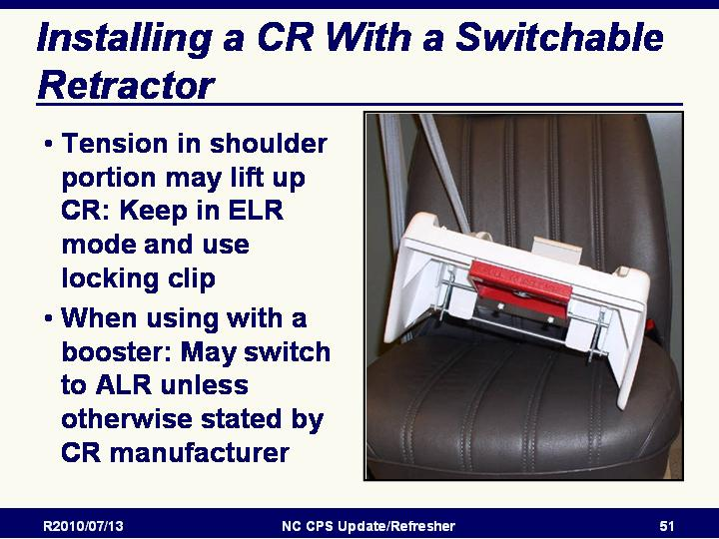
Installing a CR With a Switchable Retractor
- For situations where tension in shoulder portion may lift up CR, keep in the retractor in ELR mode and use a locking clip.
- When using with a BPB, may switch to ALR unless otherwise stated by CRS manufacturer

Slide 68

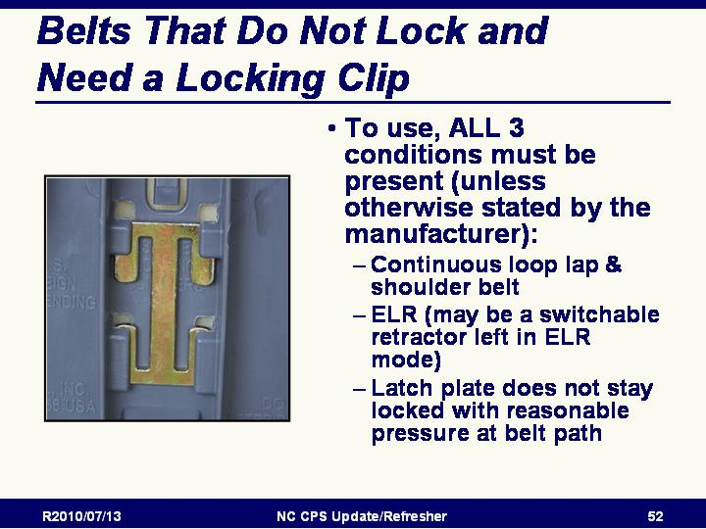
Review of locking clip
- Reminder: To use a locking clip, ALL 3 conditions must be present (unless otherwise stated by the manufacturer):
- Continuous loop lap & shoulder belt
- ELR (may be a switchable retractor left in ELR mode
- Latch plate does not stay locked with reasonable pressure at belt path

- A continuous loop belt with a locking latch plate does not need a locking clip – even if the latch plate is the “lightweight” variety. Adding a locking clip to a belt with a locking latch plate is incorrect.

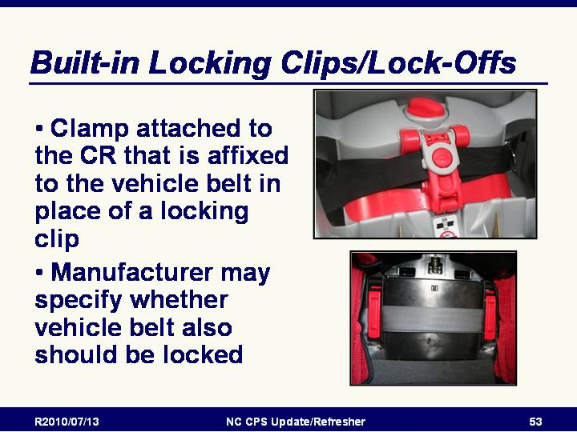
Slide 69

Lock-Offs
- Clamp that is attached to the CR that clamps onto the vehicle seat belt in place of a locking clip
- Most CRs with built-in lock-oﬀs have them on both sides of the CR.
- Lock-oﬀs are provided by the CR manufacturer and are recommended and approved for use with the vehicle seat belt.

Slide 70

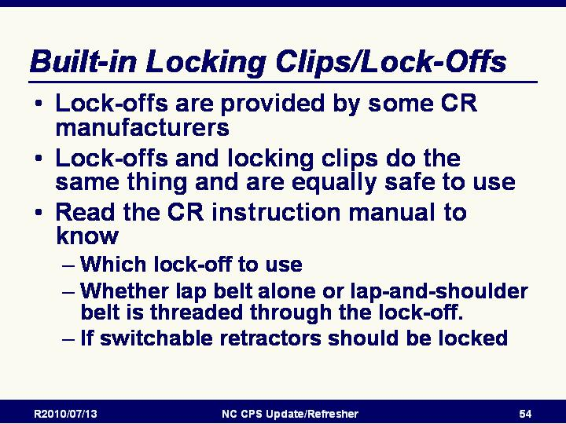
Built-in Locking Clips/Lock-Offs
- Lock-offs clamp the tightened vehicle seat belt to make the lap belt a fixed length.
- Lock-offs are used on lap-and-shoulder seat belts that have a sliding latchplate (no pre-crash lockability) and an ELR (no pre-crash lockability).
- Most CRs with built-in lock-offs have them on both sides of the CR.
- Read the CR instruction manual to know which lock-off to use and to know whether the lap belt alone or the lap-and-shoulder belt is threaded through the lock-off.
- Some manufacturers may recommend using both lock-offs; others may select one or the other. Follow the instructions for that particular CR.
- Lock-offs are provided by the CR manufacturer and are recommended and approved for use with the vehicle seat belt.
- Lock-offs and locking clips are equally safe to use. They do the same thing.
- A lock-off ensures that the seat belt is locked pre-crash, so the CR does not move more than 1 inch side-to-side or front-to-back.
- Lock-offs are used according to CR manufacturer instructions. They may even be used on seat belts that have pre-crash locking features.
- Teach parents to use the lock-oﬀ as directed by their CR manufacturer

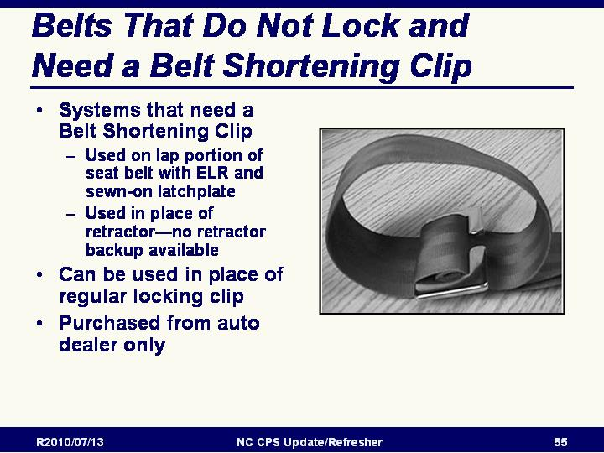
Slide 71

Review of Belt Shortening Clip
- Systems that need a Belt Shortening Clip
  - Used on lap portion of seat belt with ELR and sewn-on latchplate
  - Used in place of retractor—no retractor backup available
- Can be used in place of regular locking clip
- Purchased from auto dealer only

Slide 72

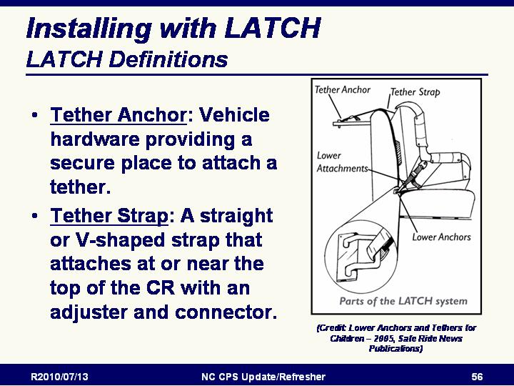
Installing with LATCH

LATCH Definitions
NOTE: It is important that we all use the same terms for the parts of the LATCH System:
- Tether Anchor: Vehicle hardware providing a secure place to attach a tether.
- Tether Strap: A straight or V-shaped strap that attaches at or near the top of the CR with an adjuster and connector.
Source: Lower Anchors and Tethers for Children – 2005, Safe Ride News Publications

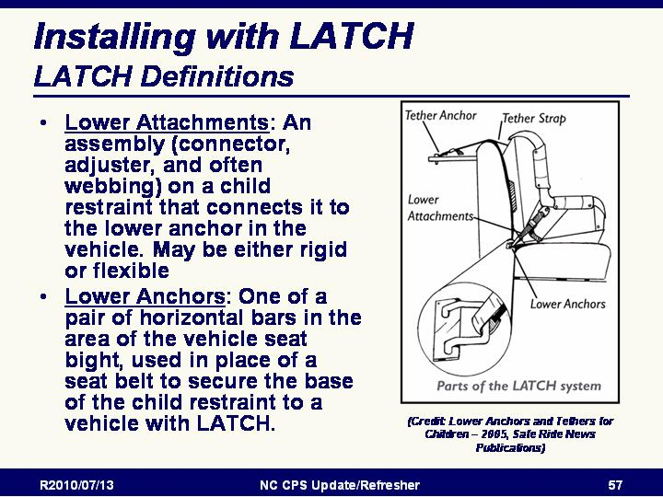
Slide 73

Installing with LATCH: LATCH Definitions
NOTE: It is important that we all use the same terms for the parts of the LATCH System:
- Lower Attachments: An assembly (connector, adjuster, and often webbing) on a child restraint that connects it to the lower anchor in the vehicle. May be either rigid or flexible
- Lower Anchors: One of a pair of horizontal bars in the area of the vehicle seat bight, used in place of a seat belt to secure the base of the child restraint to a vehicle with LATCH.
Source: Lower Anchors and Tethers for Children – 2005, Safe Ride News Publications

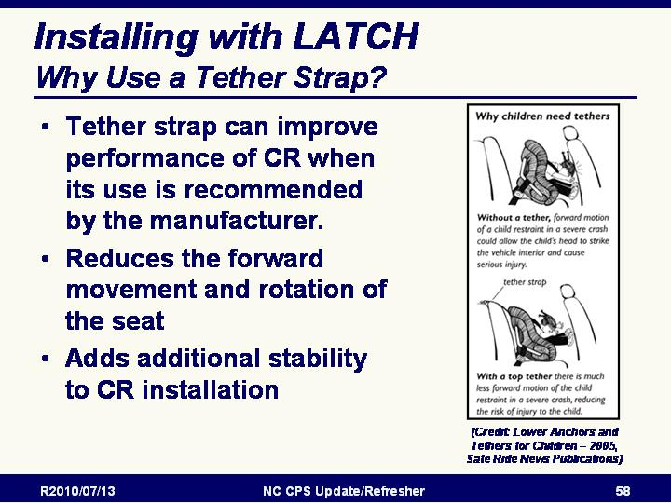
Slide 74

Installing with LATCH: Why Use a Tether Strap?
- Tether strap can improve performance of CR when its use is recommended by the manufacturer.
- Reduces the forward movement and rotation of the seat
- Adds additional stability to CR installation
(Credit: Lower Anchors and Tethers for Children – 2005, Safe Ride News Publications)

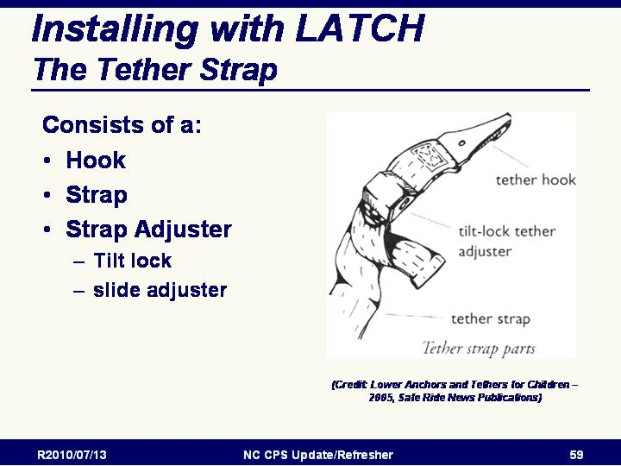
Slide 75

The Tether Strap
- Hook
- Strap
- Strap Adjuster
  - Tilt lock
  - Slide adjuster
(Credit: Lower Anchors and Tethers for Children – 2005, Safe Ride News Publications)
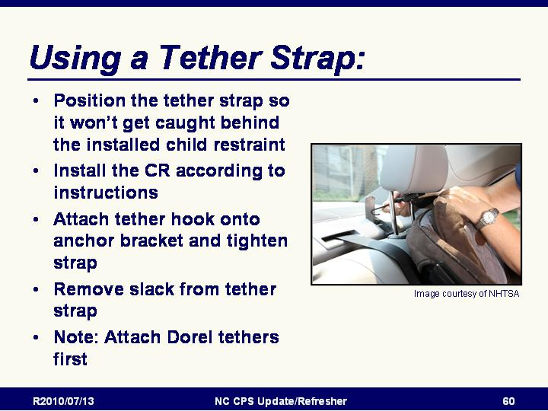
Slide 76

Using a Tether Strap
- Position the tether strap so it won’t get caught behind the installed child restraint
- Install the CR according to instructions
- Attach tether hook onto anchor bracket and tighten strap
- Remove slack from tether strap
- NOTE: Attach tethers with slide type strap adjusters (as is found on some Dorel CR’s) first before installing the CR with the belt or lower attachments.
- NOTE: Tethers can be tightened too much such that it is next to impossible to loosen it in order to remove the CR from the vehicle. Snug the tether down, but do not over-tighten.
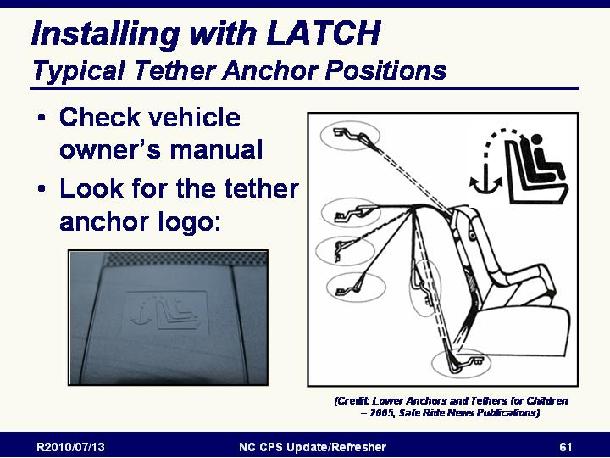
Slide 77

Typical tether anchor hardware positions
- Check vehicle owner’s manual
- Look for the tether anchor logo
(Credit: Lower Anchors and Tethers for Children – 2005, Safe Ride News Publications)

Slide 78

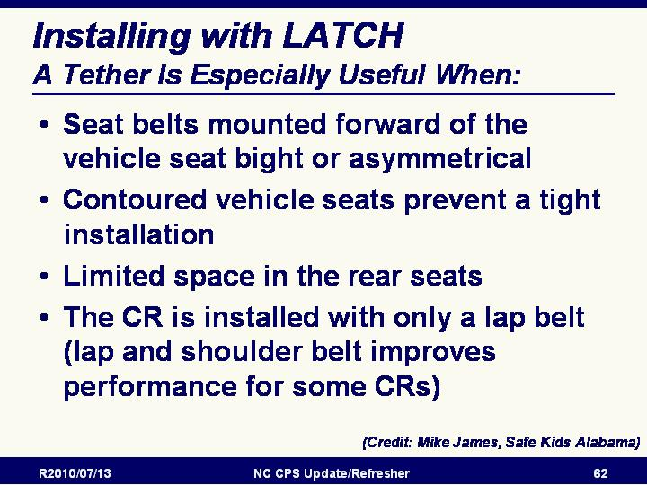
A Tether Is Especially Useful When:
- Seat belts mounted forward of the vehicle seat bight or asymmetrical
- Contoured vehicle seats prevent a tight installation
- Limited space in the rear seats
- The CR is installed with only a lap belt (lap and shoulder belt improves performance for some CRs)
(Credit: Mike James, Safe Kids Alabama)

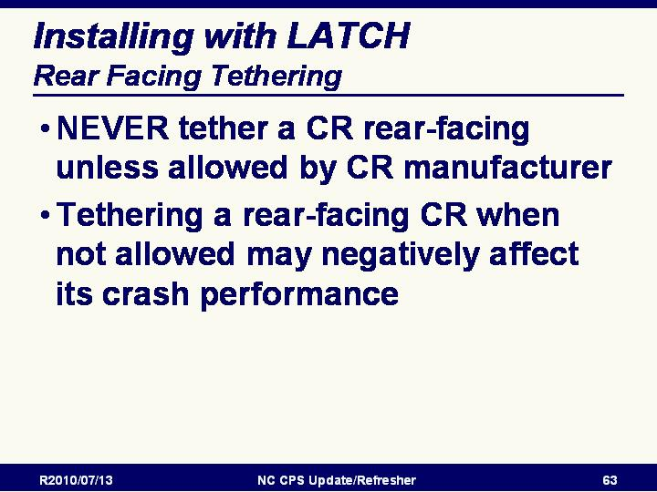
Slide 79

Rear Facing Tethering
- NEVER tether a CR rear-facing unless allowed by CR manufacturer
- Tethering a rear-facing CR when not allowed may negatively affect its crash performance

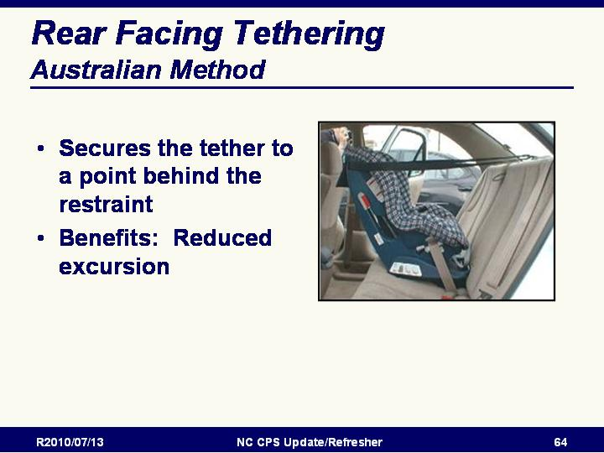
Slide 80

Rear Facing Tethering: Australian Method
- Secures the tether to a point behind the restraint
- Benefits: Reduced excursion

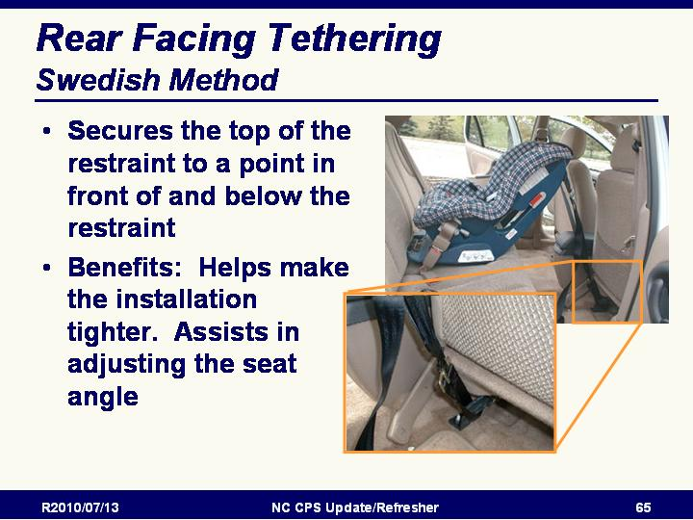
Slide 81

Rear Facing Tethering: Swedish Method
- Secures the top of the restraint to a point in front of and below the restraint
- Benefits: Helps control rebound. Assists in adjusting the seat angle

Slide 82

Changes to Britax RF Tethering
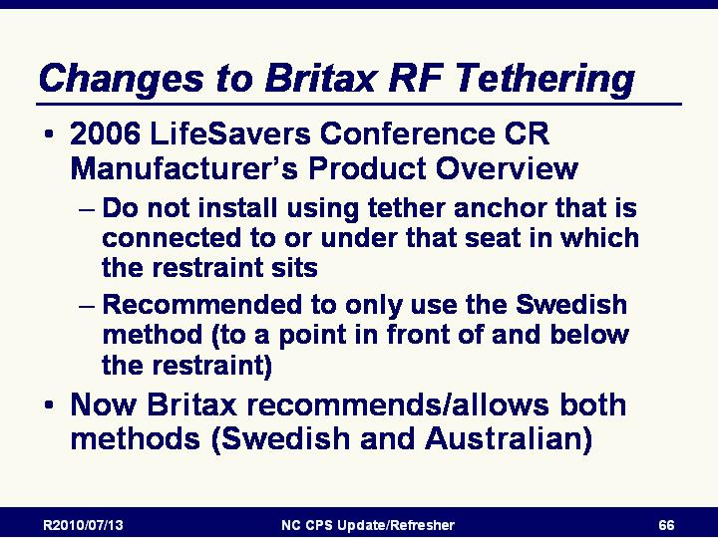
- Changes announced at LifeSavers Conference 2006 CSS Manufacturer’s Product Overview
  - Do not install using tether anchor that is connected to or under that seat in which the restraint sits
  - Recommended to only use the Swedish method (to a point in front of and below the restraint)
- Now Britax recommends/allows both methods (Swedish and Australian)

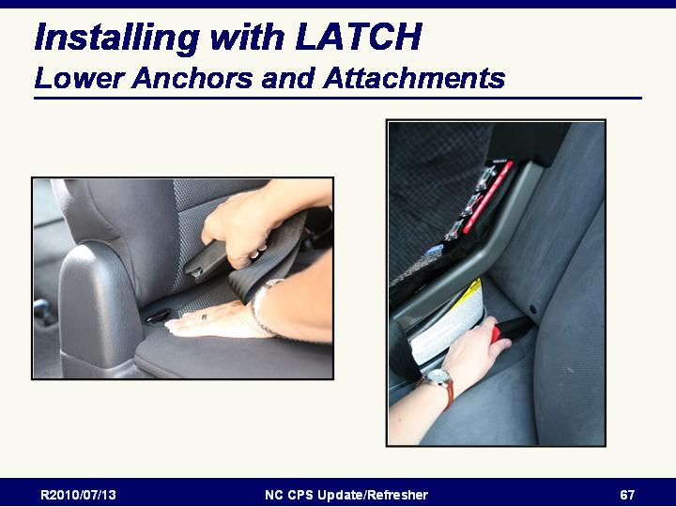
Slide 83

Lower Anchors and Attachments
- Some Lower Anchors are visible in the seat bight and others are marked

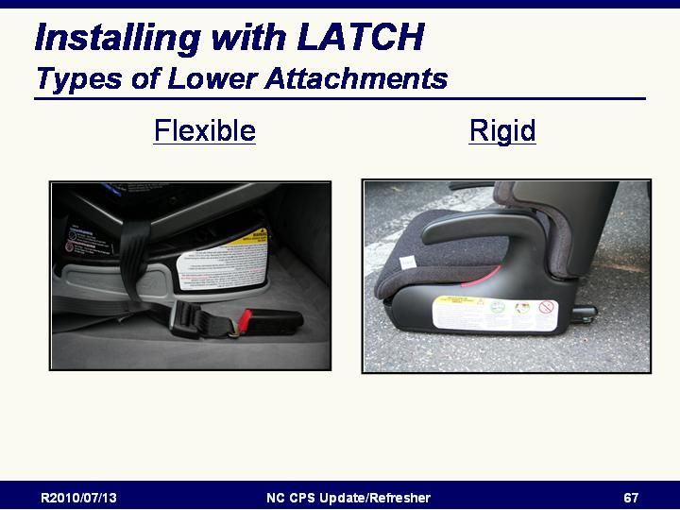
Slide 84

Types of Lower Attachments
- Flexible
- Rigid

Flexible attachments are much more common.

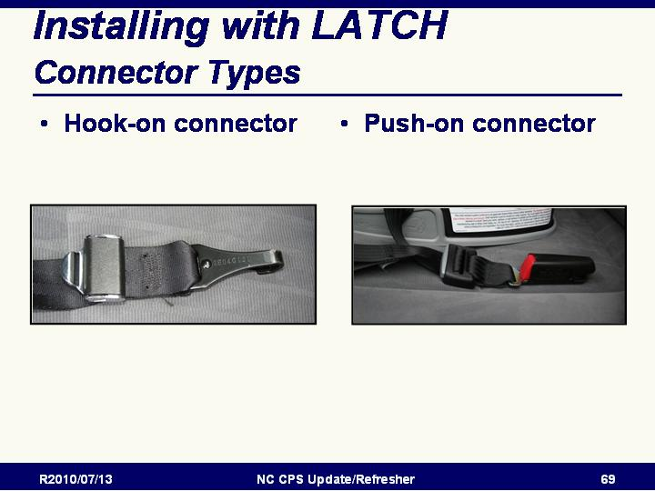
Slide 85

Connector Types
- Hook-on connector
- Push-on connector
(Credit: Lower Anchors and Tethers for Children – 2005, Safe Ride News Publications)

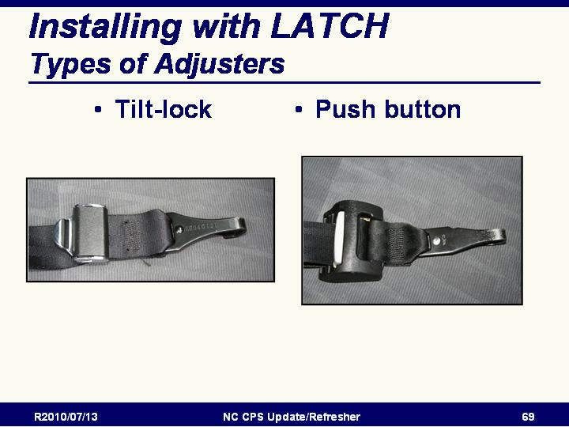
Slide 86

Types of Adjusters
- Tilt-lock
- Push button
(Credit: Lower Anchors and Tethers for Children – 2005, Safe Ride News Publications)
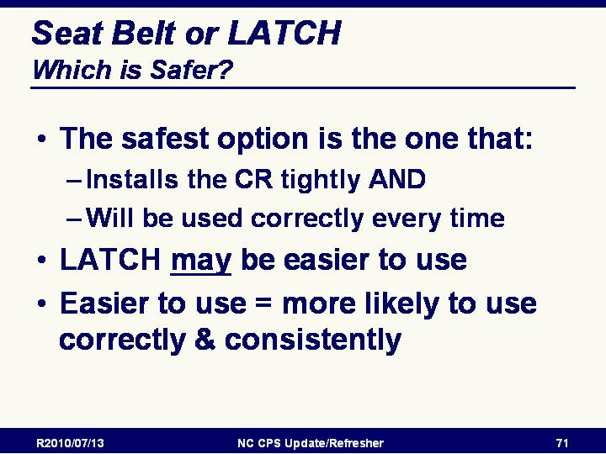
Slide 87

Seat Belt or LATCH - Which is Safer?
- Safest option is one that installs tightly and will be used correctly every time
- LATCH may be easier to use
- Easier to use correctly = more likely to use correctly & consistently
- Whichever method works best is the one that should be used

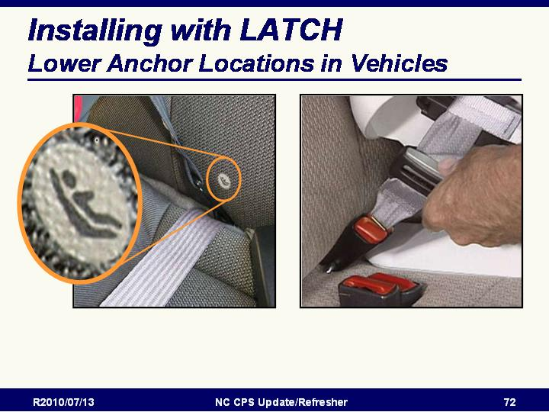
Slide 88

Lower Anchor Locations in Vehicles
- May be visible or may be hidden
- If hidden, look for lower anchor logo or look in vehicle owner’s manual

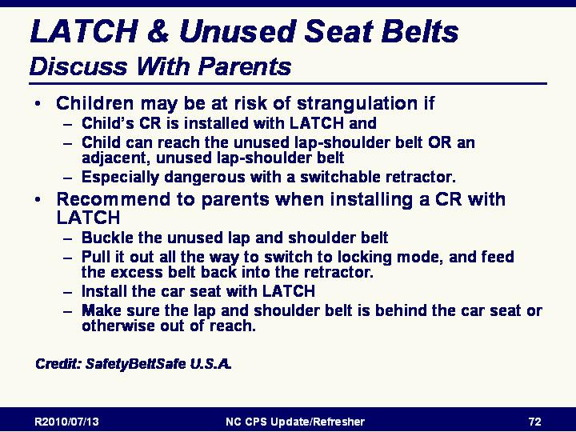
Slide 89

Discuss With Parents: LATCH & Unused Seat Belts
Children may be at risk of strangulation if
- Child’s CR is installed with LATCH and
- Child can reach the unused lap-shoulder belt OR an adjacent, unused lap-shoulder belt
- Especially dangerous with a switchable retractor.

Recommend to parents
- Any unused belt within reach of a small child should be buckled and, if possible, locked.
- When installing a CR with LATCH:
  - Buckle the unused lap and shoulder belt
  - Pull belt out all the way to switch to locking mode, and feed the excess belt back into the retractor.
  - Then install using LATCH
  - Make sure the lap and shoulder belt is behind the CR or otherwise out of reach.

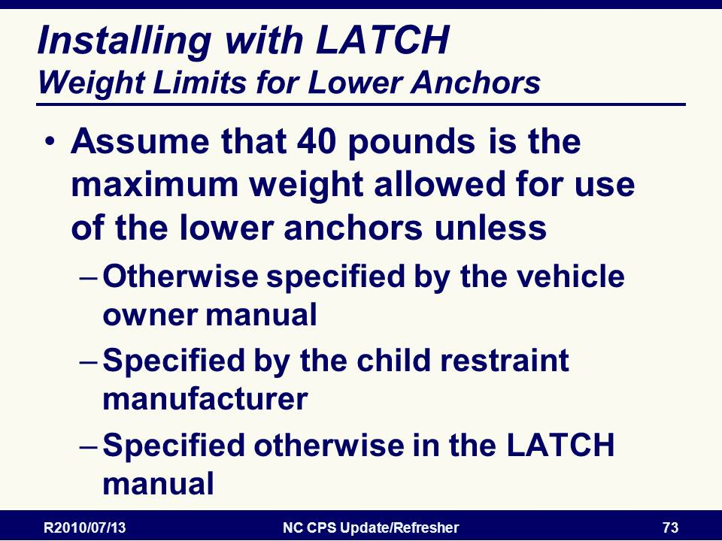
Slide 90

Weight Limits for Lower Anchors
Assume that 40 pounds is the maximum weight allowed for use of the lower anchors unless
- Otherwise specified by the vehicle owner manual
- Specified by the child restraint manufacturer
- Specified otherwise in the LATCH manual

NOTE: Point out that the LATCH Manual has charts that list the anchor weight limits for vehicles and lower attachment and tether weight limits for CR manufacturers.

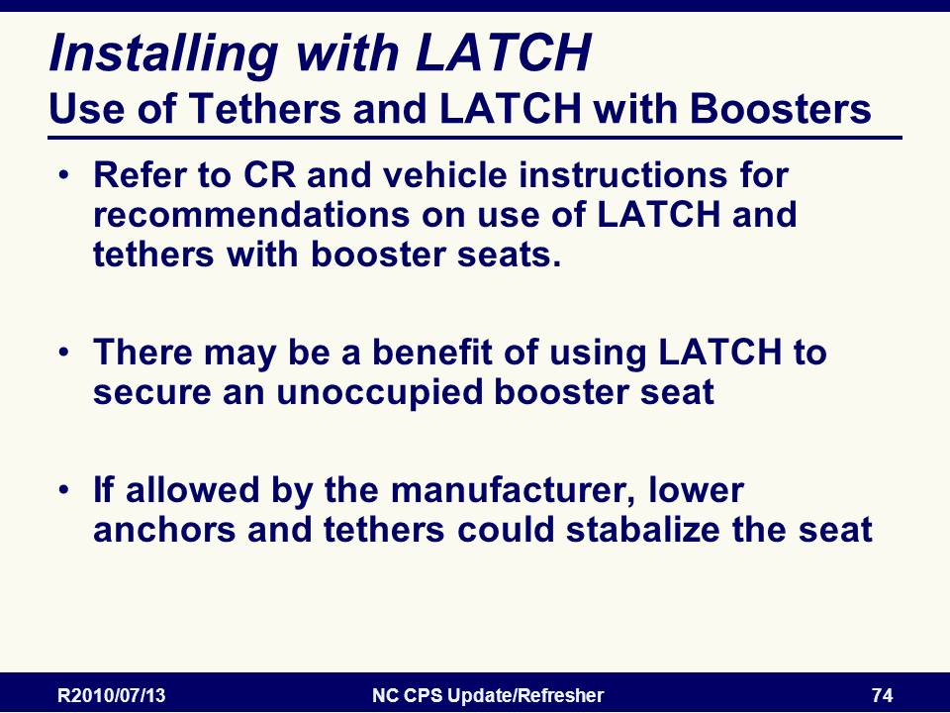
Slide 91

Use of Tethers and LATCH with Boosters
- Refer to CR and vehicle instructions for recommendations on use of LATCH and tethers with booster seats.
- There may be a benefit of using LATCH to secure an unoccupied booster seat
- If allowed by the manufacturer, lower anchors and tethers could stabilize the seat

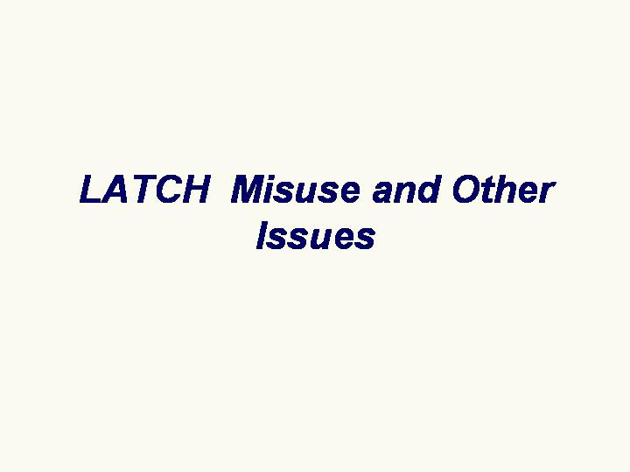
Slide 92

LATCH Misuse and Other Issues – Discussion of ways lower anchors and tethers can be misused

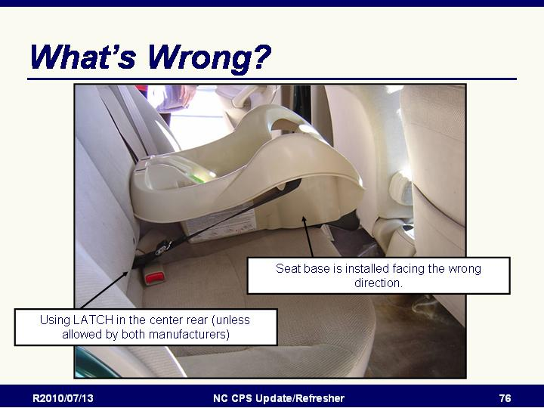
Slide 93

Using lower anchors in center position with inboard bars is considered to be misuse unless it is allowed by both the vehicle and CR manufacturers
(This base is also installed facing the wrong direction.)

Slide 94

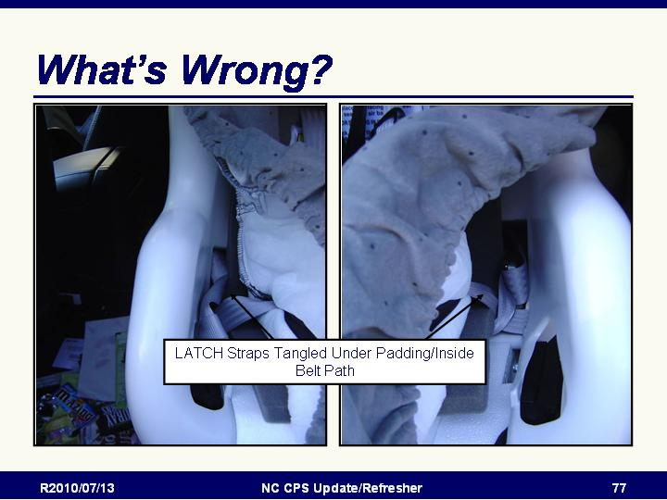
LATCH Straps Tangled Under Padding/Inside Belt Path
Misuse may be there, even if it isn’t obvious.

Slide 95

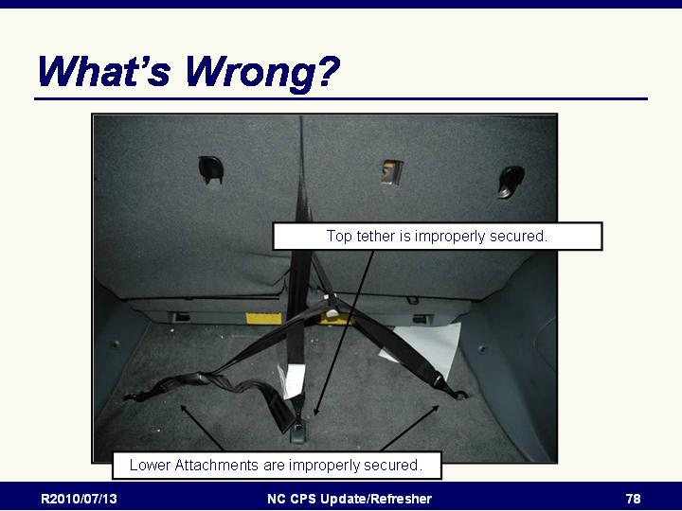
Improper attachment of top tether and lower attachments
Note the lower attachments from the CR that were pulled the vehicle seat split and hooked to cargo tie-downs.

Only designated anchors can be used to secure child restraints. Consult the vehicle owner’s manual to determine locations in the vehicle

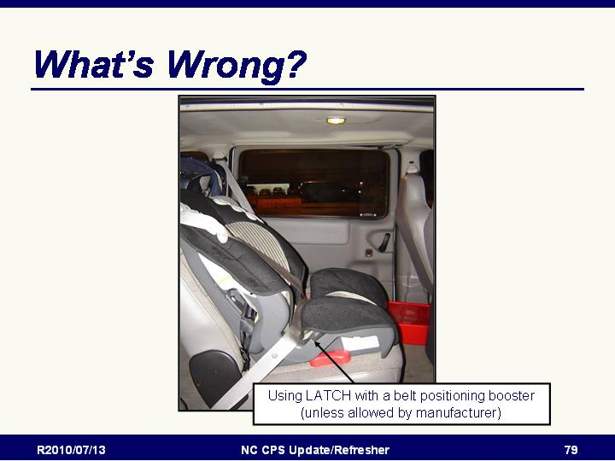
Slide 96
Using LATCH with a belt positioning booster is incorrect unless allowed by the booster manufacturer.

Slide 97

Child restraint installed using the wrong belt path
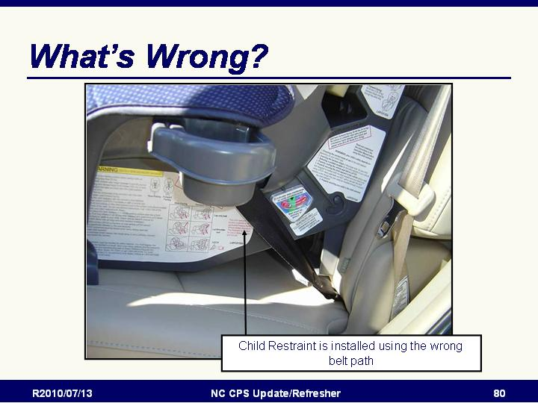

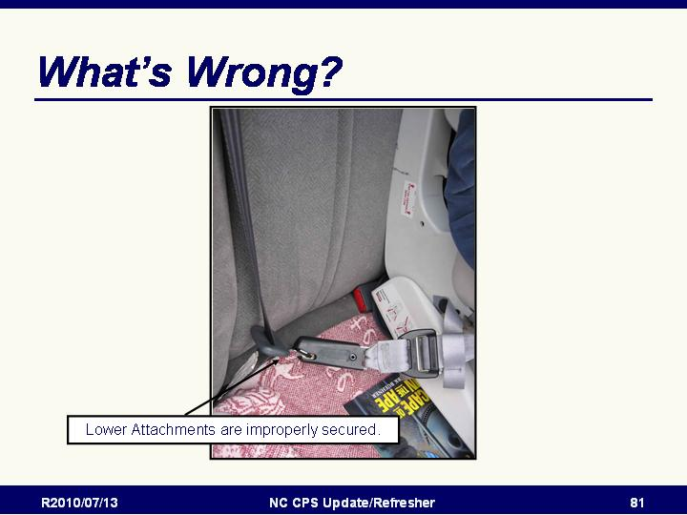
Slide 98

Lower straps connected to something besides the lower anchors
- Lower attachment is hooked to the sliding latchplate AND the attachment is still routed through the rear-facing belt path.
- Better hope the tether is hooked correctly and snug enough to prevent catastrophic failure!!!

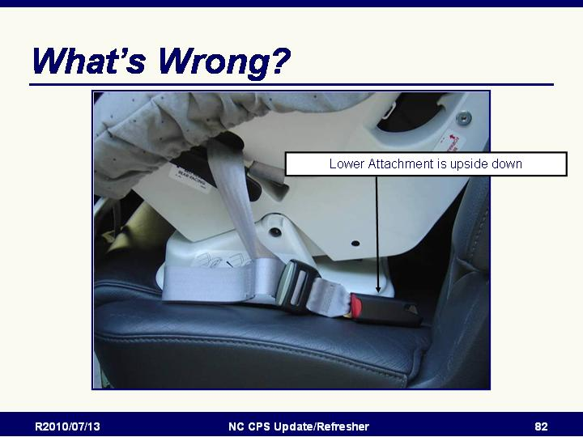
Slide 99

Lower Anchors are not attached correctly
Notice the Upside down connecter

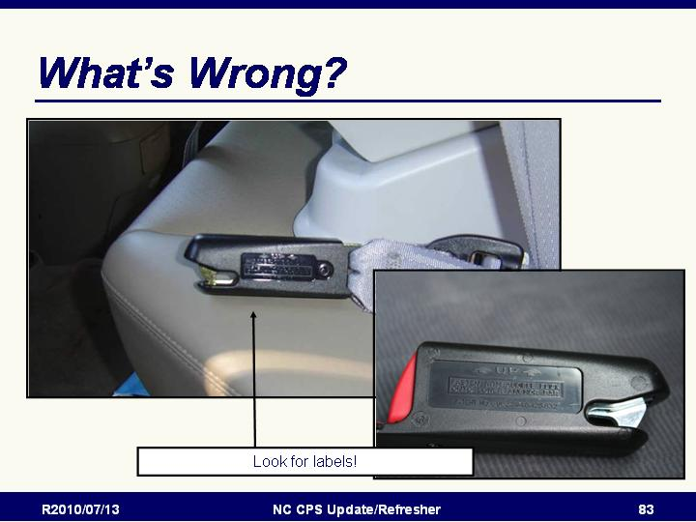
Slide 100

Close up makes it easier to see it is upside down
Notice the label on the buckle indicating which side should be up.

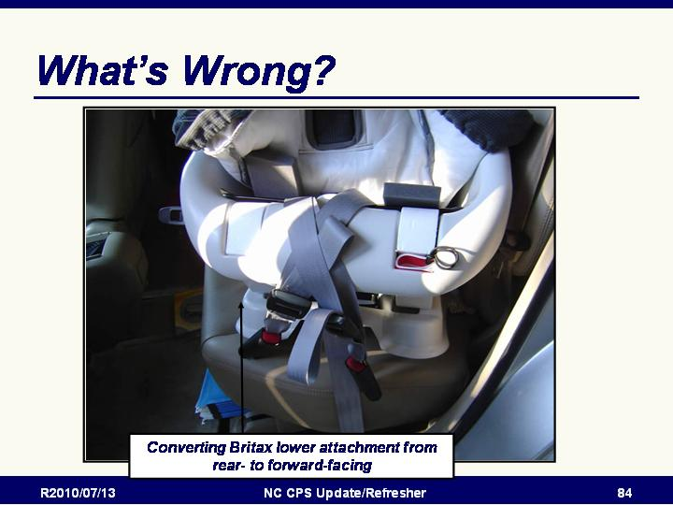
Slide 101

Demonstration of how to convert lower attachments from rear facing to forward facing in Britax CRs

Slide 102

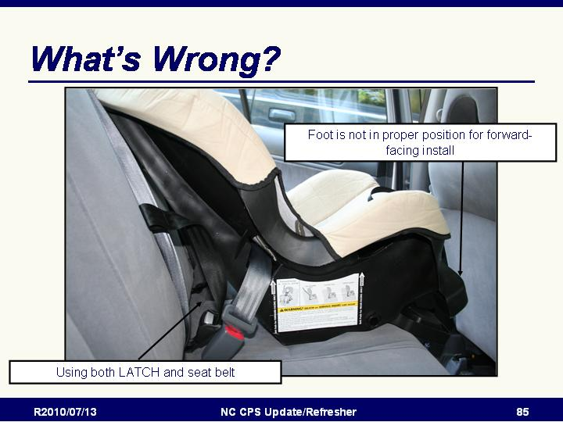
Using both LATCH and the vehicle belt
Also, foot is not in proper position for forward-facing install

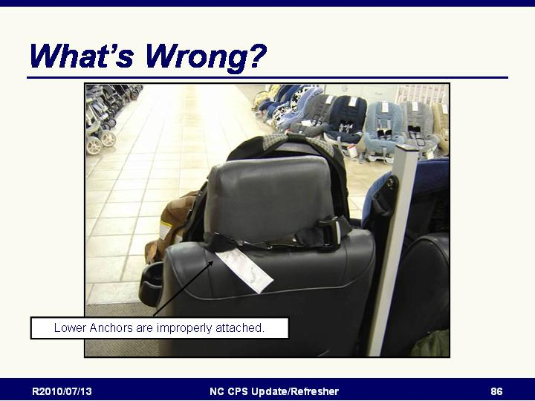
Slide 103

Improper use of LATCH lower anchor attachments
(Store display shown on slide)

Slide 104

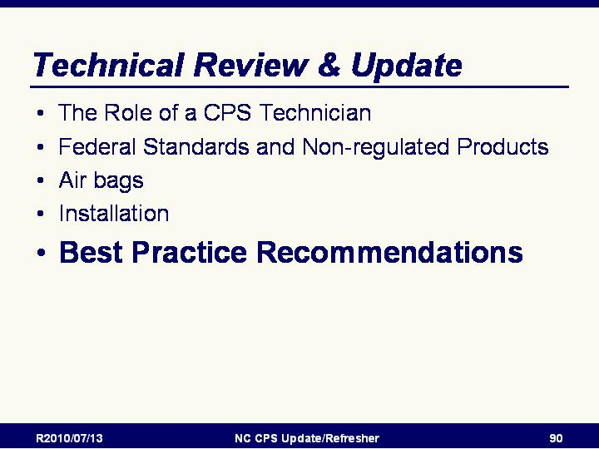
Best Practice Recommendations Introduction
- Introductory Slide
- In this section we will be discussing
  - Restraint Selection
  - Using rear-facing CRs
  - Using forward-facing with harness CRs
  - Using booster seats
  - Using seat belts

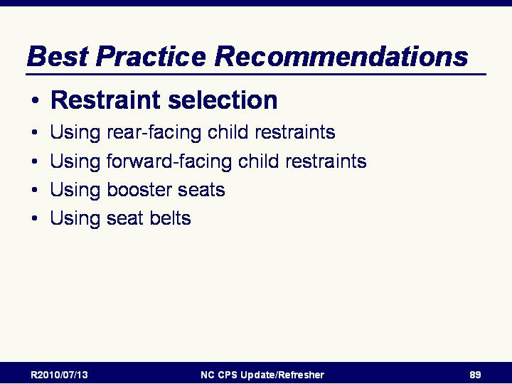
Slide 105

Restraint Selection
- Will be talking about selecting the best restraint for a child.

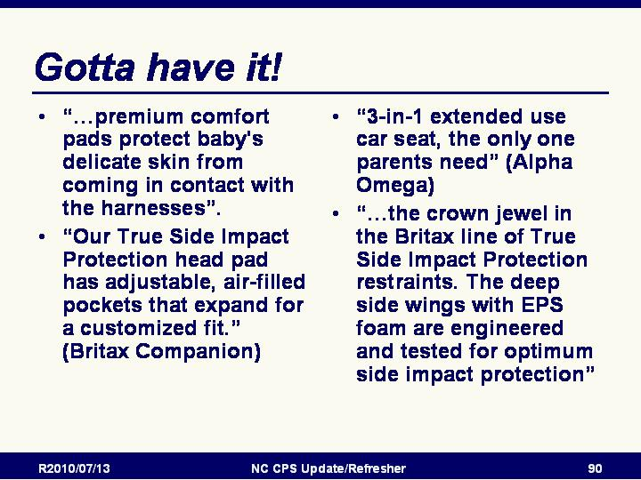
Slide 106

Gotta have it!
Advertisements for CRs stress features that may or may not relate to performance in a crash. Can find lots of exciting advertising copy…
- “…premium comfort pads protect baby's delicate skin from coming in contact with the harnesses”.
- “Our True Side Impact Protection head pad has adjustable, air-filled pockets that expand for a customized fit.” (Britax Companion)
- “3-in-1 extended use car seat, the only one parents need” (Alpha Omega)
- “…the crown jewel in the Britax line of True Side Impact Protection restraints. The deep side wings with EPS foam are engineered and tested for optimum side impact protection”

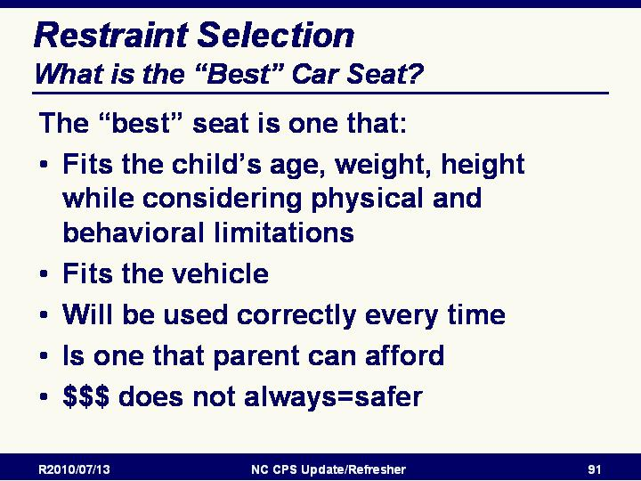
Slide 107

What is the “Best” Car Seat?
Reminder that the best seat is the one that:
- Fits the child’s age, weight, height while considering physical and behavioral limitations
- Fits the vehicle
- Will be used correctly every time
- Is one that parent can afford
Reminder that more expensive does not always equal being a safer model
- FMVSS 213 requires that a child restraint’s performance be measured through "crash" tests that simulate 30 mph frontal crashes into a solid barrier. This is considered to be a very severe crash. Manufacturers are required to test their child restraints using the FMVSS 213 requirements and to place labels on them with the model number and date of manufacture. If the restraint is missing the label, or if the label has no model number or date of manufacture, you should recommend not using the restraint.

- Since all child restraints are certified to meet federal standards and must perform to a certain level, the “best” or “safest” restraint is the one that fits the child, fits the vehicle and will be used correctly every ride. All other things being equal, the least expensive model will protect the child as well as the most expensive model.

Slide 108

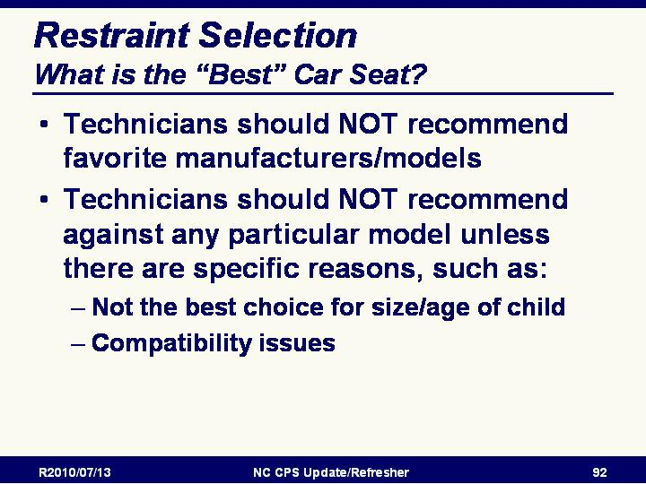
What is the “Best” Car Seat?
- Technicians should NOT recommend favorite manufacturers/models
- Technicians should NOT recommend against any particular model unless there are specific reasons such as:
  - Not the best choice for size/age of child
  - Compatibility issues
- Technicians must be prepared and willing to assist parent/care giver with their chosen restraint - unless it is an unsafe restraint

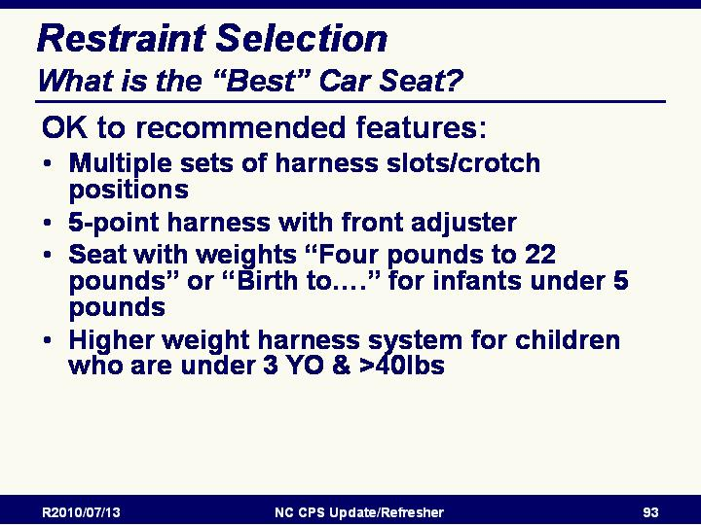
Slide 109

What is the “Best” Car Seat?
- OK to recommended features:
  - Multiple sets of harness slots/crotch positions
  - 5-point harness with front adjuster
  - Seat with weights “Four pounds to 22 pounds” or “Birth to….” for infants under 5 pounds
  - Higher weight harness system for children who are under 3 YO & >40lbs

Slide 110

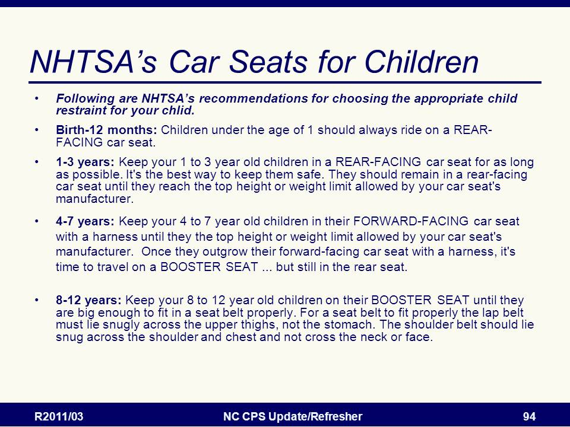
Restraint selection overview

Following are NHTSA’s recommendations for choosing the appropriate child restraint for your chlid.

Birth-12 months: Children under the age of 1 should always ride on a REAR-FACING car seat.

1-3 years: Keep your 1 to 3 year old children in a REAR-FACING car seat for as long as possible. It's the best way to keep them safe. They should remain in a rear-facing car seat until they reach the top height or weight limit allowed by your car seat's manufacturer.

4-7 years: Keep your 4 to 7 year old children in their FORWARD-FACING car seat with a harness until they the top height or weight limit allowed by your car seat's manufacturer. Once they outgrow their forward-facing car seat with a harness, it's time to travel on a BOOSTER SEAT ... but still in the rear seat.
- 8-12 years: Keep your 8 to 12 year old children on their BOOSTER SEAT until they are big enough to fit in a seat belt properly. For a seat belt to fit properly the lap belt must lie snugly across the upper thighs, not the stomach. The shoulder belt should lie snug across the shoulder and chest and not cross the neck or face.

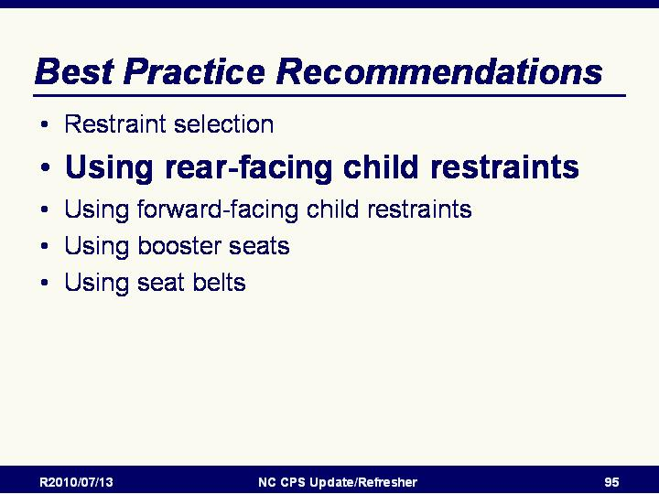
Slide 111

Using rear-facing CRs

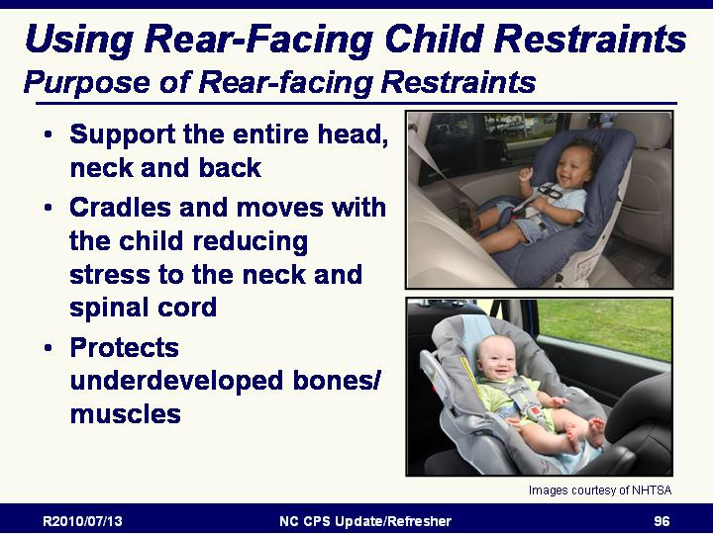

Slide 112

Purpose of Rear-facing Restraints
- Support the entire head, neck and back
- Cradles and moves with the child reducing stress to the neck and spinal cord
- Protects underdeveloped bones/ muscles

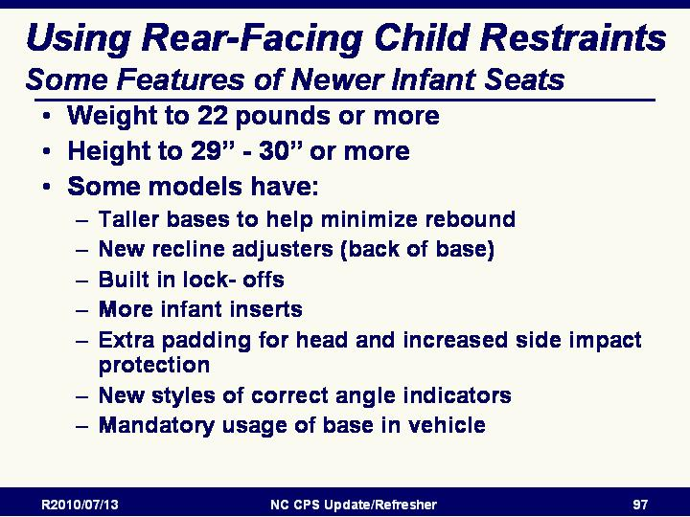
Slide 113

Some Features of Newer Infant Seats
- Weight to 22 pounds or more
- Height to 29” or 30” or more
- Some models have:
  - Taller bases to help minimize rebound
  - New recline adjusters (back of base)
  - Built in lock- offs
  - More infant inserts
  - Extra padding for head and increased side impact protection
  - New styles of correct angle indicators
  - Mandatory usage of base in vehicle
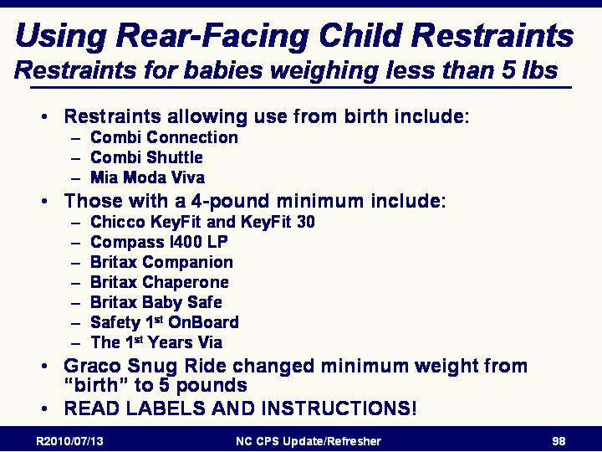
Slide 114

Restraints for babies weighing less than 5 lbs.
- Restraints allowing use from birth include:
  - Combi Connection
  - Combi Shuttle
  - Mia Moda Viva
- Those with a 4-pound minimum include:
  - Chicco KeyFit and KeyFit30
  - Compass I400 LP
  - Britax Companion
  - Britax Chaperone
  - Safety 1st OnBoard
  - The 1st Years Via
- Graco SnugRide has changed minimum weight
- Important to read labels and instructions!!!

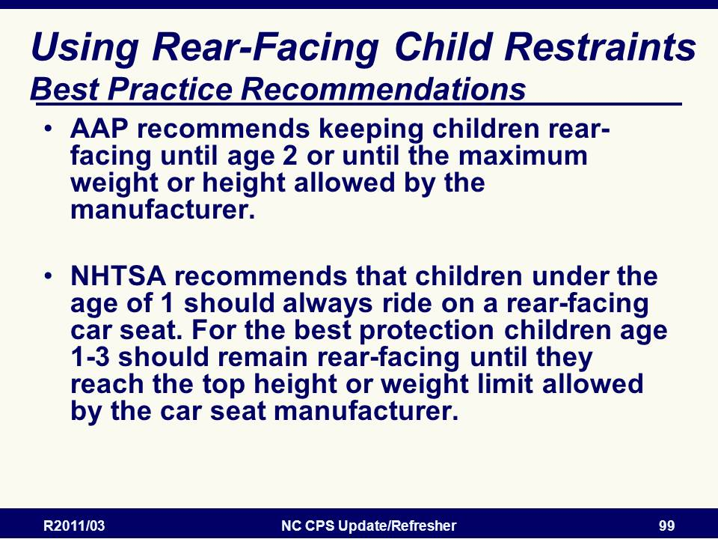
Slide 115

Rear-facing Best Practice Recommendations
- AAP recommends keeping children rear-facing until age 2 or until the maximum weight or height allowed by the manufacturer.
- NHTSA recommends that children under the age of 1 should always ride on a rear-facing car seat. For the best protection children age 1-3 should remain rear-facing until they reach the top height or weight limit allowed by the car seat manufacturer.

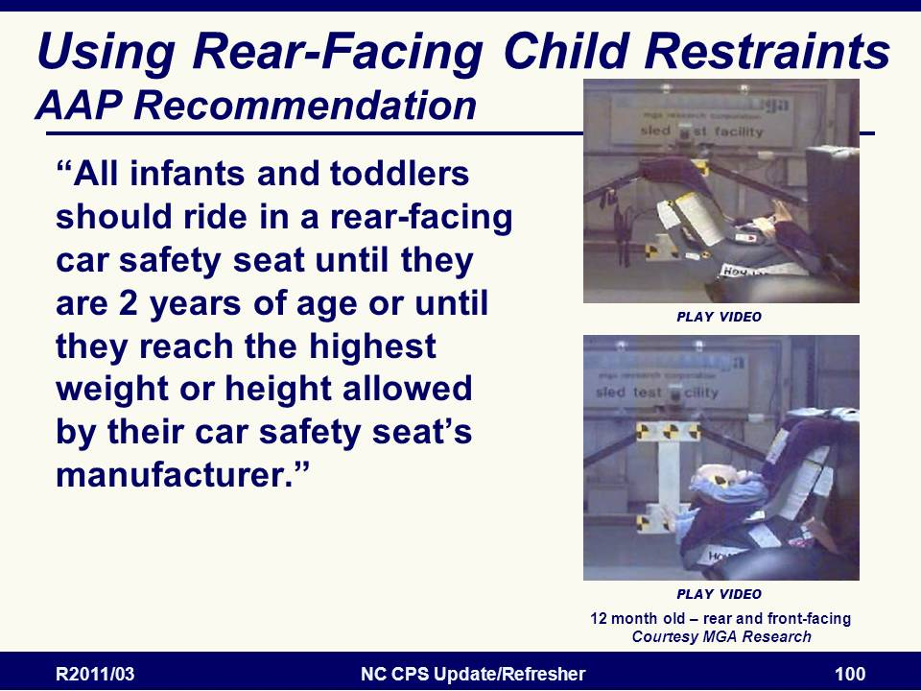
Slide 116

AAP Recommendations for Rear-Facing
NOTE: VIDEO AVAILABLE

- Top video demonstrates the ride down and protection provided to a 12-month old size child by a rear facing convertible restraint.
- Bottom video demonstrates the difference when the same restraint is turned and faces the front of the vehicle. Flexation of the neck is not a major concern for older and larger children.

AAP Recommendations
“All infants and toddlers should ride in a rear-facing car safety seat until they are 2 years of age or until they reach the highest weight or height allowed by their car safety seat’s manufacturer.”

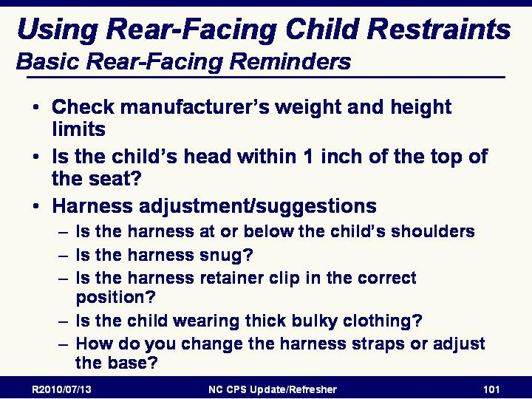
Slide 117

Basic Rear-Facing Reminders
  - Follow manufacturer’s weight and height limits for rear-facing and forward facing use. Must consult labels and instructions. Cannot tell by looking.
  - “1 inch” head rule - Rear-facing restraint is outgrown when child’s head is within an inch of the top of the shell even if has not reached maximum weight.

  - Harness adjustment/suggestions
    - 3 point vs. 5 point?
    - At or below shoulders
    - Snug harness
  - Harness retainer clip position

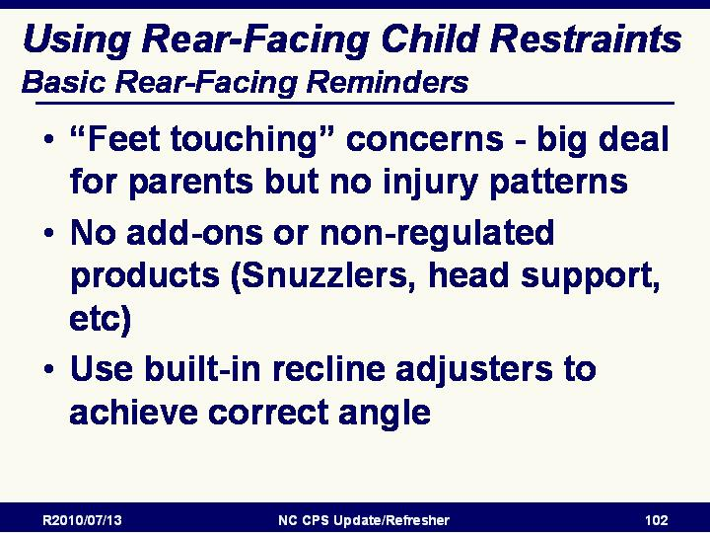
Slide 118

Basic Rear-Facing Reminders
- “Feet touching” concerns-”big” deal for parents but no injury patterns
- No add-ons or non-regulated products
- Correct angle-use built-in recline adjusters

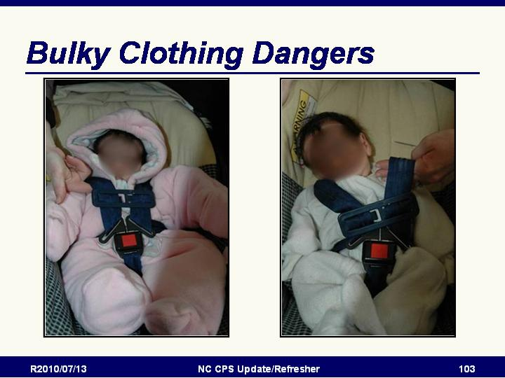
Slide 119

Bulky Clothing Dangers
- Review picture on slide
- Point out how the harness is pushed out of position by the heavy clothes.
- Parents should be taught to harness the child in the CR wearing clothes that do not interfere with the harness and then cover the baby with blankets.

Slide 120

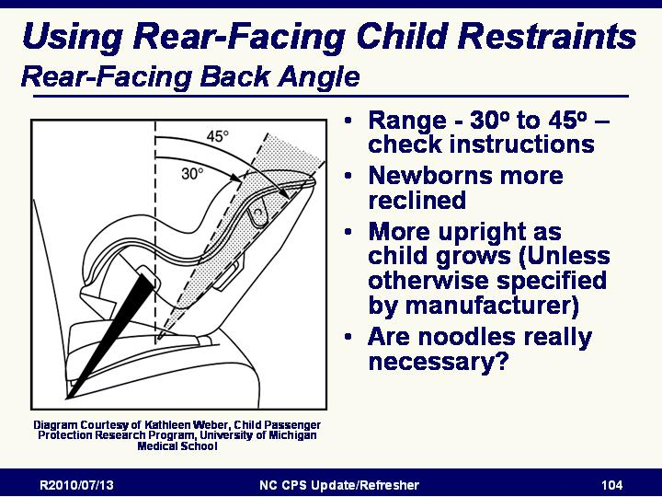
Rear-Facing Back Angle
- Range - 30º to 45º – check instructions
- Newborns more reclined
- More upright as child grows (Unless otherwise specified by manufacturer)
- Are noodles really necessary?
(Diagram Courtesy of Kathleen Weber, Child Passenger Protection Research Program, University of Michigan Medical School)

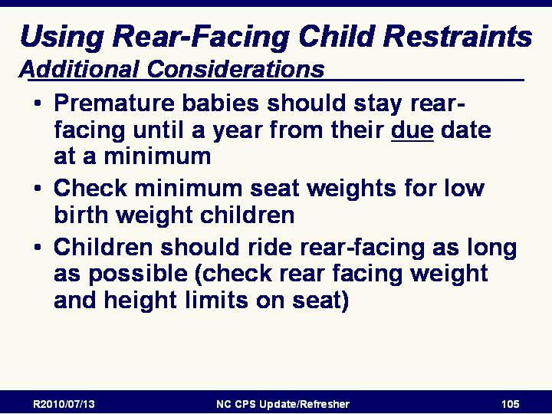
Slide 121

Additional Rear-facing Considerations
- Check minimum seat weights for low birth weight children
- Children should ride rear-facing as long as possible

Slide 122

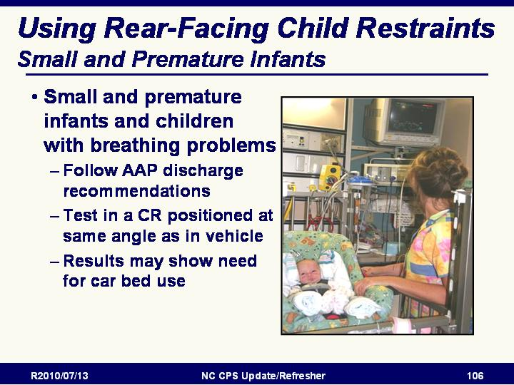
Small and premature infants
- Follow AAP discharge recommendations (see below)
- Test in a CR positioned at same angle as in vehicle
- Results may show need for car bed use
- The American Academy of Pediatrics (AAP) recommends that all infants born before 37 weeks (more than 3 weeks early) be monitored before they leave the hospital for possible breathing problems or slowing of the heart rate when sitting in a semi- reclined position. h e physician will determine if the infant can use a rear-facing CR or should ride lying face downward or face upward in a car bed.
- Contact the Automotive Safety Program, Riley Hospital for Children, for information about a 2-day special needs restraint systems course for CPS technicians.
- The National Center for the Safe Transportation of Children With Special Healthcare Needs has a database of CPS technicians who have taken the course. For information, contact the center at 1-800- 755-0912 or go to http://www.preventinjury.org
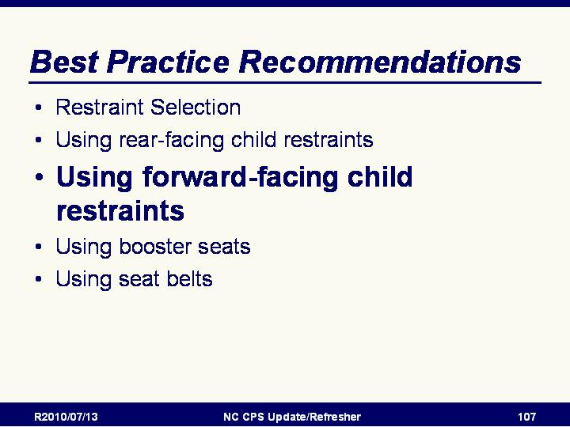
- Or contact UNC Highway Safety Research Center at 800-672-4527 for additional information or referral to local resources.

Slide 123

Using Forward-facing with Harness CRs

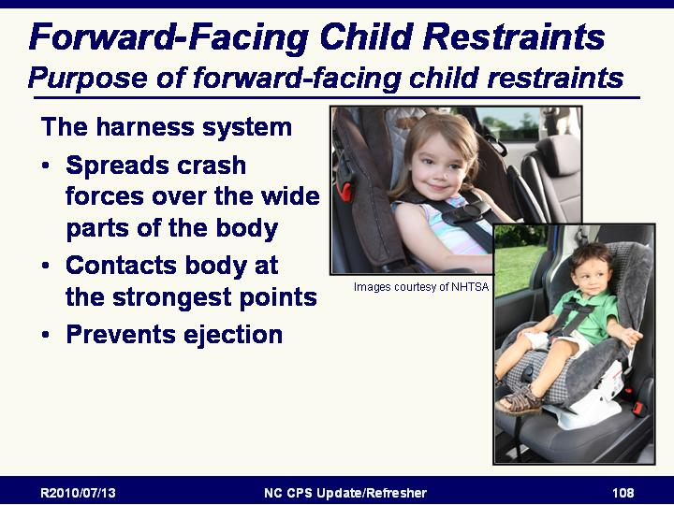
Slide 124

Purpose of Forward-Facing Restraints
The harness system
- Spreads crash forces over the wide parts of the body
- Contacts body at the strongest points
- Prevents ejection

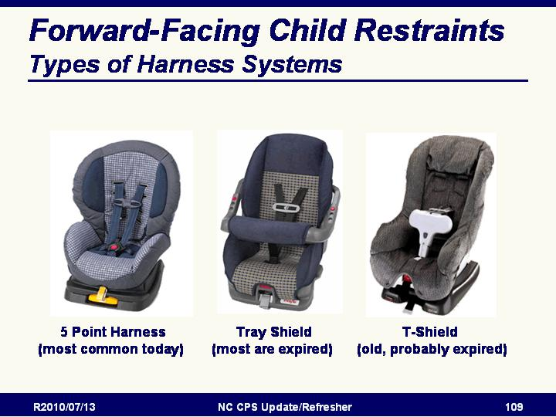
Slide 125

Review of Types of Harness Systems introductory slide
- 5 Point Harness
- Tray shield (if you see one the seat is probably too old)
- T-shield (if you see one the seat is almost certainly too old)

Slide 126

Differences in Harnesses
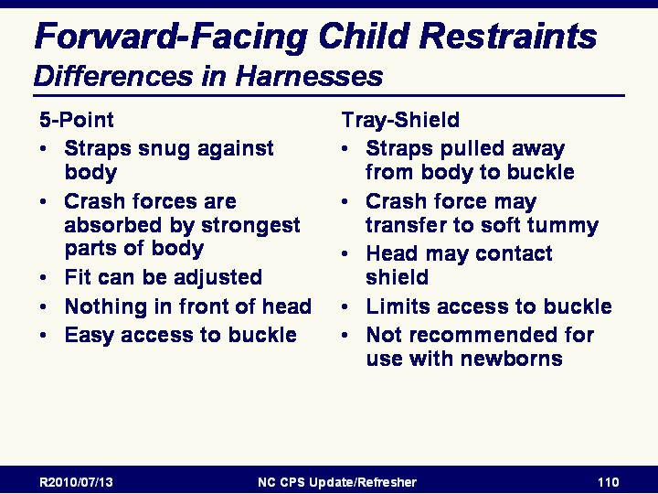
- 5-Point
  - Straps snug against body
  - Crash forces are absorbed by strongest parts of body
  - Fit can be adjusted
  - Nothing in front of head
  - Easy access to buckle
- Tray-Shield
  - Straps pulled away from body to buckle
  - Crash force may transfer to soft tummy
  - Head may contact shield
  - Limits access to buckle
  - Not recommended for use with newborns

Slide 127

Basic Forward-Facing Reminders
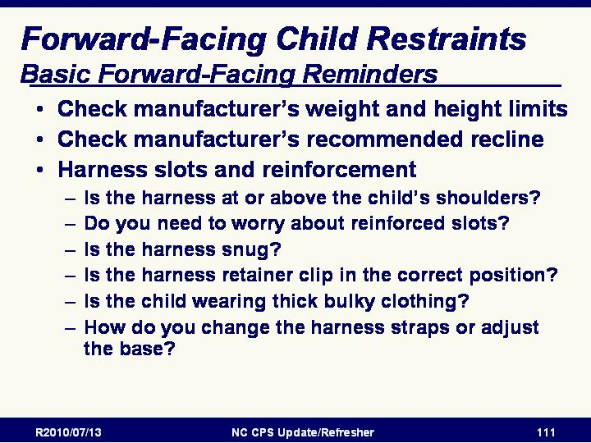
- Manufacturer’s weight and height limit
- Manufacturer’s recommended recline
- Harness slots and reinforcement
  - At or above shoulders
  - Do you need to worry about reinforced slots?
  - Snug harness
  - Harness retainer clip position
  - No heavy coats
- Changing harness straps and adjusting base

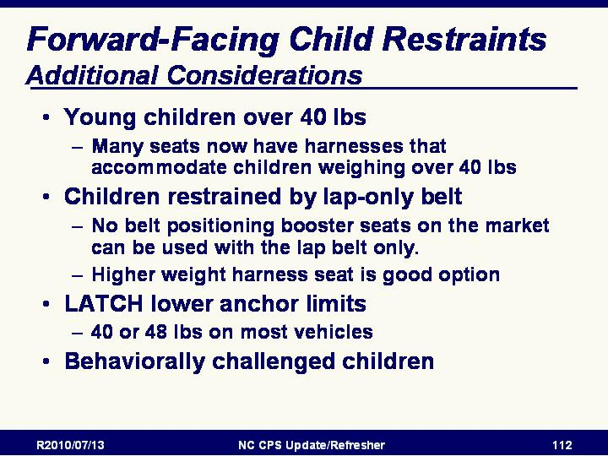
Slide 128

Additional considerations for forward-facing
- Young children over 40 lbs can use higher weight seats
- Children restrained by lap-only belt - no belt positioning boosters are available
- Behaviorally “challenging” children

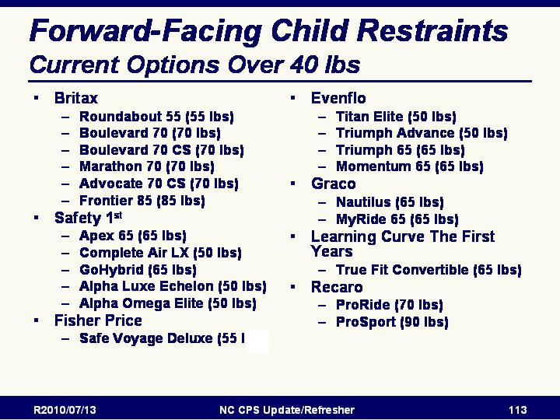
Slide 129

Current Options For Keeping Children Over 40 Pounds In Harness Systems
There are now many seats with harnesses that go above 40 lbs.

Slide 130

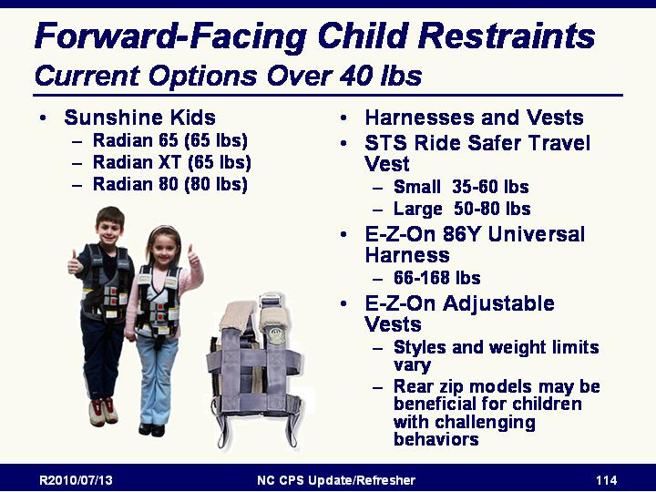
Current Options For Keeping Children Over 40 Pounds In Harness Systems
- Kid-Y-Safety Harness (E-Z On Products) is designed for vehicles without shoulder belts. The Kid-Y-Safety Harness must be used with the Ride-Ryte Booster (Safety Angel). The Kid-Y-Safety Harness goes from 30–80 pounds.
- RideSafer Travel Vest from Safe Traffic Systems. Small fits a child 35–60 pounds with tether and lap belt. The large size fits children 50–80 pounds. Must be used with special dual tether and lap belt. For information, go to http://www.safetrafficsystem.com or call 847-329-8111.
Source: Safe Ride News July/August 2005, September/October 2005 and E-Z-On Products website, http://www.ezonpro.com/index.shtml.

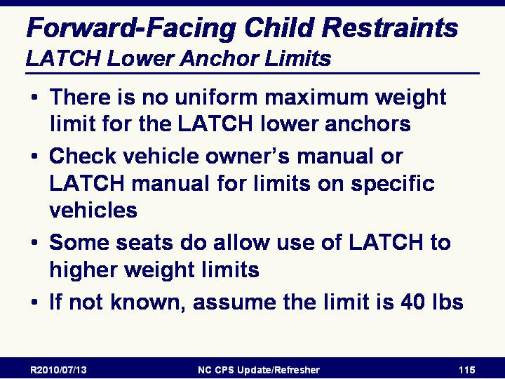
Slide 131

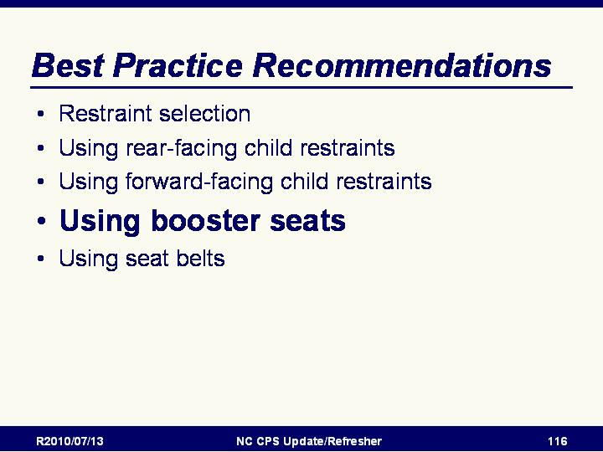
Slide 132

Using booster seats

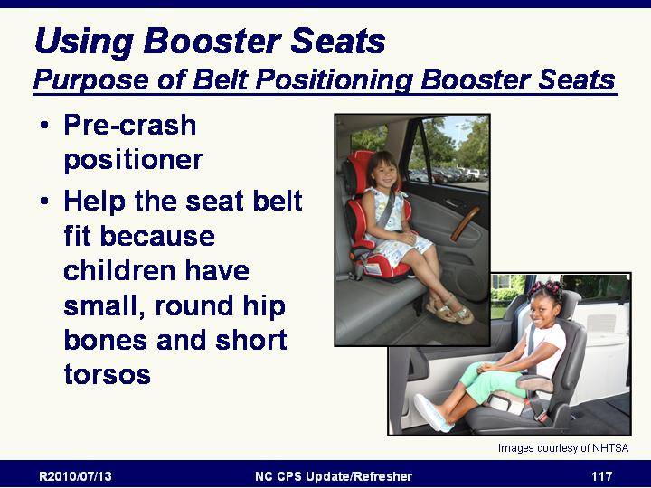
Slide 133

Purpose of Belt Positioning Booster Seats
Pre-crash positioner
Help the seat belt fit because children have small, round hip bones and short torsos

Slide 134

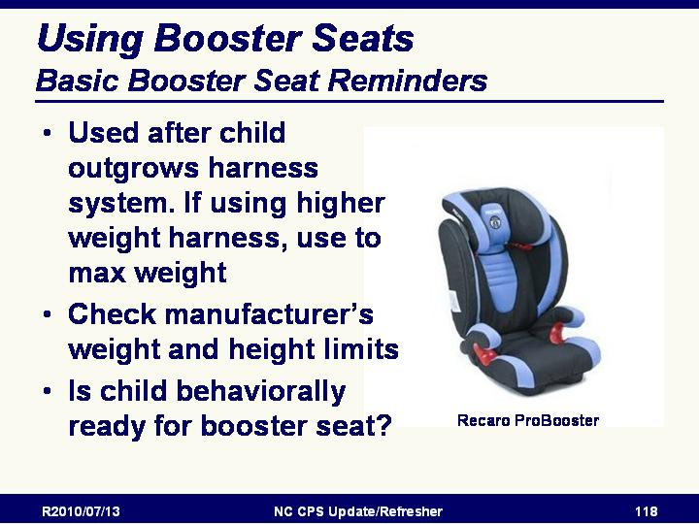
Basic Booster Seat Reminders
- Used after child outgrows harness system. If using higher weight harness, use to max weight
- Manufacturer’s weight and height limit
- Is child behaviorally ready for booster seat?
- Must be used with lap and shoulder belt
- Example: Recaro ProBooster

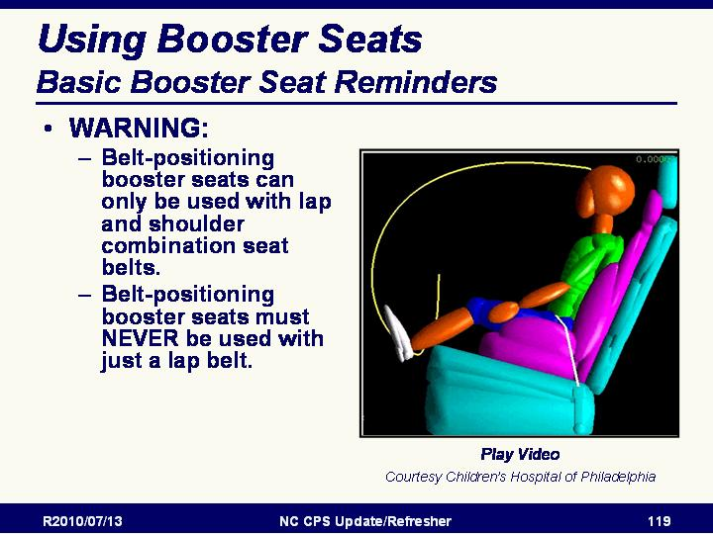

Slide 135

Basic Booster Seat Reminders
VIDEO AVAILABLE
- WARNING: Belt-positioning booster seats can only be used with lap and shoulder combination seat belts.
- Belt-positioning booster seats must NEVER be used with just a lap belt.

Slide 136

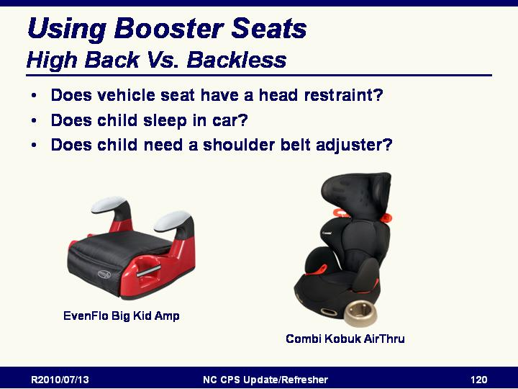
High Back Vs. Backless
Considerations:
- Does vehicle seat have head support?
- Does child sleep in car?
- Does child need a shoulder belt adjuster?

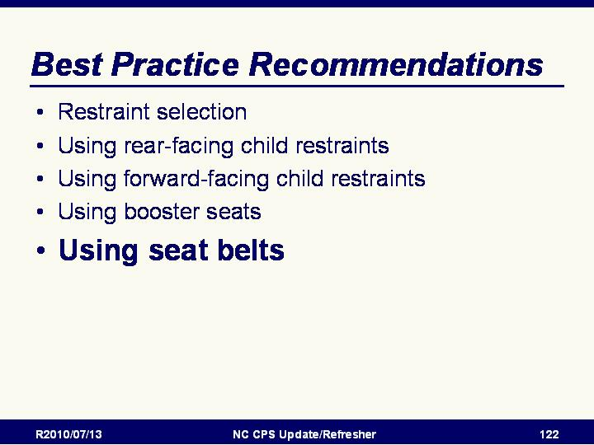
Slide 137

Using seat belts

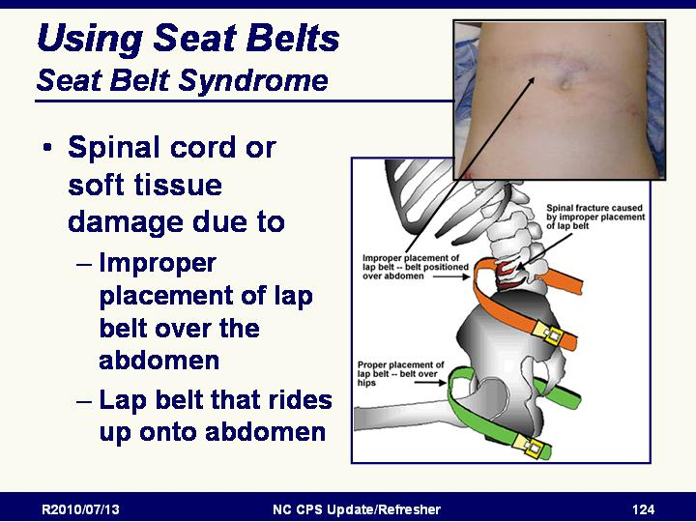

Slide 138

Seat Belt Syndrome
- Spinal cord or soft tissue damage due to
- Improper placement of lap belt over the abdomen
- Lap belt that rides up onto abdomen

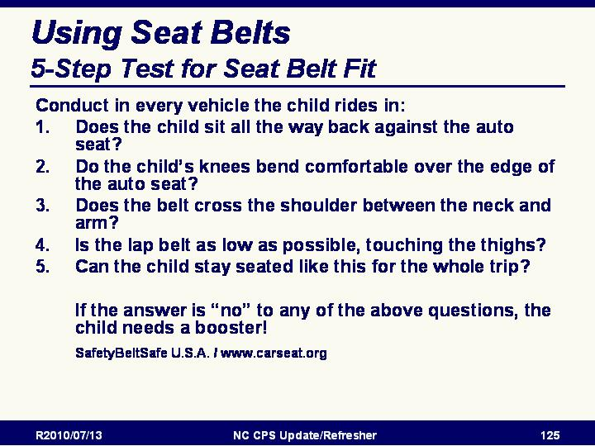
Slide 139

5-Step Test for Seat Belt Fit
Conduct in Every vehicle:
- Does the child sit all the way back against the auto seat?
- Do the child’s knees bend comfortable over the edge of the auto seat?
- Does the belt cross the shoulder between the neck and arm?
- Is the lap belt as low as possible, touching the thighs?
- Can the child stay seated like this for the whole trip?

If the answer is “no” to any of the above questions, the child needs a booster!
SafetyBeltSafe U.S.A. / www.carseat.org
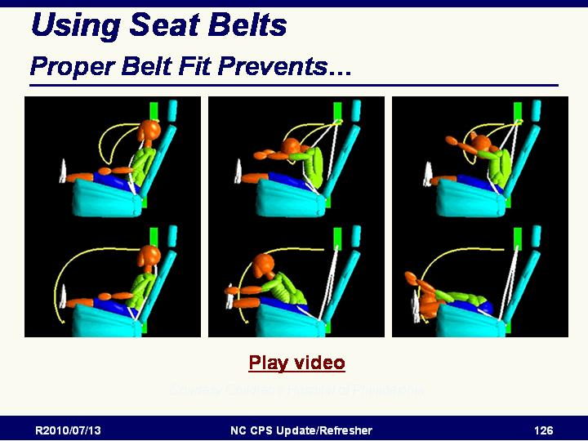
Slide 140

Proper Belt Fit Prevents…
VIDEO AVAILABLE
Video showing child dummy jackknifing over lap belt

Module 6: Resources

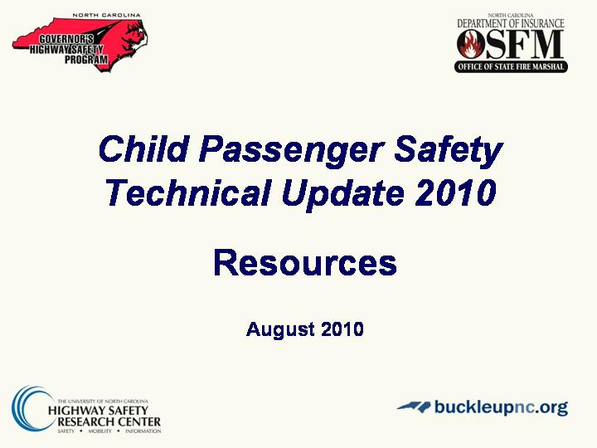
Slide 141

Resources
Review of available resources

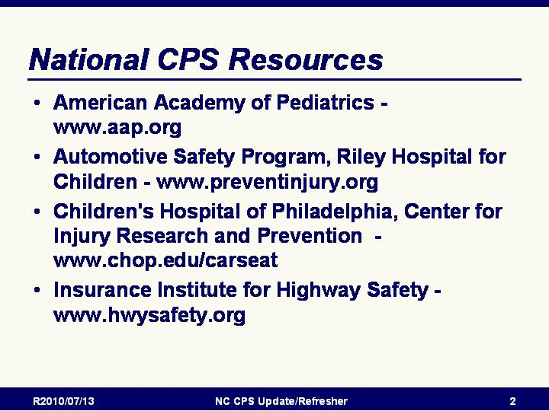
Slide 142

National CPS Resources

American Academy of Pediatrics - www.aap.org
- The AAP's child passenger safety information includes policy statements relevant to recommendations for transporting children safely. Pamphlets on safety seat use, restraint choice available. Produce a shopping guide for children with special transportation needs and an annual car seat shopping guide.

Automotive Safety Program, Riley Hospital for Children - www.preventinjury.org
- The Automotive Safety Program provides general consumer information for the State of Indiana. In addition, information is available for transporting children with special needs including ambulance transport safety.
- The National Center for the Safe Transportation of Children with Special Health Care Needs is funded by the National Highway Traffic Safety Administration and is based at the Automotive Safety Program. The National Center for the Safe Transportation of Children with Special Health Care Needs serves as a resource for families, health care professionals, transportation providers, and child passenger safety advocates. The National Center has a toll-free hot line (Monday – Friday, 8:00 a.m. – 5 p.m. EST) staffed by child passenger safety technicians who are experienced in resolving issues associated with the transportation of children with special health care needs.

Children's Hospital of Philadelphia, Center for Injury Research and Prevention - www.chop.edu/carseat
- Partners for Child Passenger Safety is a research partnership of The Children’s Hospital of Philadelphia, and the University of Pennsylvania, and State Farm Insurance developed to study how and why children are injured and killed in motor vehicle crashes and to help parents and caregivers learn more about child safety seats, booster seats and seatbelts. The Partners team has studied more than 300,000 motor vehicle crashes to learn more about child safety. Research findings and fact sheets can be found through their Education and Advocacy and Publications sections of the Center for Injury Research and Prevention site.

- The information on their Keeping Kids Safe During Crashes: Every Child Deserves a Safe Ride site includes videos and other useful information on installing and using child safety seats and on seat belt use for older children and quick tips to help you review the information and links to other online resources.
- Partners for Child Passenger Safety now has a Spanish version of their "Keeping Kids Safe" site on their Cómo mantener a los niños fuera de peligro durante los choques: Todos los niños merecen viajar seguros site.

Insurance Institute for Highway Safety - www.hwysafety.org
- Distributes the newsletter "Status Report", and produces low-cost videos on a variety of highway safety topics. Produce fact sheets and lists of state seat belt and child passenger safety laws.

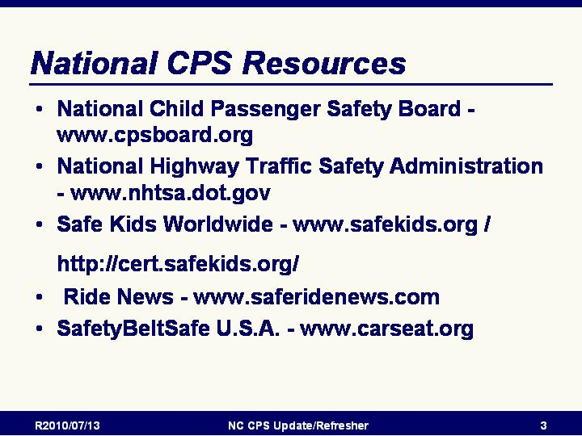
Slide 143

National CPS Resources (continued)

National Child Passenger Safety Board - www.cpsboard.org
- The National Child Passenger Safety Board was established to monitor and provide program direction and technical guidance to states, communities and organizations as a means to maintain a credible, standardized child passenger training and certification program. The purpose of the National Child Passenger Safety Board is to manage the implementation of a standardized quality program (the NHTSA Child Passenger Safety Training and AAA Certification Programs) that has been adopted across the country by organizations wishing to implement child passenger safety training programs to benefit the public. Individuals can obtain information about certification, re-certification, and information on upcoming child passenger safety workshops or clinics that are being conducted.

National Highway Traffic Safety Administration - www.nhtsa.dot.gov
- Federal agency with primary responsibility for establishing and enforcing motor vehicle safety standards. Establishes and promotes national and state highway safety related programs and materials including child passenger safety. Pamphlets, technical reports; program manuals, car seat Manufacturers' Instruction Manual (through 1996); recall lists, etc. are available through NHTSA.

Safe Kids Worldwide - www.safekids.org / http://cert.safekids.org/
- Safe Kids Worldwide is the certifying body for the National Standardized Child Passenger Safety Training Program and manages the online system for registration and other certification processes.

Safe Ride News - www.saferidenews.com
- National newsletter and technical updates related to child passenger, pedestrian, and bicycle safety. Available by subscription.

SafetyBeltSafe U.S.A. - www.carseat.org
- Pamphlets in multiple languages, flyers on correct use of safety seats, training courses and materials, supplement to NHTSA distributed Manufacturers' Instructions Notebook, recall list, and other materials.

Slide 144

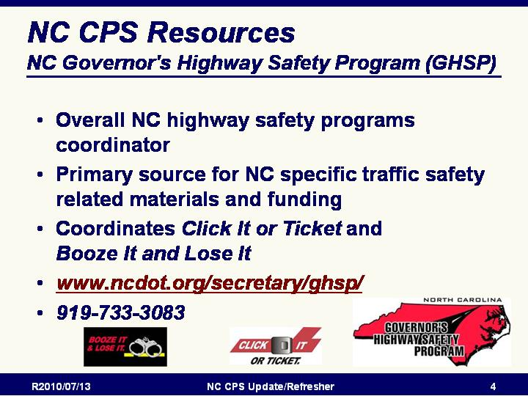
NC CPS Resources

NC Governor's Highway Safety Program (GHSP)
- Overall NC highway safety programs coordinator
- Primary source for NC specific traffic safety related materials and funding
- Coordinates Click It or Ticket and Booze It and Lose It
- www.ncdot.org/secretary/ghsp/
- 919-733-3083

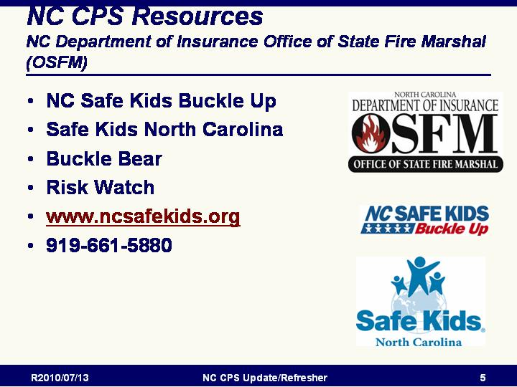
Slide 145

NC Department of Insurance Office of State Fire Marshal (OSFM)
- NC Safe Kids Buckle Up
- Safe Kids North Carolina
- Buckle Bear
- Risk Watch
- www.ncsafekids.org
- 919-661-5880

Slide 146

El Pueblo
- Primary coordinating agency for Nuestra Seguridad, NC’s Hispanic/Latino highway safety program
- Coordinates development and distribution of culturally appropriate Spanish-language materials on highway safety
- 919-835-1525
- www.elpueblo.org

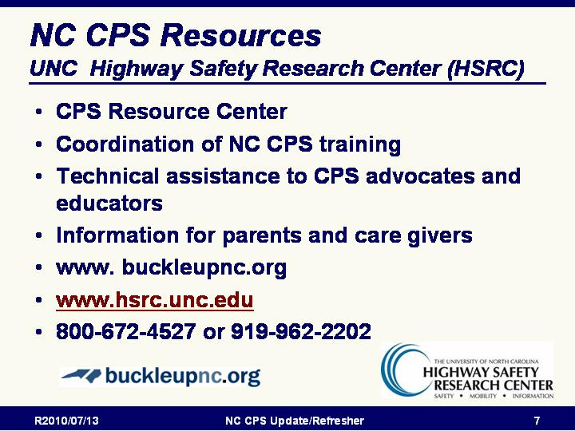
Slide 147

UNC Highway Safety Research Center (HSRC)
- CPS Resource Center
- Coordination of NC CPS training
- Technical assistance to CPS advocates and educators
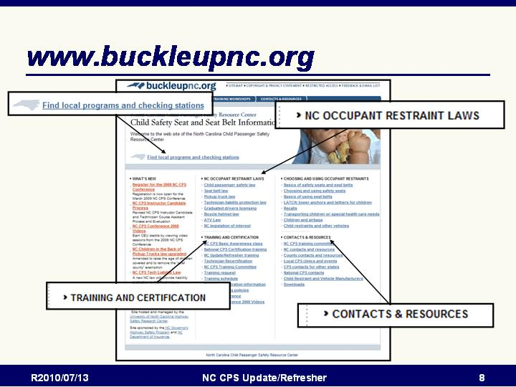
- Information for parents and care givers
- www.buckleupnc.org
- www.hsrc.unc.edu
- 800-672-4527 or 919-962-2202

Slide 148

www.buckleupnc.org
- Information on Local Programs/Contacts, occupant restraint laws, training and certification, and contacts and resources

- NC OCCUPANT RESTRAINT LAWS  - Child passenger safety law  - Seat belt law  - Pickup truck law  - Graduated drivers licensing  - Bicycle helmet law  - ATV Law  - TRAINING WORKSHOPS  - NC CPS basic awareness class  - National CPS certification training  - NC Update/Refresher training  - Technician Recertification  - NC CPS training committee  - Training request  - Training schedule  - Training registration information  - NC CPS training policies  - NC CPS Conference  - Conference Videos | - CHOOSING AND USING OCCUPANT RESTRAINTS  - Basics of safety seats and seat belts  - Choosing and using safety seats  - Basics of using seat belts  - LATCH: lower anchors and tethers for children  - Recalls  - Transporting children w/ special health care needs  - Children and airbags  - Child restraints and other vehicles  - CONTACTS & RESOURCES  - NC CPS training committee  - NC contacts and resources  - County contacts and resources  - Local CPS clinics and events  - CPS contacts for other states  - National CPS contacts  - Child Restraint and Vehicle Manufacturers  - Downloads

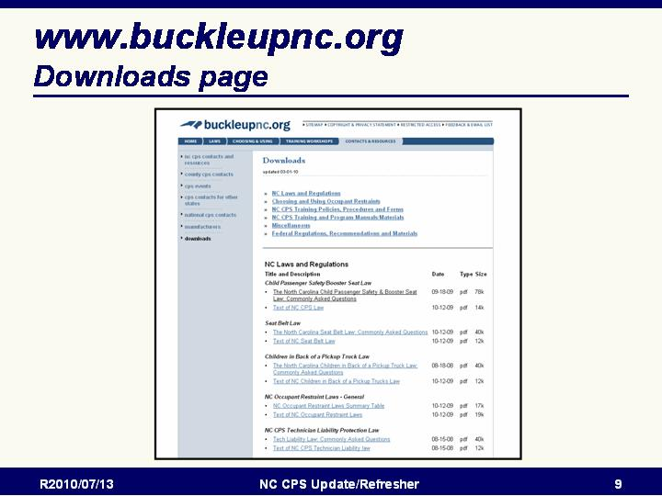
Slide 149

www.buckleupnc.org
Downloads page

Module 7: New Products/Products with Interesting Features

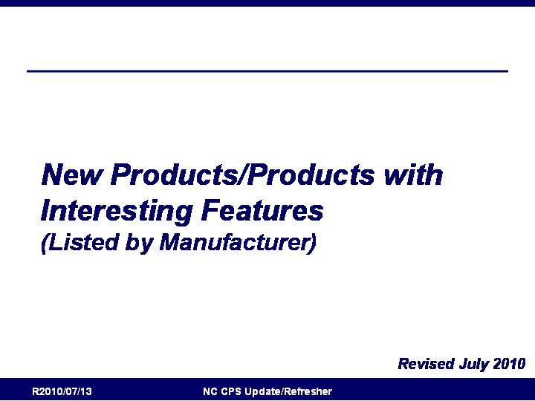
Slide 150

New Products/Products with Interesting Features Listed by Manufacturer

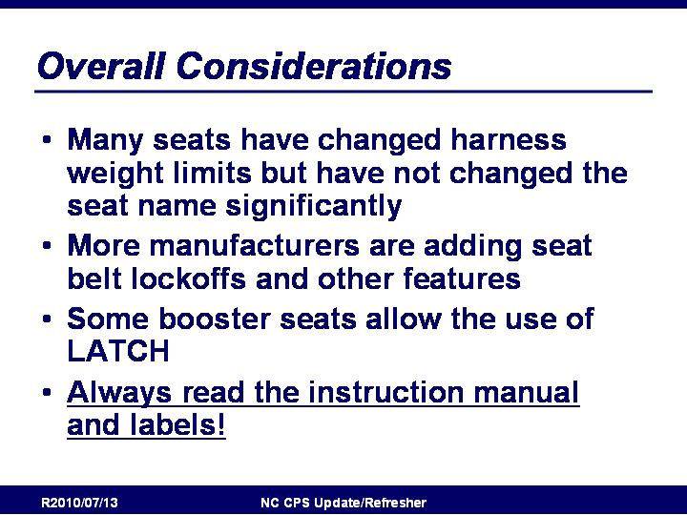
Slide 151

Overall Considerations
- Many seats have changed harness weight limits
but have not changed the seat name significantly
- More manufacturers are adding seat belt lockoffs
and other features
- Some booster seats allow the use of LATCH
- Always read the instruction manual and labels!

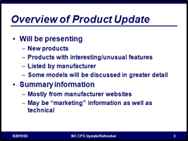
Slide 152

Overview of Product Update
- Will be presenting
  - New products
  - Products with interesting/unusual features
  - Listed by manufacturer
  - Overview of all models by a manufacturer will be listed
  - Some models will be discussed in greater detail
- Summary information
  - Mostly from manufacturer websites
  - May be “marketing” information as well as technical
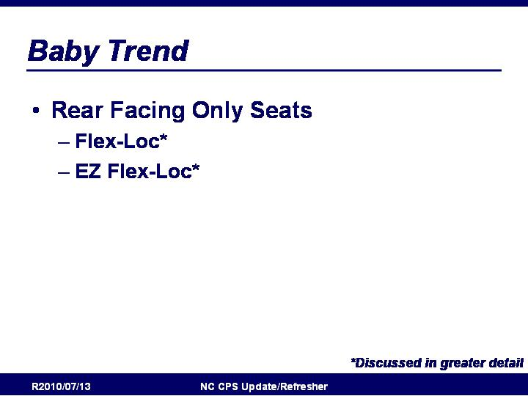
Slide 153

Baby Trend: Overview
- Rear Facing Only Seats
  - Flex-Loc*
  - EZ Flex-Loc*

www.babytrend.com

Slide 154

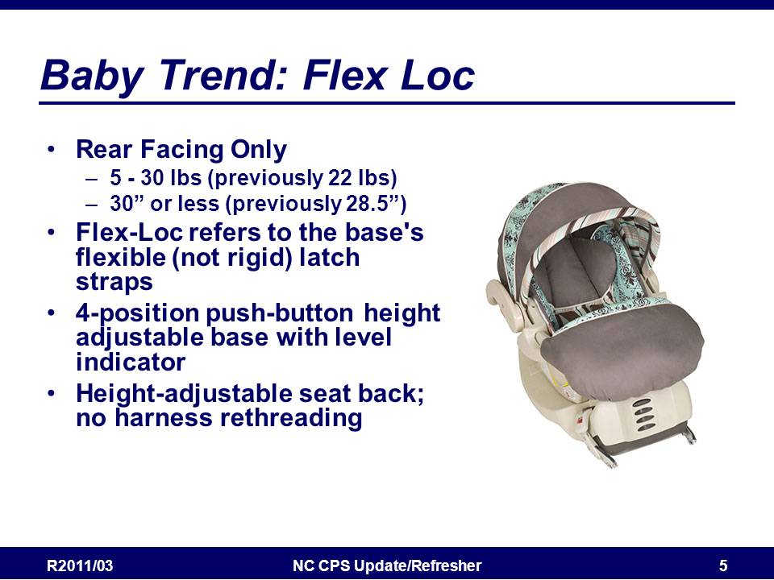
Baby Trend: Flex-Loc
- Rear Facing Only
  - 5 - 30 lbs (previously 22 lbs)
  - 30” or less (previously 28.5”)
- Flex-Loc refers to the base's flexible (not rigid) latch straps
- 4-position push-button height adjustable base with level indicator
- Height-adjustable seat back; no harness rethreading

From Baby Trend Website:
- #1 rated infant car seat
- For weights between 5 and 30 pounds (2.2 and 13.6kg.) heights of 30 inches or less (76.2cm)
- 5-point safety harness; easy one-hand harness adjustment; push-button release
- 4-position push-button height adjustable base with level indicator for proper installation
- Height-adjustable seat back; no harness rethreading
- One-hand easy-access seat release
- EPS energy-absorbing foam for superior side impact head protection
- Smooth carrying handle, won't scratch your arm
- Boot providing extra warmth and comfort
- Flex-Loc refers to the base's flexible (not rigid) latch straps
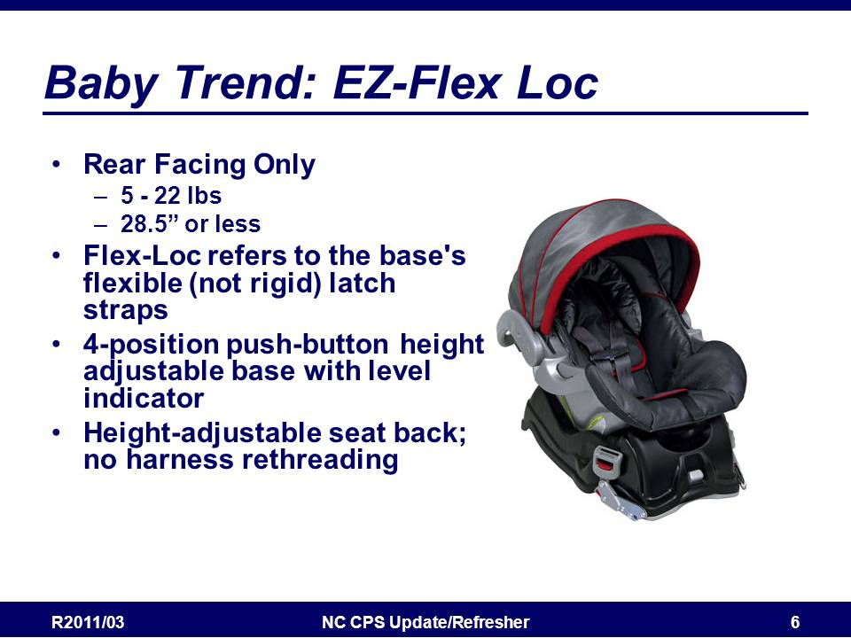
Slide 155

Baby Trend: EZ-Flex Loc
- Rear Facing Only
  - 5 - 22 lbs
  - 28.5” or less
- Flex-Loc refers to the base's flexible (not rigid) latch straps
- 4-position push-button height adjustable base with level indicator
- Height-adjustable seat back; no harness rethreading

From Baby Trend Website:
- Top rated infant car seat
- For weights between 5 and 22 pounds (2.2 and 10kg.) heights of 28.5 inches or less (72.4cm)
- 5-point safety harness; easy one-hand harness adjustment; push-button release
- 4-position push-button height adjustable base with level indicator for proper installation
- One-hand easy-access seat release
- EPS energy-absorbing foam for superior side impact head protection
- Smooth carrying handle, won't scratch your arm
- Soft head support
- EZ Flex-Loc refers to the base's flexible (not rigid) latch straps

Slide 156

Britax: Overview
- Rear Facing Only Seats
  - Chaperone*
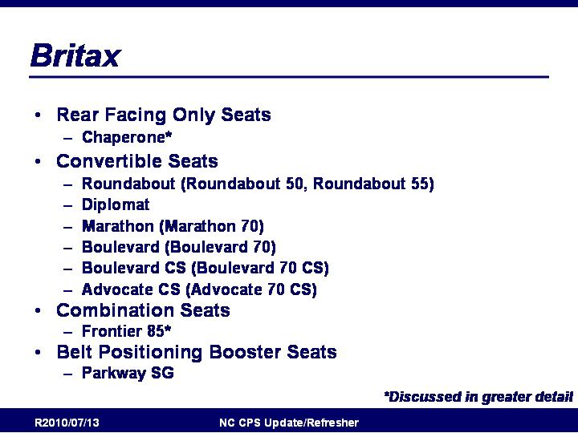
- Convertible Seats
  - Roundabout (Roundabout 50, Roundabout 55)
  - Diplomat
  - Marathon (Marathon 70)
  - Boulevard (Boulevard 70)
  - Boulevard CS (Boulevard 70 CS)
  - Advocate CS (Advocate 70 CS)
- Combination Seats
  - Frontier 85*
- Belt Positioning Booster Seats
  - Parkway SG

http://www.britaxusa.com/

Links to descriptions of Britax Features
- True Side Impact Protection
distributes crash forces, shields from vehicle intrusion, contains the head and body, and keeps the head, neck and spine "in true" or aligned, to limit injury
- Quick-Adjust Head Restraint & No-Rethread Harness
easily adjust the harness shoulder height and head restraint without disassembling the harness
- Anti-Rebound Bar
stabilizes child seat by minimizing rotational forces associated with front and rear collisions
- SafeCell™ Technology
features SafeCells designed to compress in a crash, significantly lowering the center of gravity and counteracting the forward rotation of the child seat which normally propels the child toward the front seat
- Integrated Steel Bars
strengthen the connection to the vehicle and reduce forward flexing of the child seat during a crash
- Patented, Energy-Absorbing Versa-Tether®
features a staged-release tether webbing to slow the forward movement, reducing the crash forces reaching the child, and a two-point attachment to minimize forward rotation while anchoring the top of the child seat

Slide 157

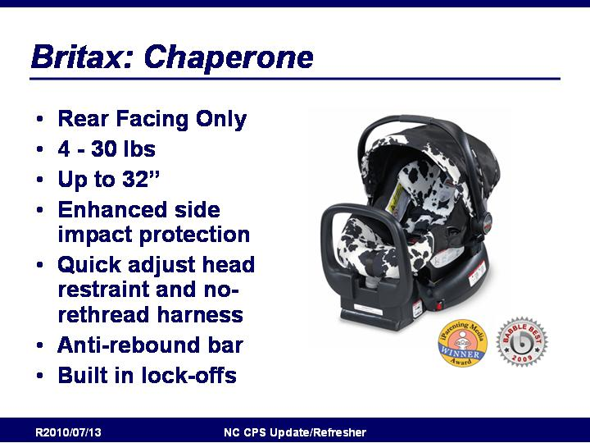
Britax Chaperone
- Rear Facing Only
  - 4 - 30 lbs
  - Up to 32”
- Enhanced side impact protection
- Quick adjust head restraint and no-rethread harness
- Anti-rebound bar
- Built in lock-offs

From Britax Website:
- True Side Impact Protection
- Quick adjust Head Restraint and No-Rethread Harness
- Anti-Rebound Bar
- Certified for Aircraft Travel
- Premium Lower LATCH Connectors for a quick and simple installation featuring a push button for easy release
- Built-in Lock-Offs ensure a snug lap and shoulder belt installation with minimal effort
- Stroller Compatible Design works with Britax Chaperone strollers and other major stroller brands when used with Britax adapter strap (Notice: if you have a Britax Chaperone infant carrier manufactured on or before May 27, 2009, you may obtain an adapter strap free of charge; please call our Consumer Services department for more information 1-888-427-4829)
- Easy-to-Install Seat-to-Base Design self-guides carrier into proper locked position
- Easy-to-Read Level Indicators (on base) provide quick reference for proper angle of recline
- Energy-Absorbing Foam Liner (EPS) absorbs and distributes crash forces
- Ergonomic Carry-Handle designed to contour to forearm to allow for more comfortable carrying of child in carrier
- Extra-Large Canopy blocks wind, rain and harmful UV rays from baby’s sensitive skin
- High Density Comfort Foam provides an extra layer of padding to gently cushion your child
- Front Harness Adjuster provides effortless front adjustment when loosening the harness system
- Plush, Premium Cover Set with matching belly pad provides extra comfort
- Easy-to-Install Base with LATCH Connector Storage (Included)
- 30-pound Weight Capacity for safety and comfort through the first years
- Five-Point Harness makes contact with the strongest parts of the body
- Height Adjustment Knob (on base) for proper seat angle and positioning

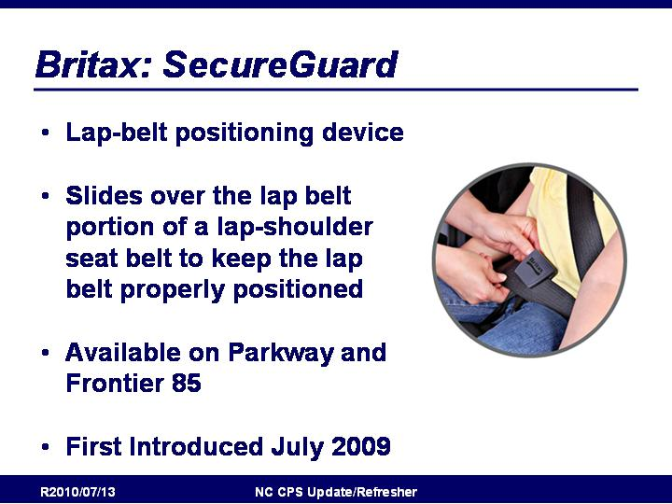
Slide 158

Britax: SecureGuard

- Lap-belt positioning device
- Slides over the lap belt portion of a lap-shoulder
seat belt to keep the lap belt properly positioned
- Available on Parkway and Frontier 85
- First Introduced July 2009

http://www.britaxusa.com/learning-center/360-degree-protection/secureguard

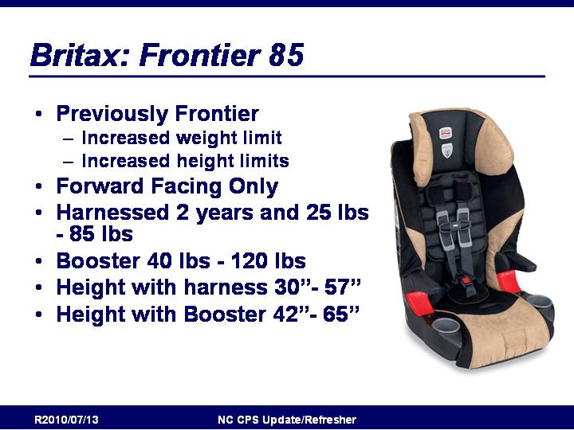
Slide 159

Britax Frontier 85
- Previously Frontier
  - Increased weight limit
  - Increased height limits
- Forward Facing Only
- Harnessed 2 years and 25 lbs - 85 lbs
- Booster 40 lbs - 120 lbs
- Height with harness 30”- 57”
- Height with Booster 42”- 65”
- Compatible with SecureGuard

From Britax Website:
• Compatible with SecureGuard which works with the vehicle safety belt in booster mode to prevent the child from sliding under the lap-belt portion of the safety belt during impact, thus minimizing the risk of abdominal injury (accessory sold separately)
• Tangle Free, 5-Point Harness with 10 harness height positions (up to 20") and three buckle positions for a snug and secure fit as your child grows
• Plush, Premium Cover Set with thick, underlying comfort foam provides extra comfort, encouraging your child to stay in the proper position
• Integrated Armrests help provide a secure fit and a natural place to rest arms
• Integrated Cup Holders are designed to fit common beverages such as 20 oz reusable water bottles
• Certified for Aircraft Travel in Harness Mode
• Patented, Energy-Absorbing Versa-Tether® features a staged-release tether webbing to slow the forward movement, reducing the crash forces reaching the child, and a two-point attachment to minimize forward rotation while anchoring the top of the child seat
• Premium Lower LATCH Connectors for a quick and simple installation featuring a push button for easy release
• Harness Ultra Guard System (HUGS™) provides resistance to forward movement in the event of a crash
• Color-Coded Vehicle Belt Guides indicate the path and positioning of the vehicle seat belt
• Durable and Washable Cover in mature fashions for the growing child
• Energy-Absorbing Foam Liner (EPS) absorbs and distributes crash forces
• High Density Comfort Foam provides an extra layer of padding to gently cushion your child
• Harness-2-Booster converts to a belt-positioning booster seat
• Energy-Absorbing Base deforms in the event of a crash to absorb impact forces

Slide 160

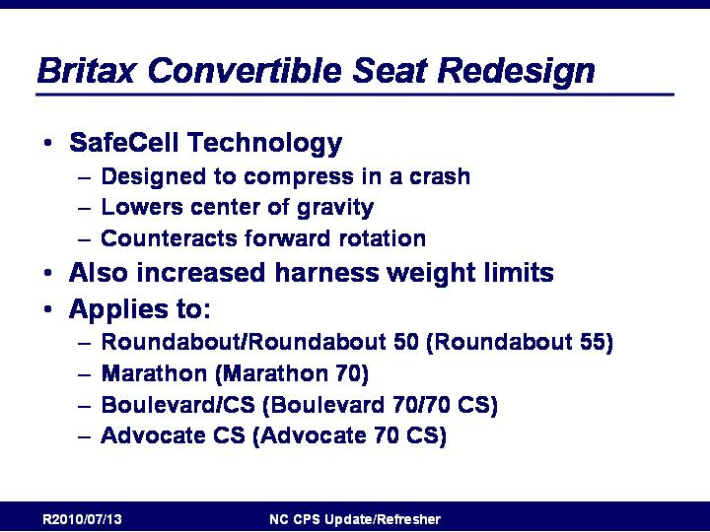
Britax Convertible Seat Redesign
- SafeCell Technology
  - Designed to compress in a crash
  - Lowers center of gravity
  - Counteracts forward rotation
- Also increased harness weight limits
- Applies to:
  - Roundabout/Roundabout 50 (now Roundabout 55)
  - Marathon (now Marathon 70)
  - Boulevard/CS (now Boulevard 70/70 CS)
  - Advocate CS (now Advocate 70 CS)

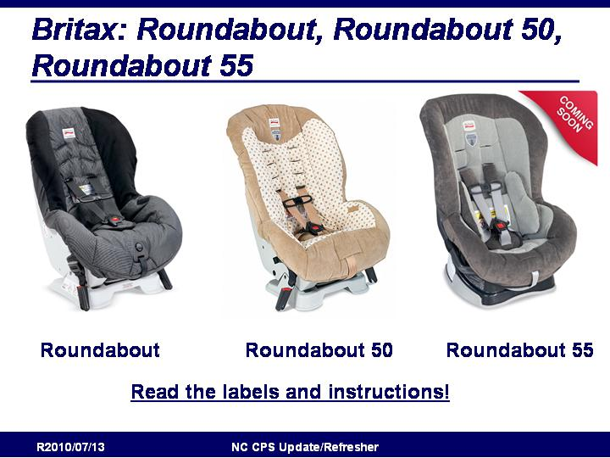
Slide 161

Britax Roundabout, Roundabout 50, Roundabout 55
- Read the labels and instructions! Some seats have very
similar names but different height/weight limits.

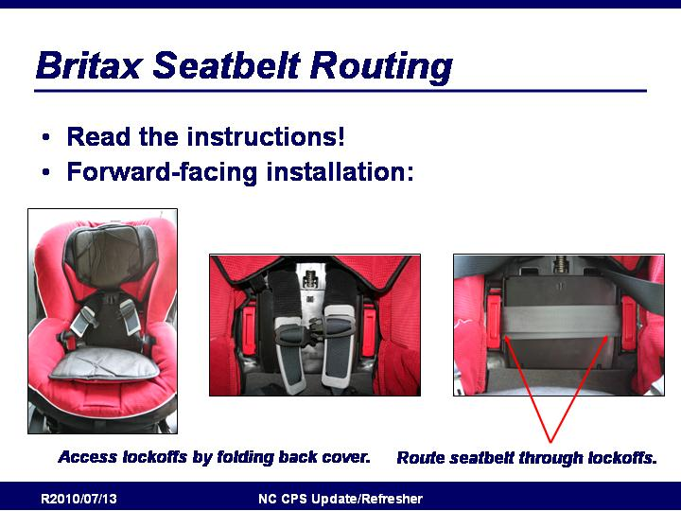
Slide 162

Britax Seatbelt Routing
- Read the labels and instructions!
- New Britax seatbelt routing is a little different than many
other seats.

http://www.britaxusa.com/learning-center/superior-ease-of-use/built-in-lock-offs
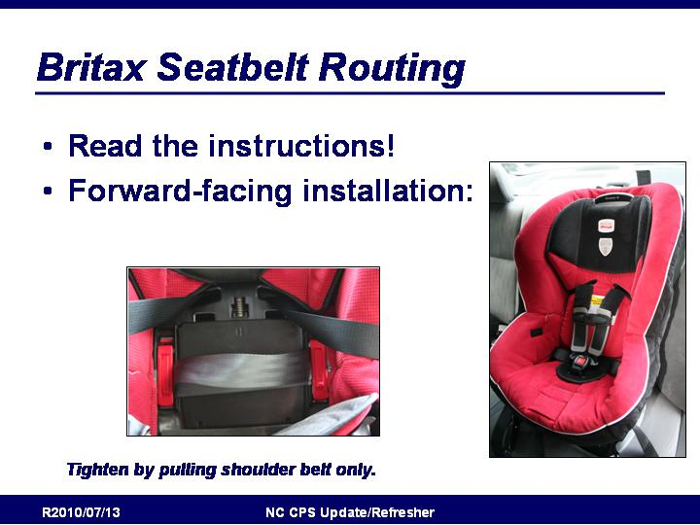
Slide 163

Britax Seatbelt Routing

Slide 164

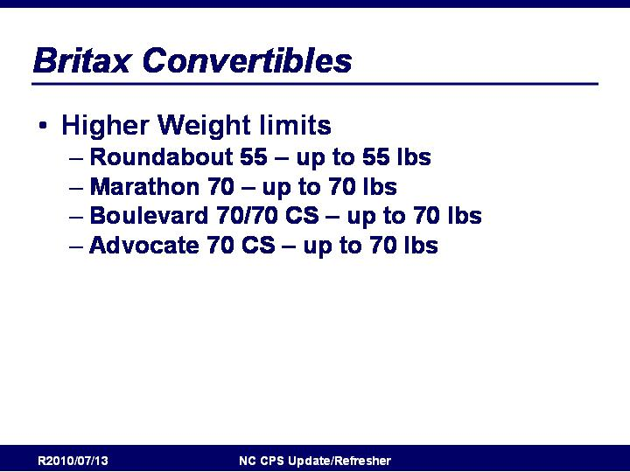
Britax Convertibles
- Higher Weight limits
  - Roundabout 55 – up to 55 lbs
  - Marathon 70 – up to 70 lbs
  - Boulevard 70/70 CS – up to 70 lbs
  - Advocate 70 CS – up to 70 lbs

Slide 165

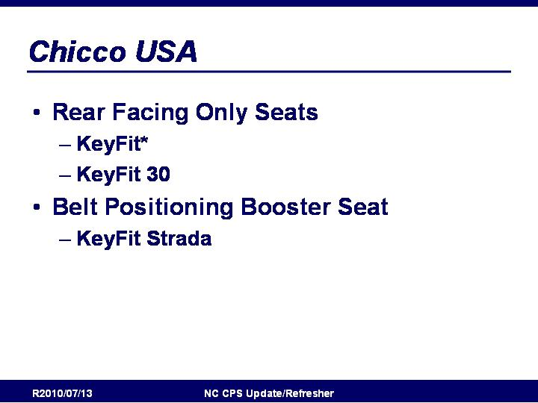
Chicco: Overview
- Rear Facing Only Seats
  - KeyFit*
  - KeyFit 30
- Belt Positioning Booster Seat
  - KeyFit Strada

http://www.chiccousa.com/

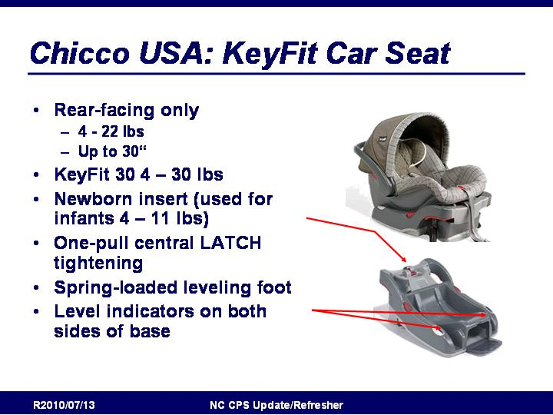
Slide 166

Chicco USA KeyFit Car Seat
- Rear-facing only
  - 4 - 22 lbs
  - Up to 30“
- KeyFit 30 4 – 30 lbs
- Newborn insert (used for infants 4 – 11 lbs)
- One-pull central LATCH tightening
- Spring-loaded leveling foot
- Level indicators on both sides of base

From Chicco Website:
KeyFit:
#1 Rated Infant Car Seat in America! The Chicco KeyFit Infant Car Seat is the premier infant carrier for safety, comfort, and convenience. With its removable newborn insert, the KeyFit Car Seat will accommodate your baby from 4 to 22 pounds. The KeyFit’s thickly cushioned seat includes a five-point safety harness and is lined with energy-absorbing foam for increased safety and comfort. The KeyFit Base’s spring-assisted level foot, two precision bubble levels, and “Center-Pull” LATCH adjustment guarantee quick and correct installment from either side of your vehicle and give you confidence that your child is safely secured in your vehicle.

KeyFit30:
The Chicco KeyFit 30 Infant Car Seat is the premier infant carrier for safety, comfort, and convenience. With its removable newborn insert, the KeyFit 30 Car Seat will accommodate your baby from four to thirty pounds. The KeyFit 30’s thickly cushioned seat includes a five-point safety harness and is lined with energy-absorbing foam for increased safety and comfort. The KeyFit 30 Base’s spring-assisted level foot, two precision bubble levels, and “Center-Pull” LATCH adjustment guarantee quick and correct installment from either side of your vehicle and give you confidence that your child is safely secured in your vehicle.

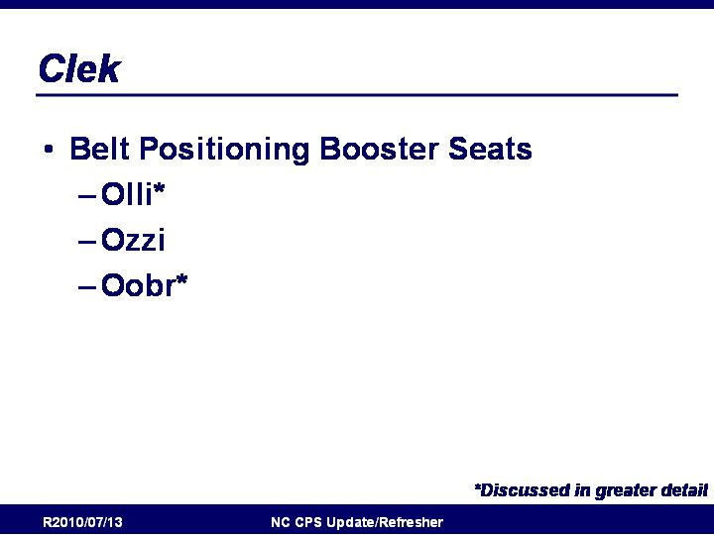
Slide 167

Clek: Overview
- Belt Positioning Booster Seats
  - Olli*
  - Ozzi
  - Oobr*

http://www.magnaclek.com

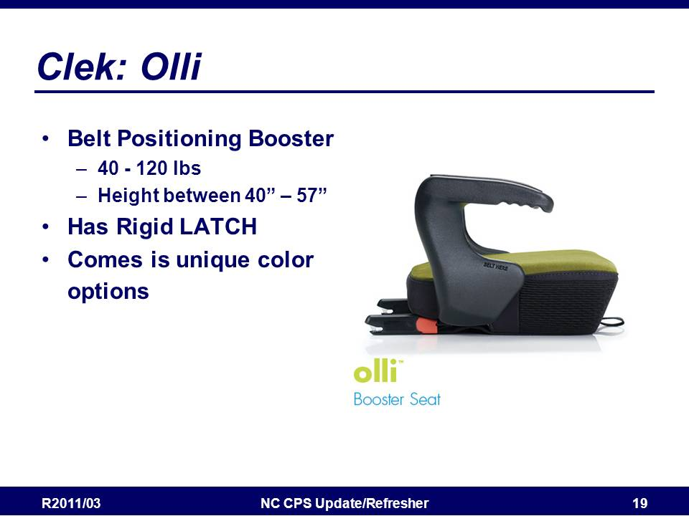
Slide 168

Clek Olli
- Belt positioning booster
- 40-100 lbs.
- Has Rigid LATCH
  - NOTE: This is an exception to the “do not use LATCH attachments/anchors and the seat belt” rule at the same time
  - Attaching the booster with LATCH attachments keeps it in place even if empty with no belt around it
  - LATCH anchors do not bear significant loading in crash, so maximum weights for vehicle lower anchors do not apply
- Comes is unique color options

From Clek Website:
The Clek™ LATCH system locks the booster seat into place quickly and easily using your vehicle’s LATCH anchorage system.

- Raises your child 4 in./10 cm. to improve in-vehicle shoulder belt fit
- Better positions the seat belt on the child’s hips to improve safety
- Locks into place to provide additional booster seat stability in a collision
- Confirms that latches are locked with an audible “click”
- Provides a secure connection even when booster seat is not occupied
- Meets all Federal Motor Vehicle Safety Standards and Canadian Motor Vehicle Safety Standards

Slide 169

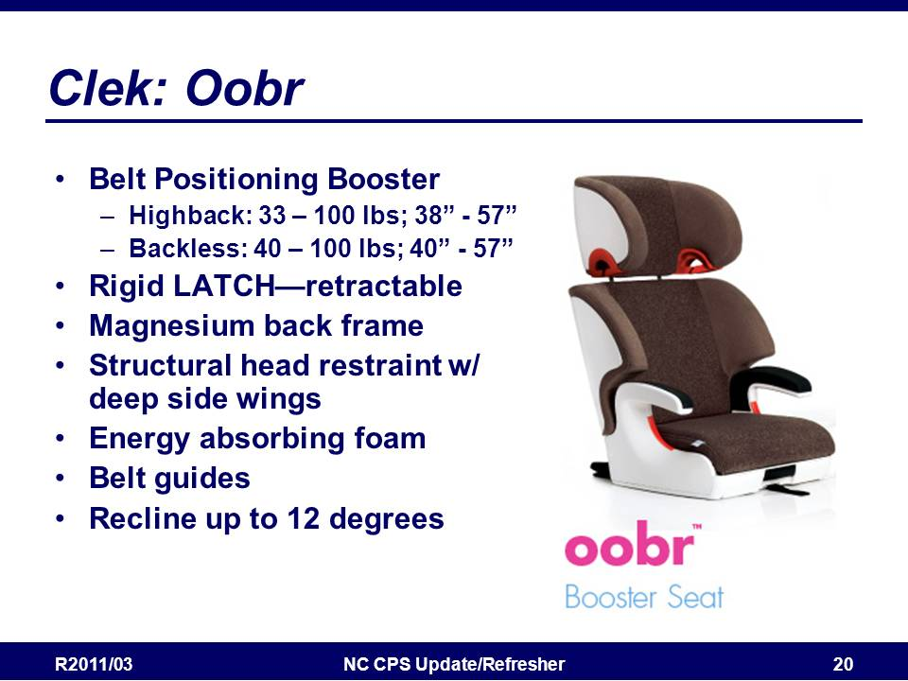
Clek: Oobr
- Belt Positioning Booster
  - Highback: 33 – 100 lbs; 38” - 57”
  - Backless: 40 – 100 lbs; 40” - 57”
- Elemental Safety System
- Rigid LATCH—retractable
- Magnesium back frame
- Structural head restraint w/ deep side wings
- Energy absorbing foam
- Belt guides
- Recline up to 12 degrees

From Clek Website:
Collisions happen from all angles. Oobr’s™ exclusive Elemental Safety System™ was engineered with front, rear and side impact protection in mind.
Comprised of five structural safety elements, the Elemental Safety System systematically secures and protects your child.

Rigid LATCH System: Locks the booster seat into place using your vehicle’s LATCH anchorage system to provide additional booster seat stability in a collision.
Magnesium Back Frame: Better contains the torso during a side impact collision and protect against vehicle intrusion.
Structural Headrest with Deep Side Wings: Connects to the magnesium frame using steel rods to reduce twisting movements and improve head protection in a collision.
Energy-Absorbing Foam Layer: Absorbs energy in a side impact collision resulting in less force transferred directly to your child.
Belt Guides: Improves belt positioning on your child’s shoulders and hips.

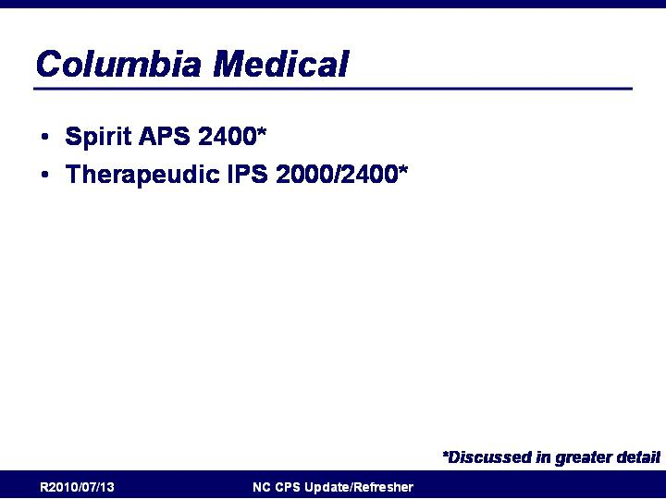
Slide 170

Columbia Medical: Overview
- Spirit APS 2400*
- Therapeudic IPS 2000/2400*

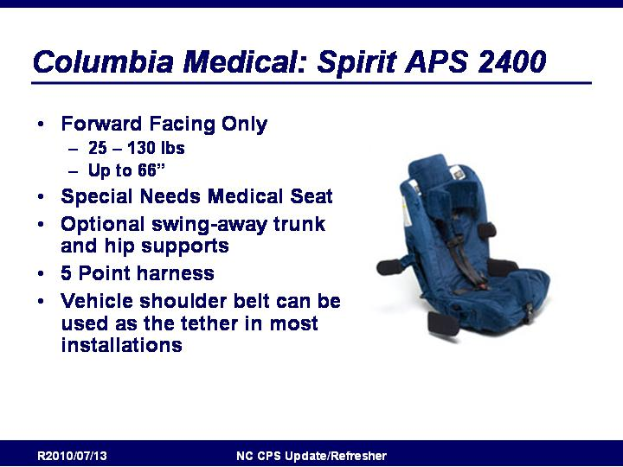
Slide 171

Columbia Medical: Spirit APS 2400
- Forward Facing Only
  - 25 – 130 lbs
  - Up to 66”
- Special Needs Medical Seat
- Optional swing-away trunk and hip supports
- 5 Point harness
- Vehicle shoulder belt can be used as the tether in most installations

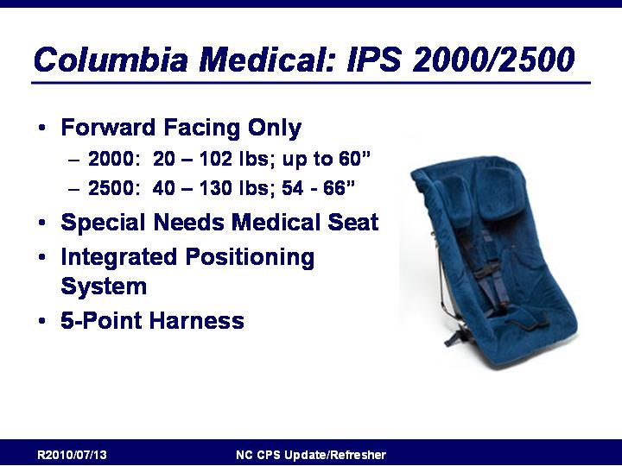
Slide 172

Columbia Medical: Spirit APS 2400
- Forward Facing Only
  - 2000: 20 – 102 lbs; up to 60”
  - 2500: 40 – 130 lbs; 54 - 66”
- Special Needs Medical Seat
- Integrated Positioning System
- 5-Point Harness

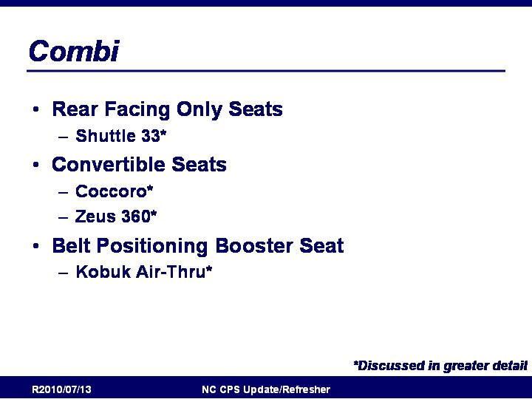
Slide 173

Combi: Overview
- Rear Facing Only Seats
  - Shuttle 33*
- Convertible Seats
  - Coccoro*
  - Zeus 360*
- Belt Positioning Booster Seat
  - Kobuk Air-Thru*

http://www.combiusa.com/
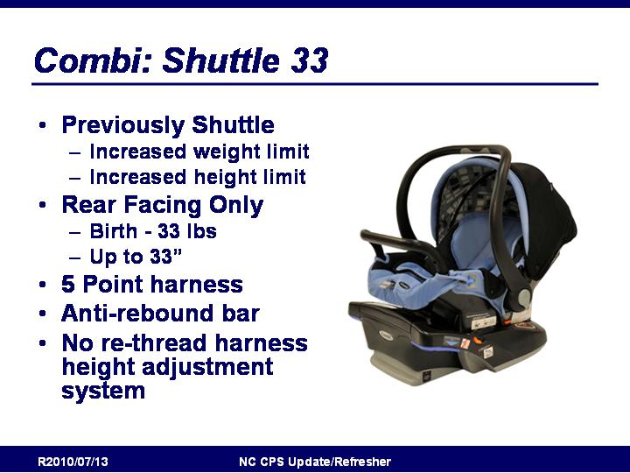
Slide 174

Combi Shuttle33
- Previously Shuttle
  - Increased weight limit
  - Increased height limit
- Rear Facing Only
  - Birth - 33 lbs
  - Up to 33”
- 5 Point harness
- Anti-rebound bar
- No re-thread harness height adjustment system

From Combi Website:
The lightweight SHUTTLE 33 infant car seat is compatible with all Combi strollers. It has been newly designed to accommodate infants from birth to 33 pounds and up to 33 inches. A 5-point harness with padding, Tru-Safe® Anti-Rebound Bar (ARB), Tru-Safe® Side Impact Protection (SIP), EZ Harness™ Height Adjustment System, and an adjustable canopy make for a safe and comfortable environment for your child. The removable and washable seat cushion and ergonomically designed handle add convenience.

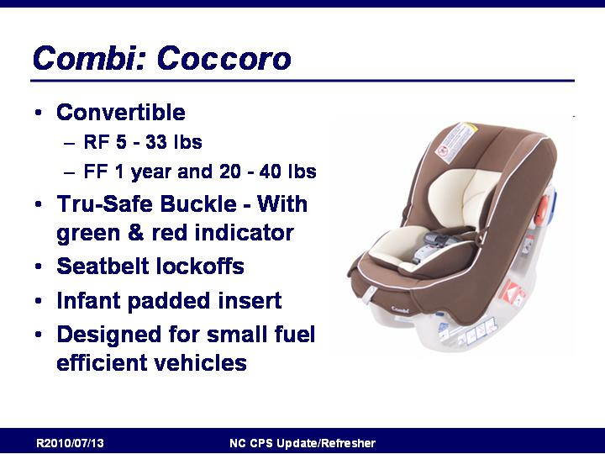
Slide 175

Combi Coccoro
- Convertible
  - RF 5 - 33 lbs
  - FF 1 year and 20 - 40 lbs
- Tru-Safe Buckle - With green & red indicator
- Seatbelt lockoffs
- Infant padded insert
- Designed for small fuel efficient vehicles

From Combi Website:
The lightweight and compact Coccoro convertible car seat is compatible with smaller vehicles. Three Coccoro seats can be installed in the rear-seat of vehicles such as the Toyota Corolla. A 5-point harness with padding, Tru-Safe® Buckle, forward and rear-facing lock-offs, energy absorbing EPS foam and 4 position height adjustments make for a safe and comfortable environment for your child. An adjustable infant insert can be positioned to the recommended 45 degree angle for your newborn. The single-pull adjustable harness system, shoulder belt retainers and washable seat cushion add convenience.

Slide 176

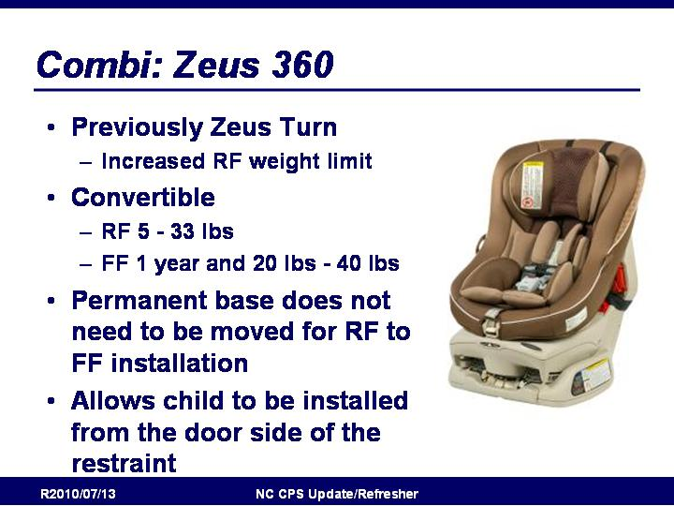
Combi: Zeus 360
- Previously Zeus Turn
  - Increased RF weight limit
- Convertible
  - RF 5 - 33 lbs
  - FF 1 year and 20 lbs - 40 lbs
- Permanent base does not need to be moved for RF to FF installation
- Allows child to be installed from the door side of the restraint

From Website:
The Zeus 360° convertible car seat is designed to rotate 360 degrees without re-installation and accommodates children up to 33 pounds rear-facing and 40 pounds forward-facing. A 5-point harness with padding, Tru-Safe® Side Impact Protection (EPS), Tru-Safe® Buckle with red/green indicator, built-in lock-offs, anti-rebound base, 2-position recline and 3-position height adjustments, make for a safe and comfortable environment for your child. An adjustable infant insert can be positioned to the recommended 45 degree angle for your newborn. Removable and washable fabric, single-pull 5-point harness and harness holders add convenience.

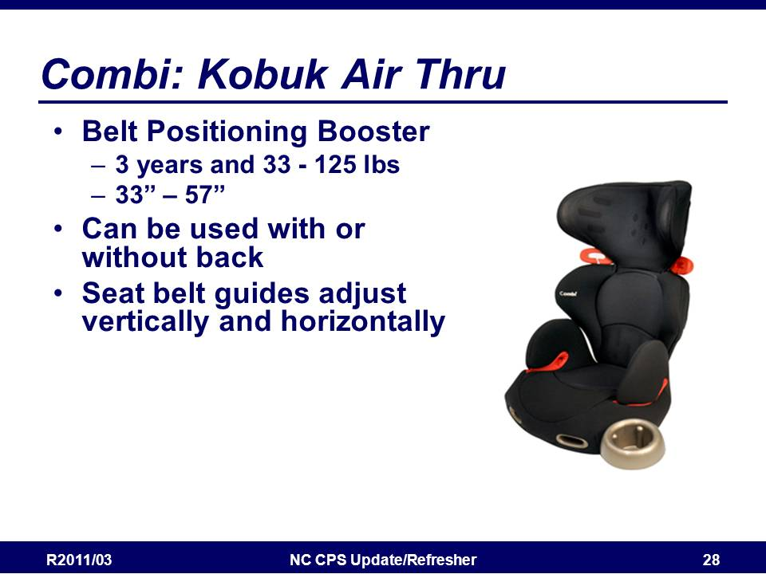
Slide 177

Combi Kobuk Air Thru
- Belt Positioning Booster
  - 3 years and 33 - 125 lbs
  - 33” – 57”
- Can be used with or without back
- Air vents
- Comfortable arm rests
- Seat belt guides adjust vertically and horizontally for optimum comfort and fit

From Website:
The Kobuk Air-Thru™ booster seat with vented shell allows hot air to escape and cool air to rush in. It can be used as a highback or as a backless booster, keeping your child safe after he or she out-grows a car seat. Deep side wings provide greater head protection. Belt guides give you the freedom to adjust the seatbelt vertically or horizontally so you can find the perfect belt position for your child. The height adjustable backrest, armrests and removable cup holder make for a comfortable environment. Removable and washable fabric adds convenience. For 3 yrs and 33-125 lb and 33-57 in.

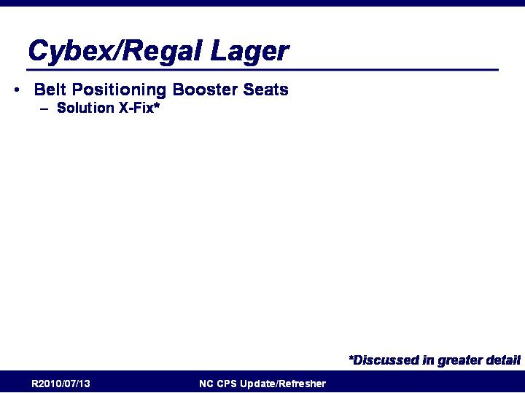
Slide 178

Cybex/Regal Lager: Overview
- Belt-Positioning Booster Seats
  - Solution X-Fix

http://cybex-online.com/

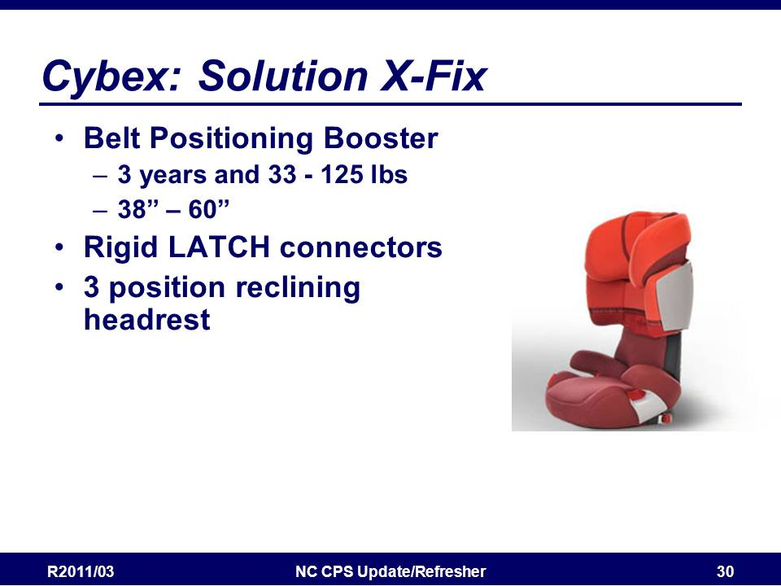
Slide 179

Cybex: Solution X-Fix
- Belt Positioning Booster
  - 3 years and 33 - 125 lbs
  - 38” – 60”
- Rigid LATCH connectors
- 3 position reclining headrest that shifts the balance point of the head back so kids stay properly positioned in the seat.
- LSP Side Impact Protection

Slide 180

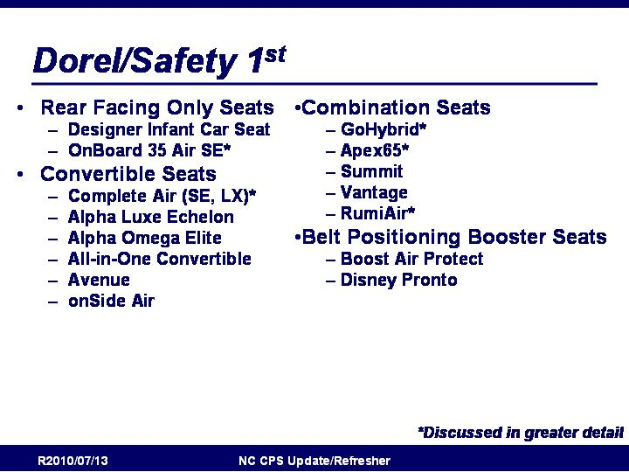
Dorel/Safety 1st: Overview
- Rear Facing Only Seats
  - Designer Infant Car Seat
  - OnBoard 35 Air SE*
- Convertible Seats
  - Complete Air (SE, LX)*
  - Alpha Luxe Echelon
  - Alpha Omega Elite
  - All-in-One Convertible
  - Avenue
  - onSide Air
- Combination Seats
  - GoHybrid*
  - Apex65*
  - Summit
  - Vantage
  - RumiAir*
- Belt Positioning Booster Seats
  - Boost Air Protect
  - Disney Pronto

http://www.safety1st.com

Air Protect Side Impact Technology: http://airprotect.safety1st.com/

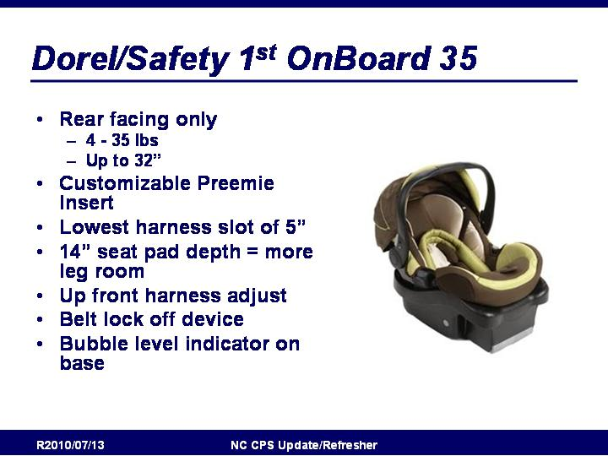
Slide 181

Dorel/Safety 1st OnBoard 35
- Previously OnBoard
  - Increased weight
- Rear facing only
  - 4 - 35 lbs
  - Up to 32”
- Customizable Preemie Insert
- Lowest harness slot of 5”
- 14” seat pad depth = more leg room
- Up front harness adjust
- Belt lock off device
- Bubble level indicator on base

From Safety 1st Website:
- Rear-facing 4-35 pounds and up to 32” in height
- Featuring Air Protect™ revolutionary side impact technology which immediately reduces side impact forces through the precise release of air
- Extended use from a tiny 4 to a full 35 pounds
- 17% more leg room than most infant car seats
- Customizable insert and low harness slots make the seat ideal for preemies and adjustable for growing babies
- Carry Curve™ Handle features ergonomic design
- Base Belt Lock easily secures your vehicle seat belt during installation
- One Click LATCH installation system
- Premium fabrics with custom embroidery

Slide 182

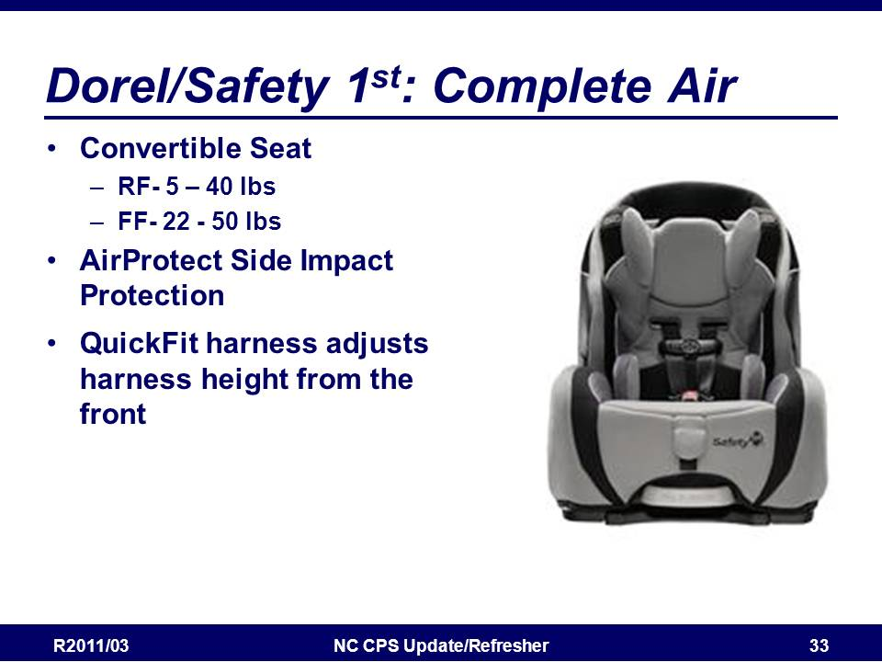
Dorel/Safety 1st Complete Air
- Convertible Seat
  - RF- 5 – 40 lbs
- FF- 22 - 50 lbs
- AirProtect Side Impact Protection shields head and immediately reduces side impact forces through the precise release of air
- QuickFit harness adjusts harness height from the front

From Safety 1st Website:
- Air Protect™ Revolutionary Side Impact Technology: Breakthrough system shields head and immediately reduces side impact forces through the precise release of air
- QuickFit™ Harness System adjusts harness height from the front in one easy step without uninstalling from the car
- Harness accommodates children up to 50 pounds
- One Click LATCH installation system allows for faster and easier installation when moving between vehicles
- 5-position adjustable headrest easily accommodates your growing child
- 4-position recline can be adjusted with one hand
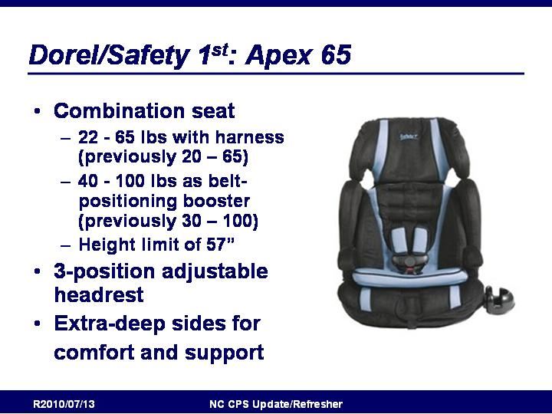
- Removable cup holder

Slide 183

Dorel/Safety 1st Apex 65
- Combination seat
  - 22 - 65 lbs with harness (previously 20 – 65)
  - 40 - 100 lbs as belt-positioning booster (previously 30 – 100)
  - Height limit of 57”
- 3-position adjustable headrest
- Extra-deep sides for comfort and support

From Safety 1st Website:
- Forward-facing 22-65 lbs.
- Belt-positioning booster 40-100 lbs.
- 5-point harness system with up-front adjustment
- 65 pound capability keeps toddlers in harness longer
- Side Impact Protection
- 4 harness heights
- 3-position adjustable headrest for children up to 57” in height
- 3 buckle locations
- Extra-deep sides for comfort and support
- Removable harness pads
- Removable toddler insert for added comfort
- Padded armrests
- Removable cup holder
- LATCH equipped for easy installation
- Meets or exceeds Federal Safety Standards

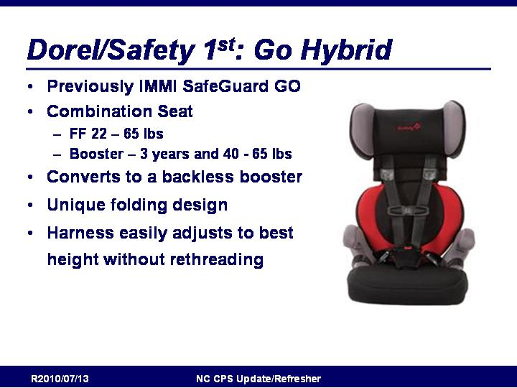
Slide 184

Dorel/Safety 1st GoHybrid
- Previously IMMI SafeGuard GO
- Combination Seat
  - FF 22 – 65 lbs
  - Booster – 3 years and 40 - 65 lbs
- Converts to a backless booster
- Unique folding design
- Harness easily adjusts to best height without rethreading

From Safety 1st Website:
- Installs in less than a minute!
- 5-point harness system for use up to 65 pounds
- Converts to a backless booster
- Unique folding design is ideal for travel
- Convenient travel bag included
- Harness easily adjusts to best height without rethreading
- Equipped with SafeGuard Secure™ advanced restraint systems for ease of use and installation

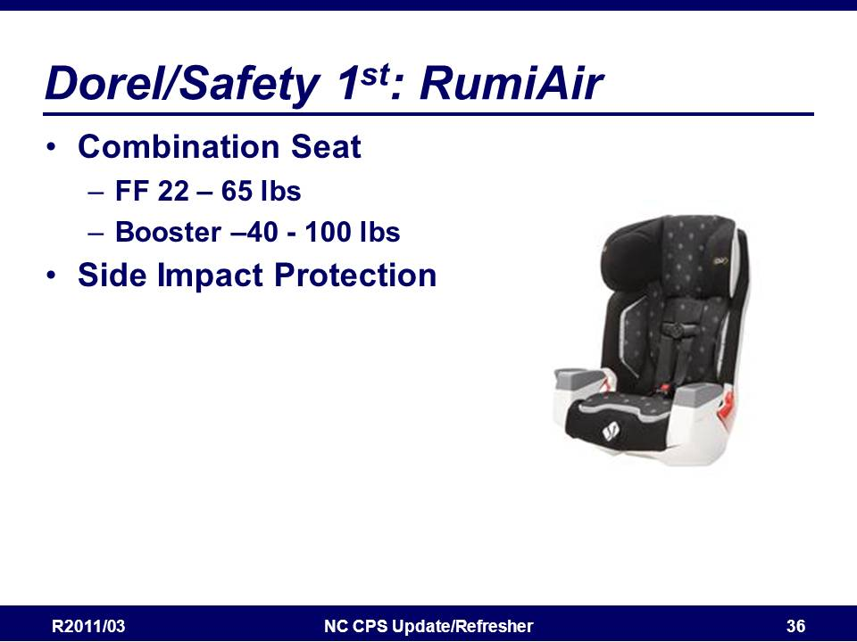
Slide 185

Dorel/Safety 1st RumiAir
- Combination Seat
  - FF 22 – 65 lbs
  - Booster –40 - 100 lbs
- Air Protect Revolutionary Side Impact Technology: Breakthrough system shields head and immediately reduces side impact forces through the precise release of air

From Safety 1st Website:
The Rümi Air features a new state-of-the-art energy management design which uses an internal truss system to absorb crash forces in the event of a motor vehicle accident. The Rümi Air combines this new internal truss with revolutionary air protect technology for better side impact protection. Air Protect™, developed with testing using the advanced Dorel/Kettering side impact criteria, provides greater energy absorption and head containment in the most severe impacts; where intrusion into the passenger compartment occurs. For customized safety, the easy-adjust 12-position headrest properly aligns the Air Protect system with the child's head, where it's needed most. A higher weight range of 65 pounds keeps your child in the internal harness system longer, as recommended by the American Academy of Pediatrics (AAP). With convenience features like the no-rethread harness, single-hand adjust headrest and integrated cup and snack holders, this car seat boasts the best of both safety and style.
- Unique truss system provides added strength while giving the seat an appealing appearance and smooth surface that helps protect vehicle interiors as well as your child
- Air Protect® Revolutionary Side Impact Technology: Breakthrough system shields head and immediately reduces side impact forces through the precise release of air

Slide 186

Dorel/Cosco: Overview
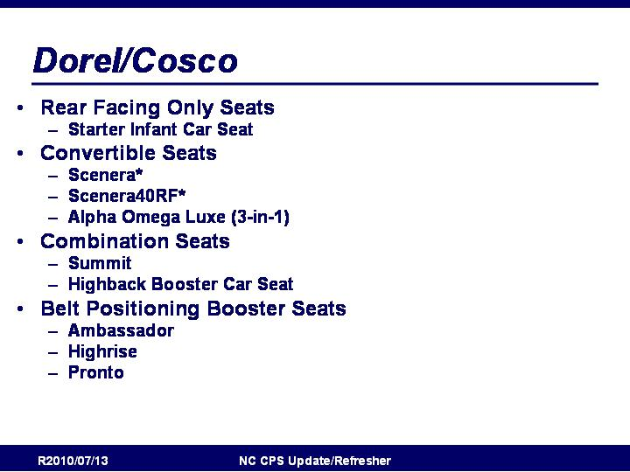
- Rear Facing Only Seats
  - Starter Infant Car Seat
- Convertible Seats
  - Scenera*
  - Scenera40RF*
  - Alpha Omega Luxe (3-in-1)
- Combination Seats
  - Summit
  - Highback Booster Car Seat
- Belt Positioning Booster Seats
  - Ambassador
  - Highrise
  - Pronto
http://www.coscojuvenile.com/usa/eng/

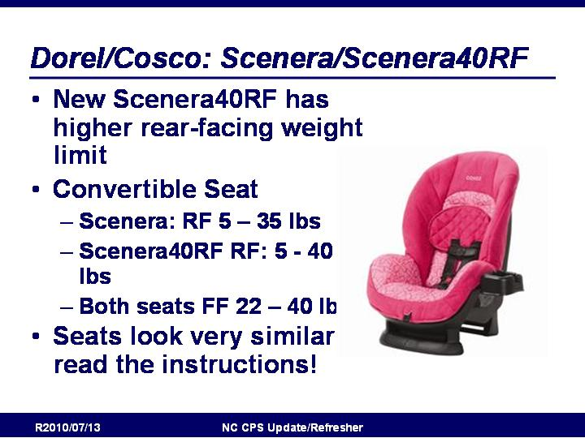
Slide 187

Dorel/Cosco Scenera/Scenera40RF
- New Scenera40RF has higher rear-facing weight limit
- Convertible Seat
  - Scenera: RF 5 – 35 lbs
  - Scenera40RF RF: 5 - 40 lbs
  - Both seats FF 22 – 40 lbs
- Seats look very similar – read the instructions!

From Cosco Website:
Safety experts agree: Babies should remain rear-facing as long as possible. The Scenera® 40RF is helping parents meet this goal with a convertible car seat that can remain rear-facing all the way to 40 pounds and 43 inches in height.
  - Rear-facing 5-40 pounds
  - Forward-facing 22-40 pounds
  - 5-point harness system with up front adjustment
  - 4 harness heights
  - 3 buckle locations

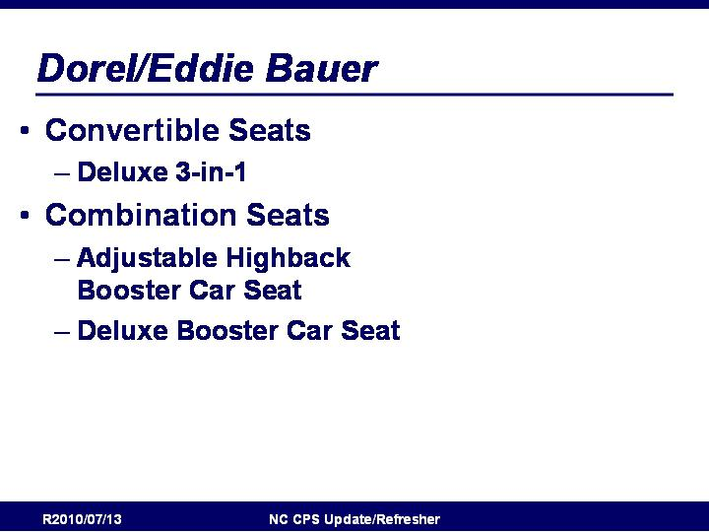
Slide 188

Dorel/Eddie Bauer: Overview
- Convertible Seats
  - Deluxe 3-in-1
- Combination Seats
  - Adjustable Highback Booster Car Seat
  - Deluxe Booster Car Seat

http://www.eddiebauer.djgusa.com/usa/eng/

Slide 189

Evenflo: Overview
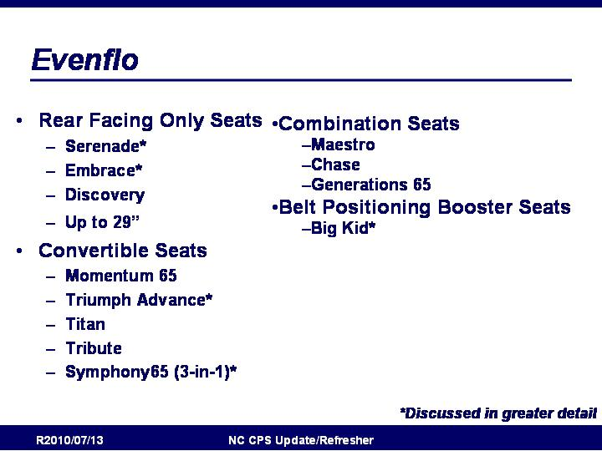
- Rear Facing Only Seats
  - Serenade*
  - Embrace*
  - Discovery
- Convertible Seats
  - Momentum 65
  - Triumph Advance*
  - Titan
  - Tribute
  - Symphony65 (3-in-1)*
- Combination Seats
  - Maestro
  - Chase
  - Generations 65
- Belt Positioning Booster Seats
  - Big Kid*

http://www.evenflo.com/

Slide 190

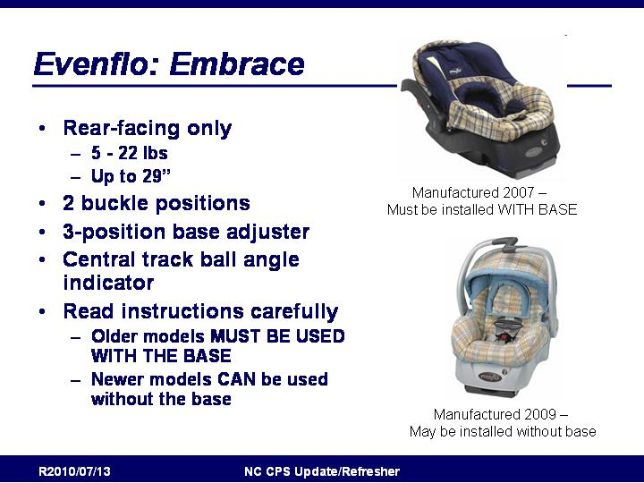
Evenflo Embrace
- Rear-facing only
  - 5 to 22 lbs
  - Up to 29”.
- 2 buckle positions
- 3-position base adjuster
- Central track ball angle indicator
- Read instructions carefully
  - Older models MUST BE USED WITH THE BASE
  - Newer models CAN be used without the base

From Evenflo Website:
- Rear Facing for infants 5 to 22 lbs.
- Upfront harness adjust makes tightening the harness quick and effortless
- Adjustable base and level indicator allow for an easy installation
- Separate integrated Stay-In-Car base allows the seat to easily come in and out
- ComfortTouch seat pad, removable head pillow and body pillow comfort your sleeping infant
- EZ Carry™ handle is an innovative design that allows for easier carrying
- 3 Shoulder harness positions and 2 crotch buckle positions for better fit and longer use
- Pivoting canopy helps keep your baby shaded
- Belt Guide for use without base
- Central Track Ball Angle indicator to ensure proper angle for infant
- Extra bases are available for your second vehicle
- Side Impact Tested! Like all Evenflo car seats, the Embrace™ Infant Car Seat is Side Impact Tested AND meets ALL Federal safety standards.
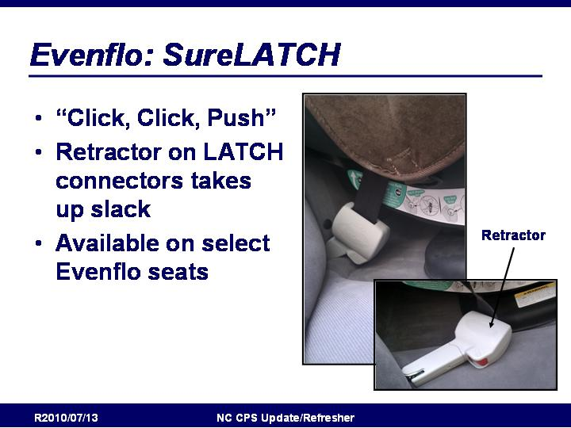
- Designed and tested for structural integrity at energy levels approximately 2X the federal crash test standard

Slide 191

Evenflo SureLatch
- “Click, Click, Push”
- Retractor on LATCH connectors takes up slack
- Available on select Evenflo seats
SureLatch Description: http://www.evenflo.com/sme_symphony.aspx?id=435
SureLatch FAQ: http://www.evenflo.com/sme_carseats.aspx?id=438

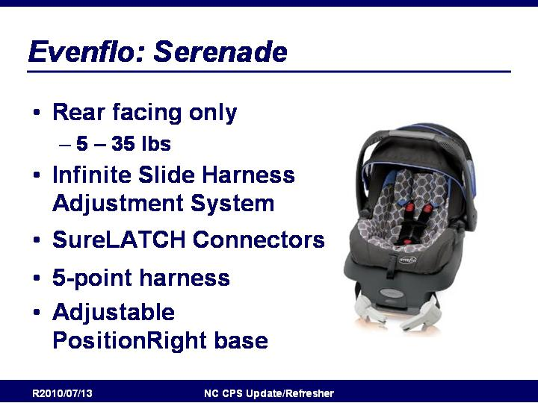
Slide 192

Evenflo: Serenade
- Rear facing only
  - 5 – 35 lbs
- Infinite Slide Harness Adjustment System
- SureLATCH Connectors
- 5-point harness
- Adjustable PositionRight base

From Evenflo Website:
- SureLATCH® technology – an exclusive Evenflo innovation consisting of two connectors for use with a vehicle’s LATCH system to promote proper installation in a fraction of the time of a traditional seat. Safety so simple!
- Infinite Slide™ Harness Adjust – an innovative harness system that simply slides for an accurate harness fit everytime!
- Full Coverage Canopy – With superior padding, and a full-coverage canopy to shade baby from every angle, baby will be comfortable everywhere you go.
- Side Impact Tested! Like all Evenflo car seats, the Serenade™ Infant Car Seat is Side Impact Tested AND meets ALL Federal safety standards.
- Designed and tested for structural integrity at energy levels approximately 2X the federal crash test standard
- Additional Features: 5-Point Harness for security, adjustable PositionRight™ base with dual level indicators and an ergonomically designed handle for a more comfortable carry.

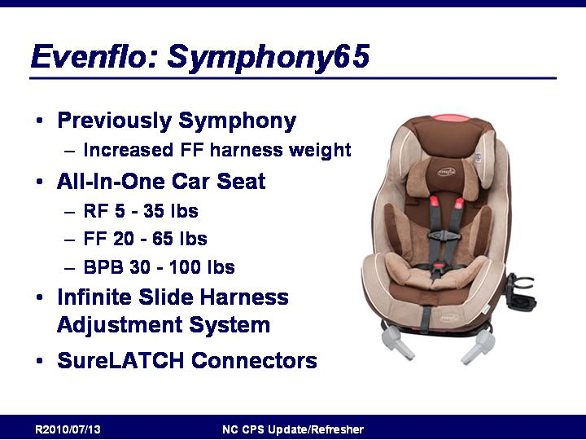
Slide 193

Evenflo Symphony65
- Previously Symphony
  - Increased FF harness weight
- All-In-One Car Seat
  - RF 5 - 35 lbs
  - FF 20 - 65 lbs
  - BPB 30 - 100 lbs
- Infinite Slide Harness Adjustment System
- SureLATCH Connectors

From Evenflo Website:
- SureLATCH® technology – an exclusive Evenflo innovation consisting of two connectors for use with a vehicle’s LATCH system to ensure proper installation in a fraction of the time of a traditional seat
- Infinite Slide Harness™ Adjust– adapts the 5 point harness to any child without removing and rethreading the harness straps
- Increased 65 lbs. Harness Weight Rating accommodates children longer in the 5-point harness
- Side Impact Tested! Like all Evenflo car seats, the Symphony™ 65 is Side Impact Tested AND meets Federal Safety Standards.
- Designed and tested for structural integrity at energy levels approximately 2X the federal crash test standard
- Additional Features: one-hand adjustable head rest, flip-out cup holder, removable washable ComfortTouch™ padding and ReclineRight™ up-front adjust.

Slide 194

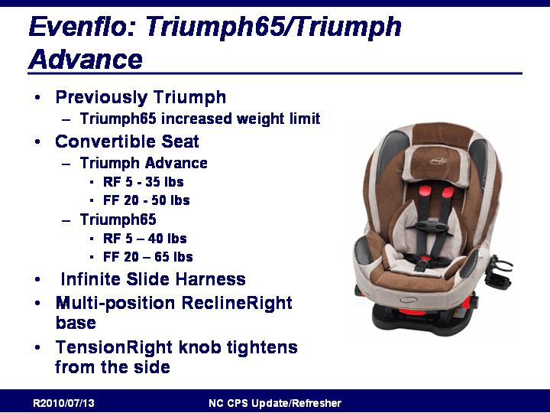
Evenflo: Triumph65/Triumph Advance
- Previously Triumph
  - Triumph65 increased weight limit
- Convertible Seat
  - Triumph Advance
    - RF 5 - 35 lbs
    - FF 20 - 50 lbs
  - Triumph65
    - RF 5 – 40 lbs
    - FF 20 – 65 lbs
- Infinite Slide Harness
- Multi-position ReclineRight base
- TensionRight knob tightens from the side

From Evenflo Website:
Triumph65
- #1 Rated convertible car seat for performance and price by a leading consumer magazine
- Increased! Rear facing for infants 5 to 40 lbs.
- Increased! Forward facing for infants 20 to 65 lbs.
- 65 lb. harness weight rating to keep children safely harnessed as they grow!
- Infinite Slide Harness™ simply slides for an accurate fit. No rethreading necessary!
- TensionRight™ knob tightens harness easily from the side
- Multiple-position upfront recline is easy to use and adds comfort for the child
- Fold-down cup holder for easy access to drinks and folds out of the way when not in use
- Removable body and infant head support pillows
- Removable, washable seat pad
- EPP, energy absorbing foam liner
- Side Impact Tested! Meets or exceeds all applicable federal safety standards and Evenflo’s side impact standards.
- Designed and tested for structural integrity at energy levels approximately 2X the federal crash test standard

Triumph Advance:
- #1 Rated convertible car seat for performance and price by leading consumer magazine
- Rear Facing for infants 5 to 35 lbs.
- Forward Facing for infants 20 to 50 lbs.
- Infinite Slide Harness™ simply slides for an accurate fit. No rethreading necessary!
- TensionRight™ knob tightens harness easily from the side
- Multiple-position upfront recline is easy to use and adds comfort for the child
- Fold-down cup holder for easy access to drinks and folds out of the way when not in use
- Removable, washable pads - seat pad, body pillow and infant head pillow
- EPP Energy Absorbing foam liner gives the added safety that parents desire
- 5-point harness preferred by safety advocacy groups
- 2-piece chest clip allows child to be put in and taken out in seconds!
- 2 crotch strap positions accommodate growing child
- Side Impact Tested! Meets or exceeds all applicable federal safety standards and Evenflo’s side impact standards.
- Designed and tested for structural integrity at energy levels approximately 2X the federal crash test standard

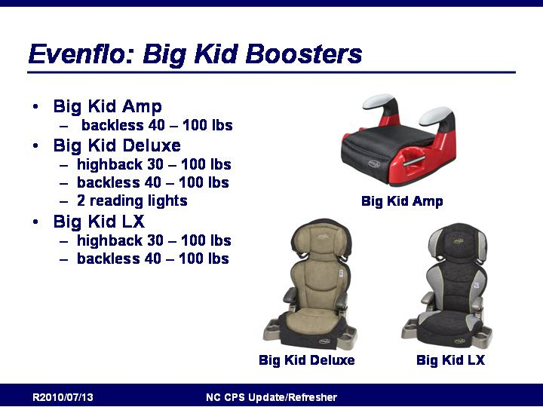
Slide 195

Evenflo: Big Kid Boosters
- Big Kid Amp
    - backless 40 – 100 lbs
- Big Kid Deluxe
    - highback 30 – 100 lbs
    - backless 40 – 100 lbs
    - 2 reading lights
- Big Kid LX
    - highback 30 – 100 lbs
    - backless 40 – 100 lbs

Slide 196

E-Z-ON

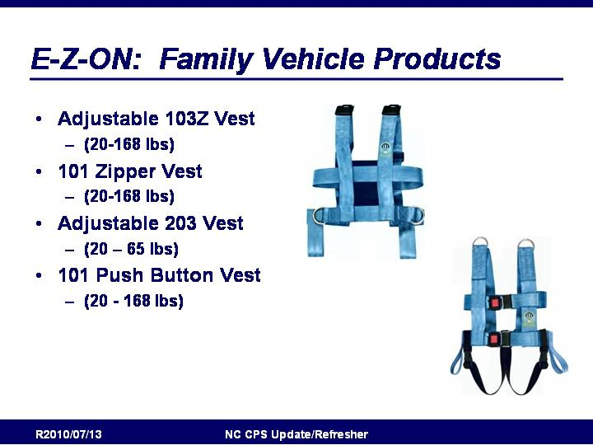
E-Z-ON Family Vehicle Products
- Adjustable 103Z Vest
  - (20-168 lbs)
- 101 Zipper Vest
  - (20-168 lbs)
- Adjustable 203 Vest
  - (20 – 65 lbs)
- 101 Push Button Vest
  - (20 - 168 lbs)
- Some of the E-Z-On products have adjustable shoulder straps, others are non-adjustable. Some have the crotch straps and for others it’s optional.

http://www.ezonpro.com/index.shtml

Slide 197

E-Z-ON 86Y Universal Harness
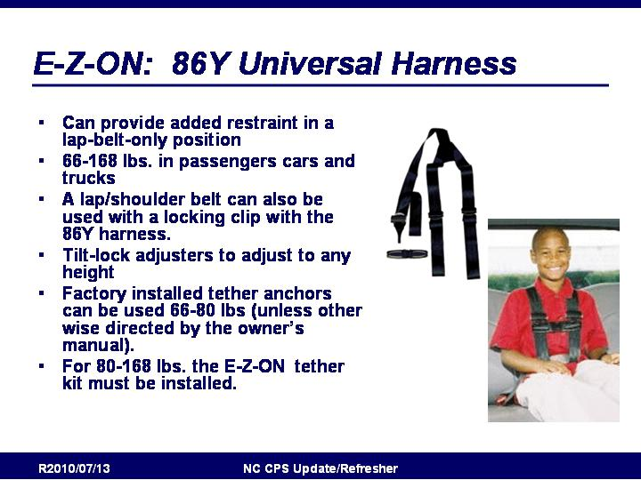
- Can provide added restraint in a lap-belt-only position
- 66-168 lbs. in passengers cars and trucks
- A lap/shoulder belt can also be used with a locking clip with the 86Y harness.
- Tilt-lock adjusters to adjust to any height
- Factory installed tether anchors can be used 66-80 lbs (unless other wise directed by the owner’s manual).
- For 80-168 lbs. the E-Z-ON tether kit must be installed.

From E-Z-ON website:
- With E-Z-ON 's UNIVERSAL HARNESS, your back seat passengers will enjoy the same level of protection as airline pilots and race car drivers.
- FMVSS Tested
- Costs hundreds of dollars less than dealer retrofits.
- Easy to install and use.
- Chest clip helps keep the harness straps in the correct position. Perfect for smaller passengers.
- A lap/shoulder belt can also be used with a locking clip with the 86Y harness.
- Tilt-lock adjusters make the harness easy to adjust to any height.
- Use 66-168 lbs. in passenger cars and trucks.
- Factory installed tether anchors can be used 66-80 lbs (unless other wise directed by the owner’s manual). For 80-168 lbs. the E-Z-ON tether kit must be installed.

Slide 198

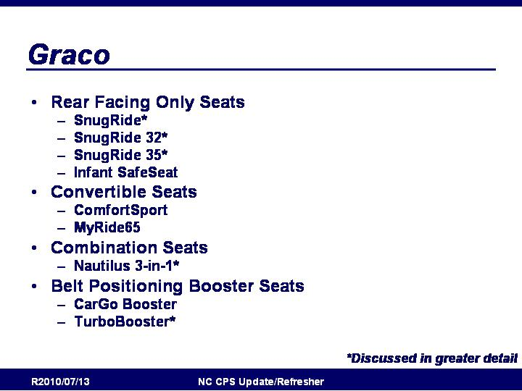
Graco: Overview
- Rear Facing Only Seats
- SnugRide*
- SnugRide 32*
- SnugRide 35*
- Infant SafeSeat
- Convertible Seats
- ComfortSport
- MyRide65
- Combination Seats
- Nautilus 3-in-1*
- Belt Positioning Booster Seats
- CarGo Booster
- TurboBooster*

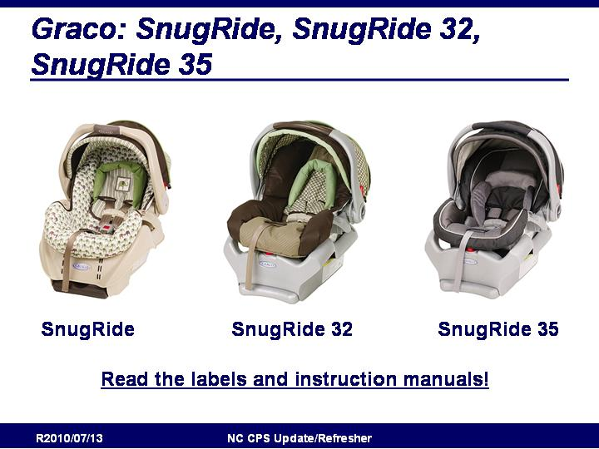
http://www.gracobaby.com

Slide 199

Graco SnugRide, SnugRide 32, SnugRide 35
- Read the Instruction Manuals!
- Seats have similar names but different features!

Slide 200

Graco SnugRide, SnugRide 32, SnugRide 35
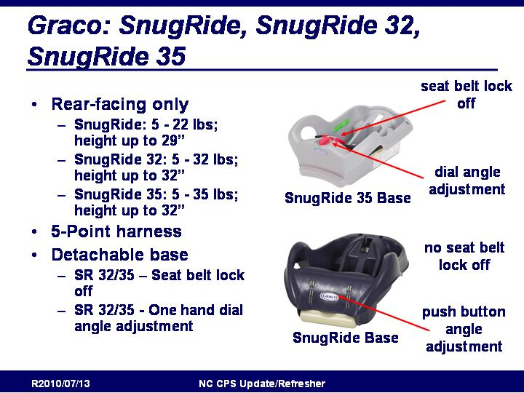
- Rear-facing only
- SnugRide: 5 - 22 lbs; height up to 29”
- SnugRide 32: 5 - 32 lbs; height up to 32”
- SnugRide 35: 5 - 35 lbs; height up to 32”
- 5-Point harness
- Detachable base
- SR 32/35 – Seat belt lock off
- SR 32/35 - One hand dial angle adjustment

From Graco Website:
Meet the car seat more moms rely on than any other. Our top-rated Graco SnugRide™ 35 has been thoughtfully constructed and rigorously tested for safety. Its LATCH-equipped, stay-in-car base has a one-hand dial adjustment to ensure the proper installation angle, and an integrated belt lock-off to further simplify installation. Add in the removable infant head support and the EPS, energy absorbing foam, and it’s easy to see why this infant car seat is one of America’s favorites.

Slide 201

Graco SnugRide, SnugRide 32, SnugRide 35
- Read instructions to determine appropriate handle placement!

Slide 202

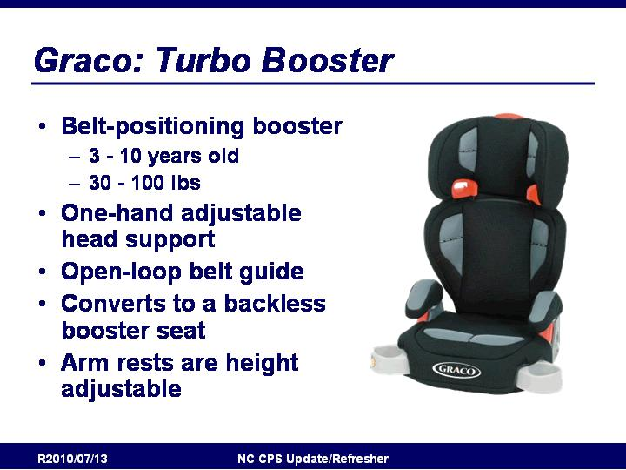
Graco: Turbo Booster
- Belt-positioning booster
- 3 - 10 years old
- 30 - 100 lbs
- One-hand adjustable head support
- Open-loop belt guide
- Converts to a backless booster seat
- Arm rests are height adjustable

From Graco Website:
- Helps safely transport your “big kid” from 30-100 lbs
- Top rated by leading consumer magazines and publications
- Rigorously crash tested to meet or exceed U.S. safety standards
- Designed with the style and comfort features that kids love
- Easily converts to backless booster for years of use
- EPS, energy absorbing foam for effective impact energy management
- Fully-adjustable headrest keeps your growing child secure
- Open-loop belt guides help you correctly position your vehicle’s seat belt
- Padded, height-adjustable armrests and hide-away cup holders keep kids smiling
- Online videos help ensure proper seat installation

Slide 203

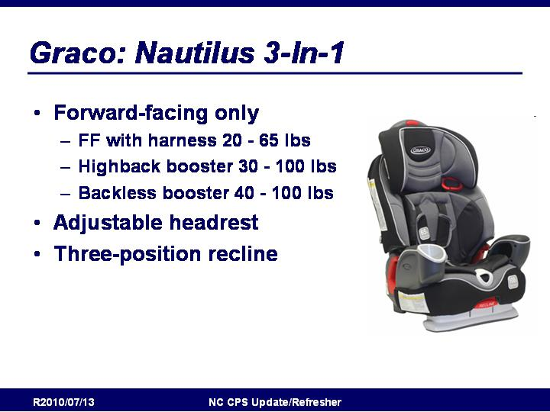
Graco: Nautilus 3-in-1
- Forward-facing only
- FF with harness 20 - 65 lbs
- Highback booster 30 - 100 lbs
- Backless booster 40 - 100 lbs
- Adjustable headrest
- Three-position recline

From Graco Website:
- 3-in-1 car seat helps protect your toddler, from 20-100 lbs.
- Top rated by leading consumer magazines and publications
- Rigorously crash tested to meet or exceed U.S. safety standards
- Side-impact tested* (*In addition to meeting or exceeding all applicable US safety standards, the Nautilus car seat has been side impact tested for occupant retention solely with the built-in 5 point harness system.)
- EPS, energy absorbing foam for effective impact energy management
- Steel-reinforced frame provides strength and durability
- 3-position recline helps keep your growing child comfy
- One-hand, adjustable headrest easily adapts to your growing toddler’s needs
- Online videos help ensure proper seat installation
- Open-loop belt guides help you correctly position your vehicle’s seat belt
- Contoured armrests with cup holder and storage pockets
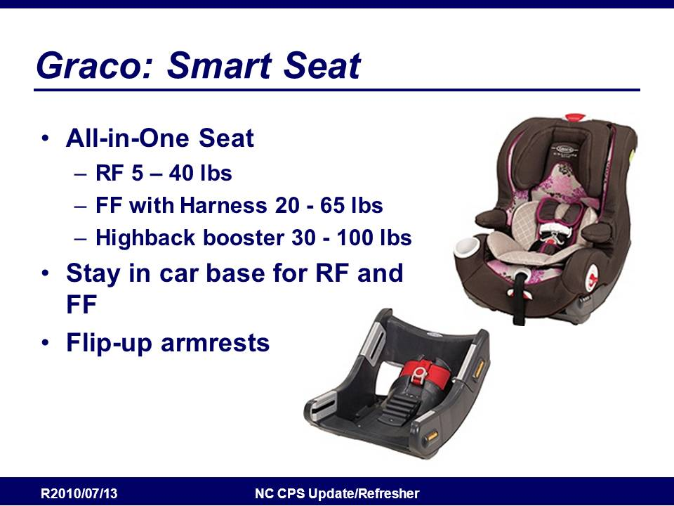
Slide 204
Graco: Smart Seat
All-in-One Seat
RF 5 – 40 lbs
FF with Harness 20 - 65 lbs
Highback booster 30 - 100 lbs
Stay in car base for RF and FF
Flip-up armrests

From Graco Website:
* Rear-facing in a harness from 5-40 lbs, forward facing in a harness from 20-65 lbs. then as a belt-positioning booster from 30-100 lbs.
* SafeSeat Engineering - Engineered & Crash Tested to Meet or Exceed US Standard FMVS213:
o Side Impact Tested* (*In addition to meeting or exceeding all applicable US safety standards, the SmartSeat™ car seat has been side impact tested for occupant retention with the built-in 5 point harness system and with a standard vehicle harness system when in high back booster mode. Please consult your vehicle's owner's manual for more specific information on the performance of your vehicle's safety belt system.)
o New Car Assessment Program (NCAP) – peak crash force approximately 2X Car Seat Standard
o Extreme Car Interior Temperatures
* Convenient, stay-in-car base with belt lock off for one time install (LATCH equipped)
* Steel-reinforced frame & car seat base provides strength and durability
* Locking indicators on seat & stay in car base to help ensure proper installation
* Integrated harness storage compartment holds the harness straps that are not in use while in the belt positioning booster mode
* Easy-to-read level indicator on the seat, helps eliminate installation guesswork
* No Re-thread harness for quick & easy harness adjustment
* One-hand, 6 position adjustable head rest for your growing child
* On-the go, 5-position recline so you can recline child while in use
* EPS, energy absorbing foam liner
* Flip-up armrests makes it easy for child to get in & out of car seat
* Child's cup holder keeps child's drink close by

Slide 205

Learning Curve The First Years: Overview
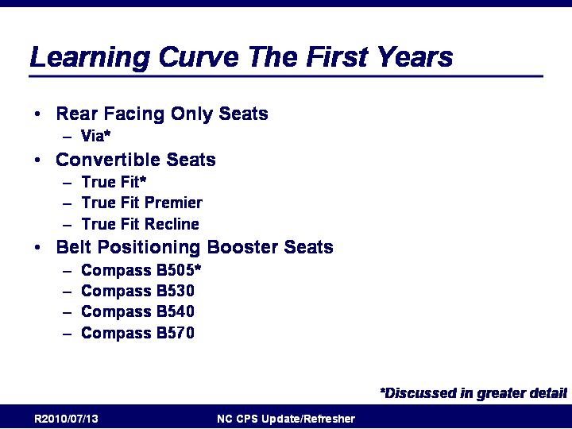
- Rear Facing Only Seats
- Via*
- Convertible Seats
- True Fit*
- True Fit Premier
- True Fit Recline
- Belt Positioning Booster Seats
- Compass B505*
- Compass B530
- Compass B540
- Compass B570

http://www.learningcurve.com

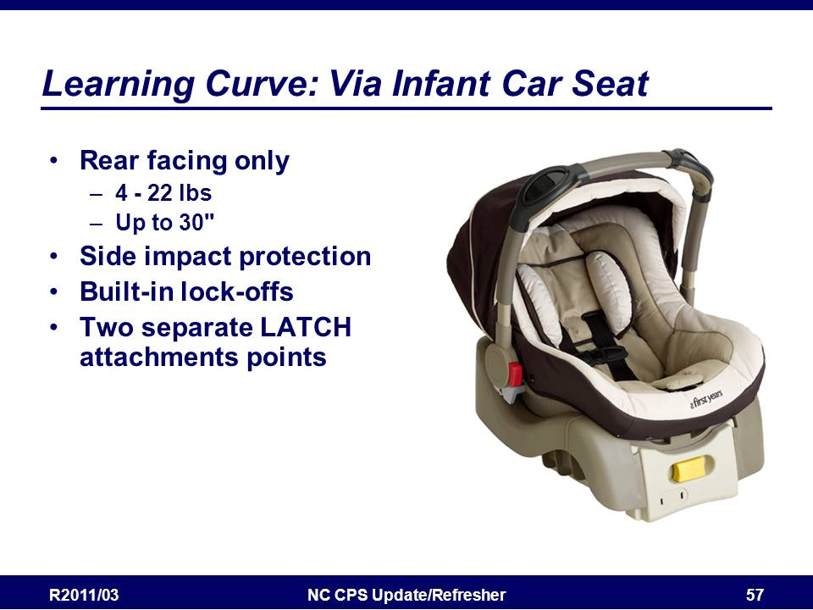
Slide 206

Via Infant Car Seat
- Rear facing only
- 4 - 22 lbs
- Up to 30"
- Uniquely designed comfort carry right handle
- Full EPS foam liner
- Deep side wings for side impact protection
- Built-in lock-off
- Two separate LATCH attachments points

From Learning Curve Website:
- side-impact tested to international standards
- deep side wings for improved side-impact protection
- fully-lined with EPS foam liner to absorb energy
- uniquely-designed comfort carry right handle
- built-in lock-off for secure installation
- multi-beam back frame to reinforce structure
- triple-layer padding provides superior comfort
- 5-point harness with LATCH system
- two separate LATCH attachments points for improved lateral control
- For use with The First Years Indigo and Wave strollers
- fits babies 4-22 lbs and up to 30"

Slide 207

Learning Curve: True Fit Seats
- Convertible
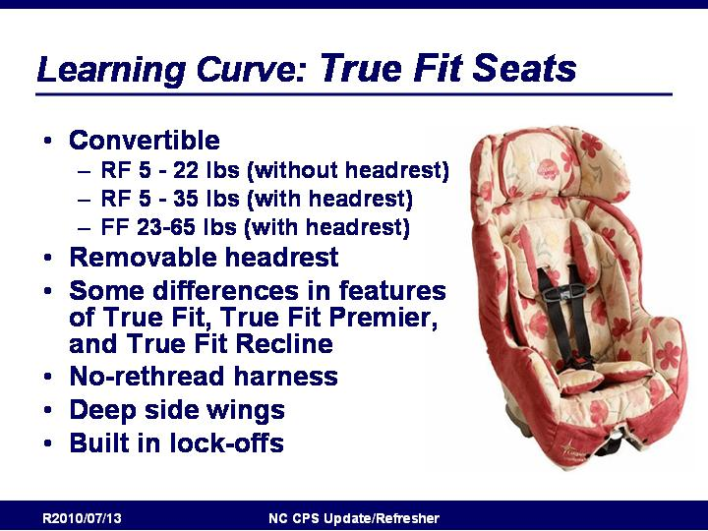
- RF 5 - 22 lbs (without headrest)
- RF 5 - 35 lbs (with headrest)
- FF 23-65 lbs (with headrest)
- Removable headrest
- Some differences in features of True Fit, True Fit Premier, and True Fit Recline
- No-rethread harness
- Deep side wings
- Built in lock-offs

From Learning Curve Website:
TrueFit
- Received four-star "Ease of Use" government rating from NHTSA (National Highway Traffic Safety Administration)
- Removable headrest for use in rear and forward-facing positions
- Easy adjust, no rethread harness for use up to 65 lbs.
- Multi-position crotch strap adjustment and larger interior dimensions for extended use as child grows
- Easy-off pad, snaps on and off with out rethreading harness
- Color-coded belt paths, built-in lock offs and LATCH system for use in rear- and forward-facing installation
- Deep side wings, side-impact tested to international standards
- For use with children 5-65lbs and up to 50" tall

TrueFit Premier:
- Received five-star "Ease of Use" government rating from NHTSA (National Highway Traffic Safety Administration)
- Features the Rebound Energy Management for use in rear-facing installation
- Removable headrest for better rear-facing installation, can be used rear-facing with headrest for infants up to 35lbs.
- Easy-to-read center angle indicator with two position settings
- Easy adjust, no rethread harness for use to 65lbs.
- Multi-position crotch strap adjustment
- Easy-off pad snaps on and off with out rethreading harness
- Color-coded belt paths for easy installation
- Built-in lock offs for both rear- and forward-facing installation, external LATCH storage
- Two-position recline for better installation
- Deep side wings, side-impact tested to international standards

TrueFit Recline:
- Removable headrest for better rear-facing installation, can be used rear facing with headrest for infants up to 35lbs.
- Easy-to-read center angle indicator with two position settings
- Easy adjust, no rethread harness for use to 65lbs
- Multi-position crotch strap adjustment
- Easy-off pad, snaps on and off with out rethreading harness
- Color-coded belt paths for easy installation
- Built-in lock offs for both rear- and forward-facing installation, external LATCH storage
- Two-position recline for better installation
- Deep side wings, side-impact tested to international standards
- For use with children 5-65lbs and up to 50' tall

Slide 208

Learning Curve: Compass Boosters
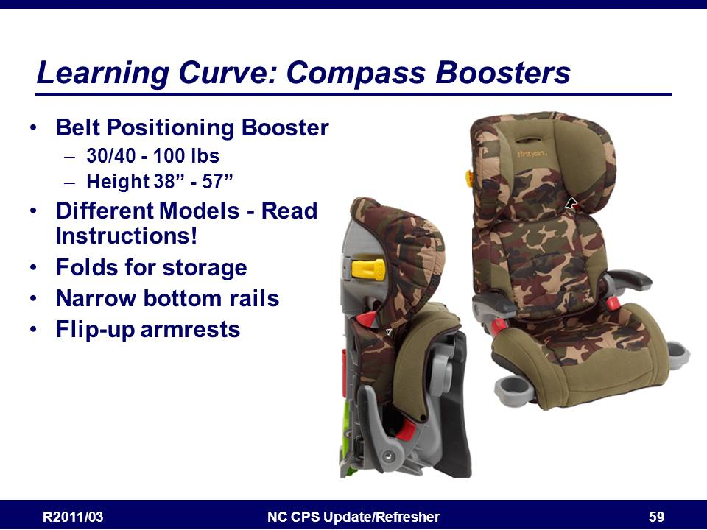
- Belt Positioning Booster
- 30/40 - 100 lbs
- Height 38” - 57”
- Different Models - Read Instructions!
- Folds for storage
- Narrow bottom rails
- Energy-absorbing EPS headrests with side wings provide improved impact protection.
- Flip-up armrests

Slide 209

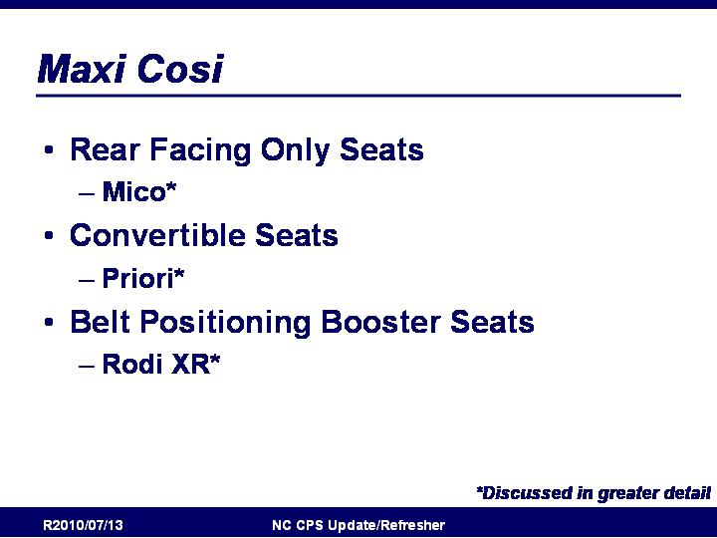
Dorel/Maxi Cosi: Overview
- Rear Facing Only Seats
- Mico*
- Convertible Seats
- Priori*
- Belt Positioning Booster Seats
- Rodi XR*

http://www.maxi-cosi.com/us-en

Slide 210

Maxi Cosi Mico
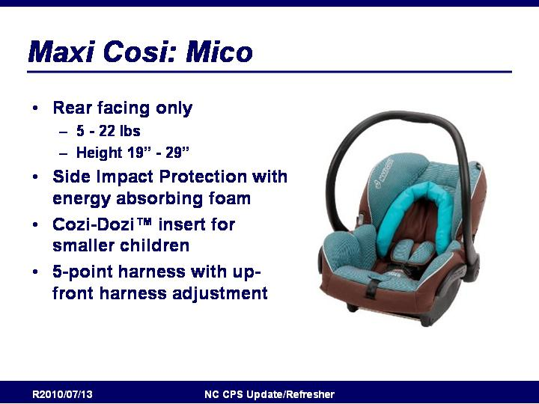
- RF ONLY
  - 5-22 lbs.
  - Height 19-29 inches
- Side Impact Protection with energy absorbing foam
- Includes Cozi-Dozi™ insert for smaller children
- 5-point harness with up-front harness adjustment

From Maxi-Cosi Website:
- Side Impact Protection
- Includes a convenient stay-in-car adjustable base
- Includes Cozi-Dozi™ insert for smaller children
- Integrated canopy, always on hand and easy to store
- 5-point harness with up-front harness adjustment
- Compatible with Quinny® Buzz™ and Zapp™ strollers

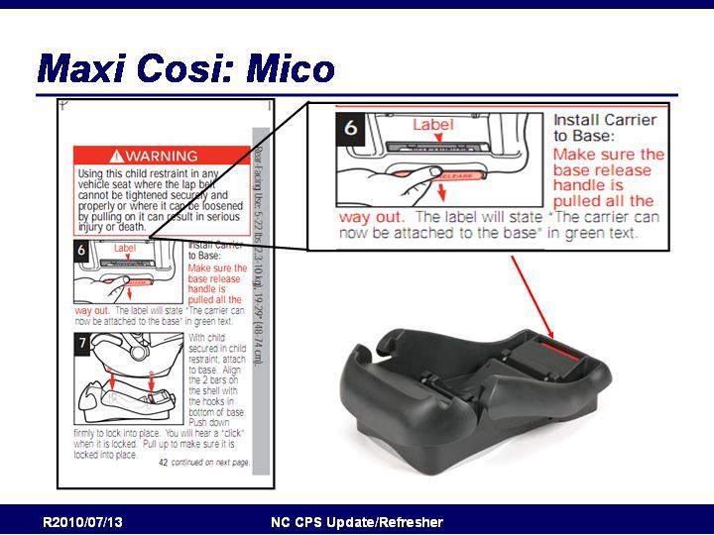
Slide 211

Maxi Cosi Mico
- Base has an unusual seat attachment mechanism.
- Read instruction to make sure seat is attached to base correctly

Slide 212
Maxi Cosi: Priori
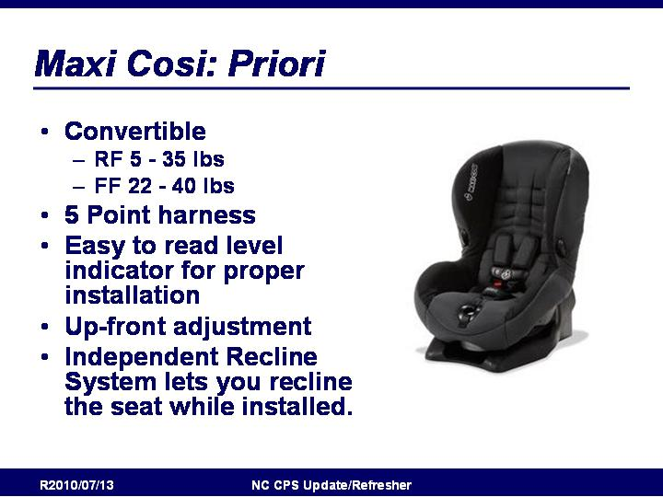
- Convertible
- RF 5 - 35 lbs
- FF 22 - 40 lbs
- 5 Point harness
- Easy to read level indicator for proper installation
- Up-front adjustment
- Independent Recline System lets you recline the seat while installed.

From Maxi Cosi Website:
- 4 independent recline positions are adjustable while your child’s in the car seat
- Side Impact Protection
- Harness holders keep harness straps out of the way
- Easy to install with 3-point seat belt and push button LATCH
- Rear-facing 5-35 lbs, 19”–36”
- Forward-facing 22-40 lbs, 34-43”

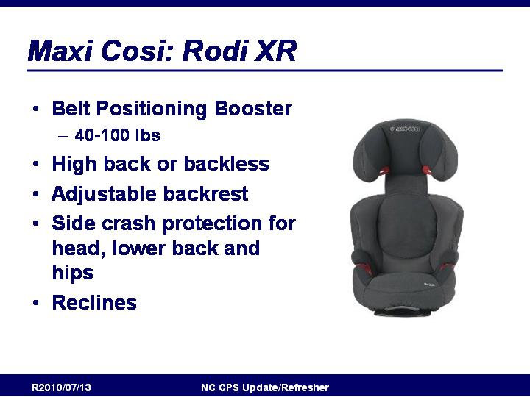
Slide 213

Maxi Cosi: Rodi XR
- Belt Positioning Booster
- 40-100 lbs
- High back or backless
- Adjustable backrest
- Side crash protection for head, lower back and hips
- Reclines

From Maxi Cosi Website:
- Unique relaxed reclining position for both small and larger childeren
- Adjustable side wings for added comfort
- Easily converts to a backless booster for children 40 – 100 lbs.
- Side Impact Protection
- Height adjustable backrest accommodates your growing child
- Cup holder for drink storage
- Easy to install with 3-point seat belt

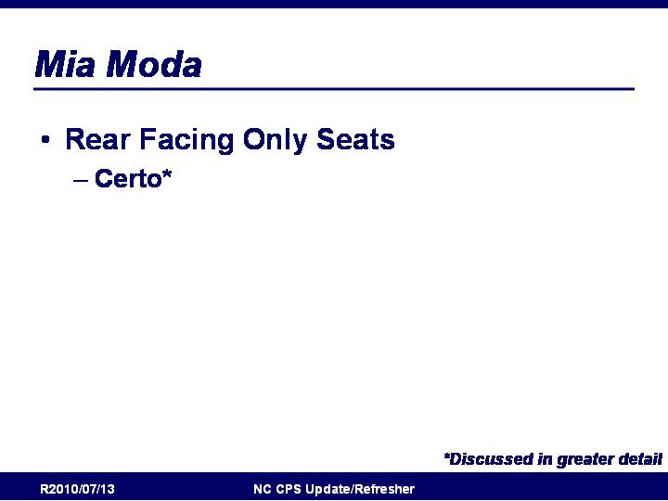
Slide 214

Mia Moda: Overview
- Rear Facing Only Seats
- Certo*

http://www.miamodainc.com/

Slide 215

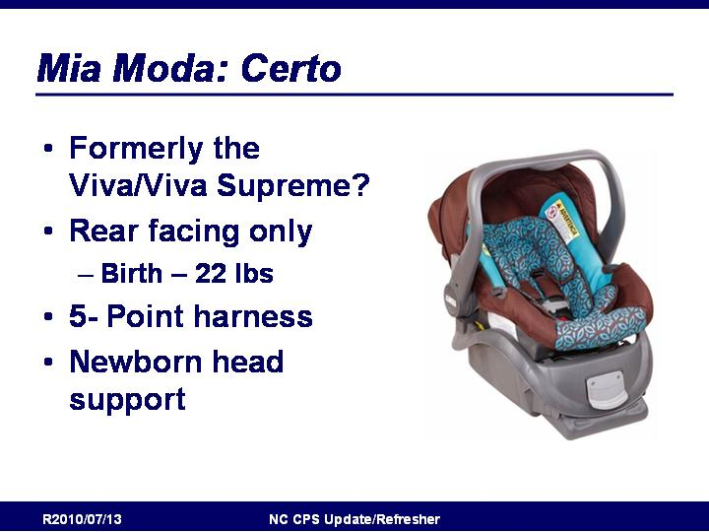
Mia Moda Certo
- Formerly the Viva/Viva Supreme
- Rear facing only
- Birth – 22 lbs
- 5- Point harness
- Newborn head support

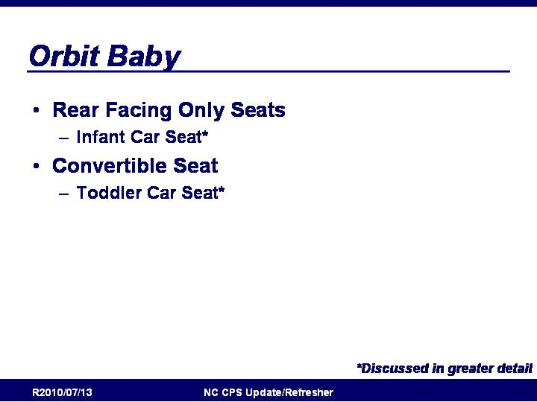
Slide 216

Orbit Baby: Overview
- Rear Facing Only Seats
- Infant Car Seat*
- Convertible Seat
- Toddler Car Seat*

http://www.orbitbaby.com/
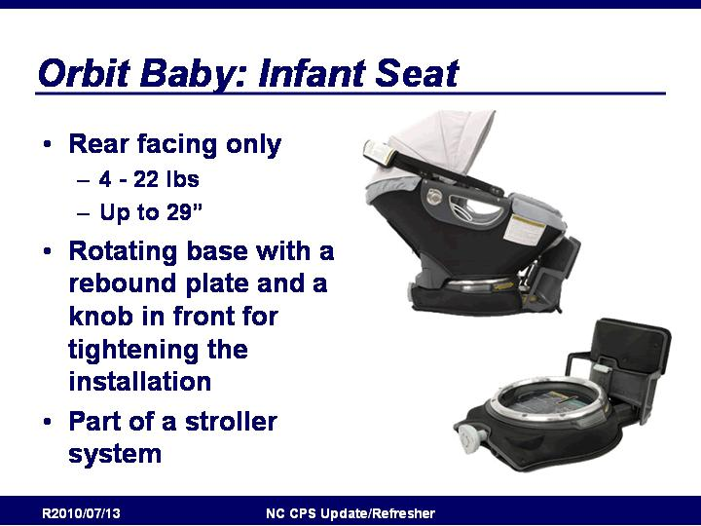
Slide 217

Orbit Baby: Infant Seat
- Rear facing only
- 4 - 22 lbs
- Up to 29”
- Rotating base with a rebound plate and a knob in front for tightening the installation
- Part of a stroller system

From Orbit Baby website:
- includes Infant Car Seat G2 and Car Seat Base G2
- comes with infant insert
- weight ratings: Infant Car Seat G2 for children 4 lbs (1.8 kg) to 22 lbs (10 kg) or 29 in (73 cm); Car Seat Base works with first generation and G2 Orbit Baby infant and toddler car seats; see car seat for weight rating with base

Slide 218

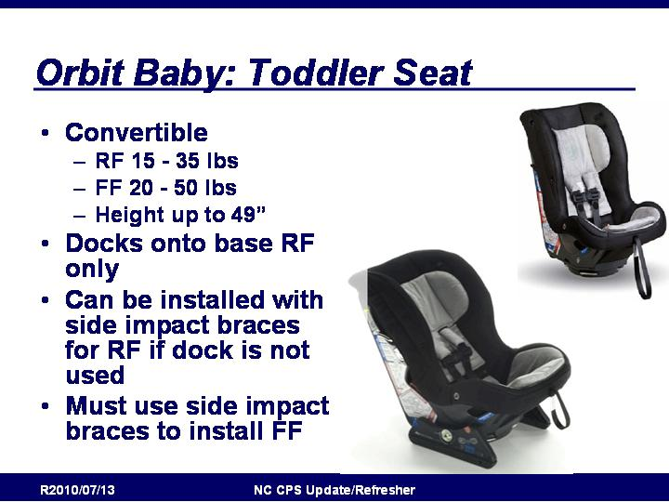
Orbit Baby Toddler Car Seat
- Convertible
- RF 15 - 35 lbs
- FF 20 - 50 lbs
- Height up to 49”
- Docks onto base RF only
- Can be installed with side impact braces for RF if dock is not used
- Must use side impact braces to install FF

From Orbit Baby website:
- the only convertible car seat that saves your back with easy docking at any angle into the car
- rotate your rear-facing car seat on the Car Seat Base toward the door for easy in and out
- world's first convertible car seat to dock onto a stroller
- comes with a removable UV sunshade
- convenient and sleek back panel stores sunshade, manual, and all dangling tethers and straps
- user-friendly upholstery panels and installation guide is color-coded for easy rear- and forward-facing installations
- integrated quick-access side pockets store LATCH belt buckles while strolling
- docks and rotates on Stroller Frame G2, Car Seat Base G2, and Rocker G2

- works with Orbit Baby Green Edition Footmuff

Slide 219

Peg Perego: Overview
- Rear Facing Only Seats
  - Primo Viaggio*

http://us.pegperego.com/us-en/

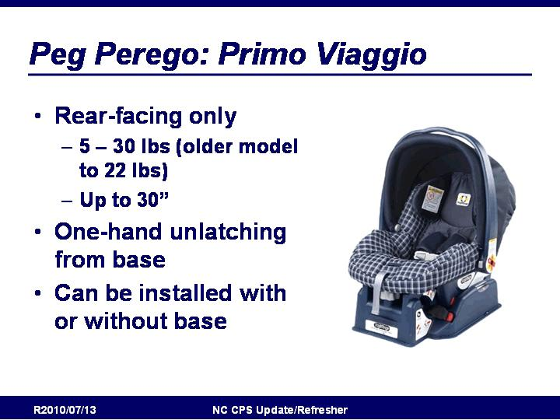
Slide 220

Peg Perego: Primo Viaggio
- Rear-facing only
  - 5 – 30 lbs (older model to 22 lbs)
  - Up to 30”
- One-hand unlatching from base
- Can be installed with or without base

From Peg Perego Website:
- Travel System compatible. The perfect complement to any Peg Perego stroller.
- Exceeds the most stringent Side Impact Protection test in the world.
- Adjustable Side Impact Protection is easy to adjust in 5 vertical positions.
- Headrest and padding made of soft Confort dry microfiber cloth that stays dry and allows proper ventilation.
- Quick-release 5-point safety harness with shoulder pads and fail-safe buckle.
- Includes a special removable cushion for newborns.
- Adjustable handle and large ratcheting hood protects baby from the sun and elements during transport.
- Tested for use with or without base.
- Certified for use in automobiles or aircraft.
- Complies with federal NHTSA* standards.

Slide 221

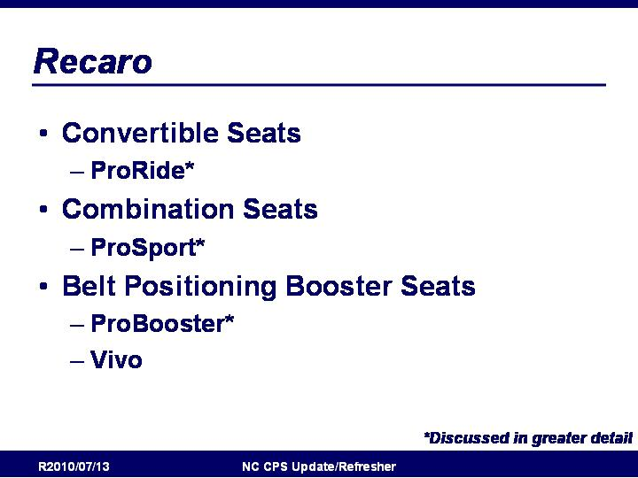
Recaro: Overview
- Convertible Seats
  - ProRide*
- Combination Seats
  - ProSport*
- Belt Positioning Booster Seats
  - ProBooster*
  - Vivo
http://www.recaro.com/

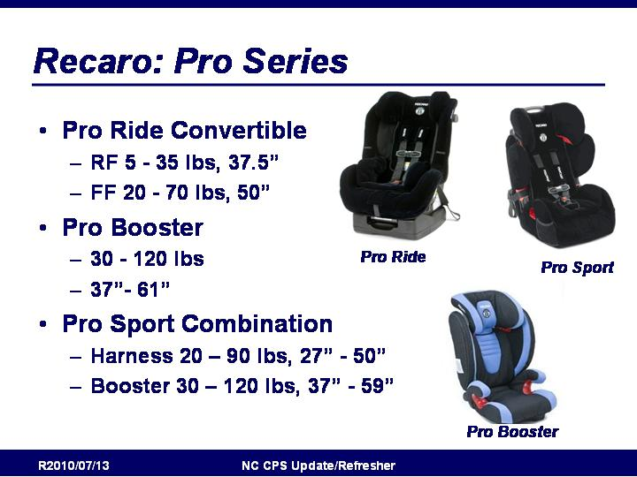
Slide 222

Recaro ProSeries
- Pro Ride Convertible
  - RF 5 - 35 lbs, 37.5”
  - FF 20 - 70 lbs, 50”
- Pro Booster
  - 30 - 120 lbs
  - 37”- 61”
- Pro Sport Combination
  - Harness 20 – 90 lbs, 27” - 50”
  - Booster 30 – 120 lbs, 37” - 59”

Slide 223

Safe Traffic System

Safe Traffic System Ride Safer Travel Vest
- Forward facing only
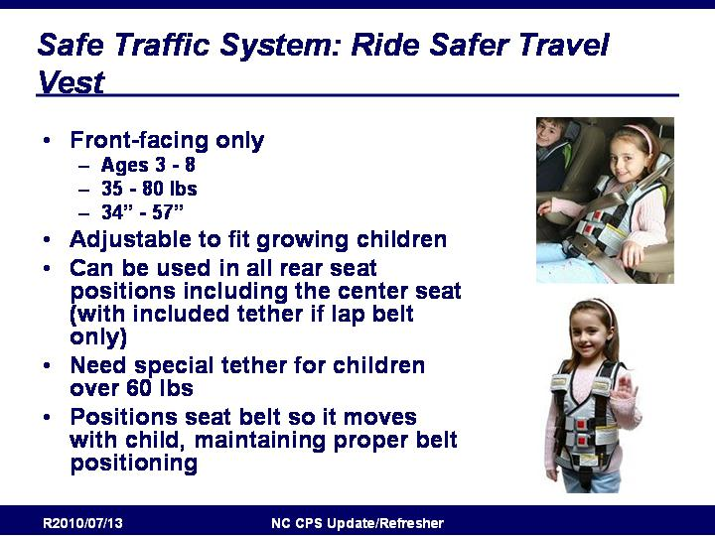
  - Children ages 3-6,
  - 35-60 pounds and
  - 38-52 inches tall.
- Adjustable to fit growing children
- Can be used in all rear seat positions including the center seat (with included tether if lap belt only)
- Positions seat belt in front of child
- Portable, compact and easy to use
- Reflective trim for low light conditions
- Made of soft fabric and padding, instead of hard plastics
- Child can continue to wear it outside of the car
- Repositions lap belt below abdomen, protecting internal organs
- Deformable multi-layered clip for Top Tether System and Shoulder Belt Positioner

Slide 224

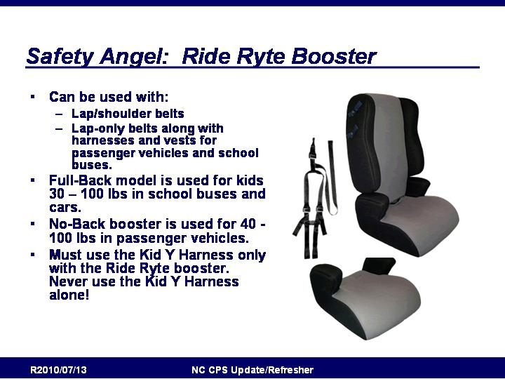
Safety Angel

Safety Angel Ride Ryte Booster
- Dynamically crash-tested to be used safely with:
- Lap/shoulder belts
- Lap-only belts along with E-Z-ON harnesses and vests for passenger vehicles and school buses.
- Full-Back model is used for kids 30-100lbs in school buses and cars.
- No-Back booster is used for 40-100lbs in passenger vehicles.
- Must use the Kid Y Harness only with the Ride Ryte booster. Never use the Kid Y Harness alone!
- Crotch straps do not need to be used on vests and harnesses when used with Ride Ryte ™ booster according to NHTSA guidelines.
- Cam Harness can only be used on a school bus vehicle seat.

Slide 225

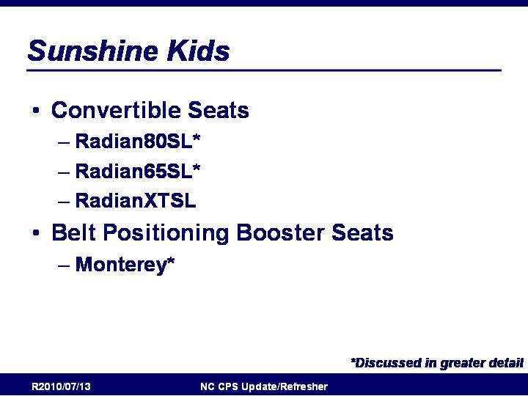
Sunshine Kids: Overview
- Convertible Seats
- Radian80SL*
- Radian65SL*
- RadianXTSL
- Belt Positioning Booster Seats
- Monterey*

http://www.skjp.com/
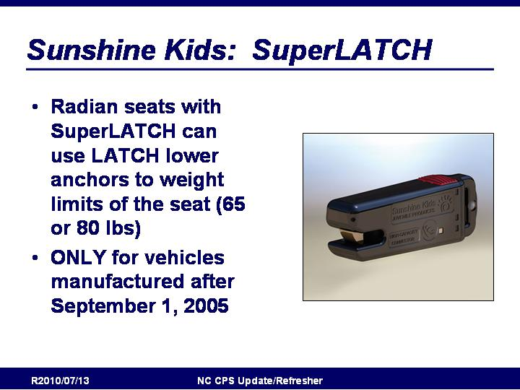
Slide 226

Sunshine Kids: SuperLatch
- Radian seats with SuperLATCH can use LATCH
lower anchors to weight limits of the seat (65 or 80 lbs)
- ONLY for vehicles manufactured after September 1, 2005

Info on SuperLatch

Slide 227

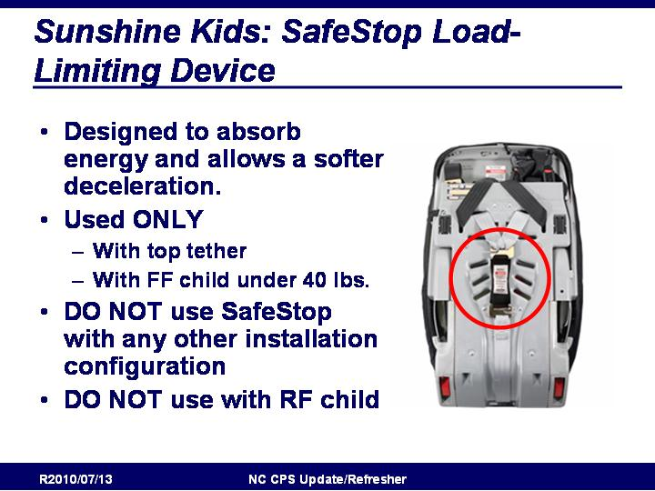
Sunshine Kids: SafeStop Load-Limiting Device
- Designed to absorb energy and allows a softer deceleration.
- Used ONLY
- With top tether
- With FF child under 40 lbs.
- DO NOT use SafeStop with any other installation configuration
- DO NOT use with RF child

SafeStop is a load limiting device designed to reduce energy and reduce impact to a smaller forward facing child.
SafeStop is stored with the tether on the back of the restraint

Slide 228

Sunshine Kids: Radian 80SL
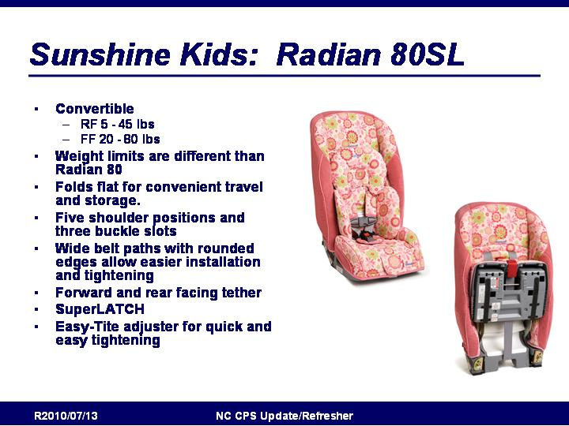
- Convertible
- RF 5 - 45 lbs
- FF 20 - 80 lbs
- Weight limits are different than Radian 80
- Folds flat for convenient travel and storage.
- Five shoulder positions and three buckle slots
- Wide belt paths with rounded edges allow easier installation and tightening
- Forward and rear facing tether
- SuperLATCH
- Easy-Tite adjuster for quick and easy tightening

From Sunshine Kids website:
The NEW Sunshine Kids Radian 80 SL car seats offer the first NCAP tested, high capacity LATCH system up to 80 pounds without the use of a seat belt!
With steel alloy frame, reinforced sides and protective EPS foam, the Radian 80SL car seat provides complete side impact protection. The Radian 80SL's low profile offers amazingly easy child boarding. In addition, with its unique patented design, the Radian 80SL car seat fits three-across in a mid-size car while providing more shoulder room for the child occupant. Memory foam padding and infant support pillows provide additional comfort. All this, and the Radian 80SL folds flat for convenient travel and storage.
- SuperLATCH™ installation up to 80 lbs - no seat belt required
- Easy-Tite™ adjuster for quick and easy tightening, installs in 1 minute
- Energy-absorbing EPS foam panels on all sides
- Safestop® energy-absorbing harness system
- Rubber bottom grips for no-slip installation
- 5 shoulder and 3 buckle positions for proper harness fit
- 3-in-1 infant/toddler full body support cushions
- Memory foam padding for superior comfort
- Folds flat for travel and storage, includes convenient carry strap
- Forward and rear-facing tether system
- 2 recline positions in forward-facing mode

Slide 229

Sunshine Kids Radian 65
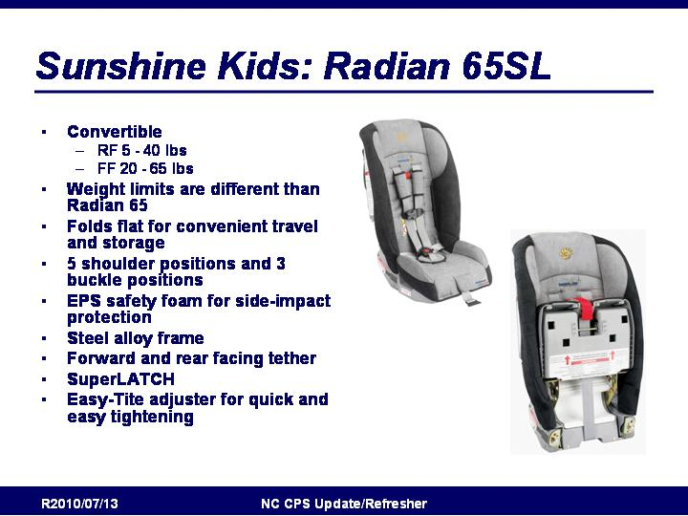
- Convertible
- RF 5 - 40 lbs
- FF 20 - 65 lbs
- Weight limits are different than Radian 65
- Folds flat for convenient travel and storage
- 5 shoulder positions and 3 buckle positions
- EPS safety foam for side-impact protection
- Steel alloy frame
- Forward and rear facing tether
- SuperLATCH
- Easy-Tite adjuster for quick and easy tightening

From Sunshine Kids Website:
The NEW Sunshine Kids Radian 65SL series car seats offer the first NCAP tested, high capacity LATCH system up to 65 pounds without the use of a seat belt!
With steel alloy frame, reinforced sides and protective EPS foam, the Radian 65SL car seat provides complete side impact protection. The Radian 65 car seat's low profile offers amazingly easy child boarding. In addition, with its unique patented design, the Radian 65 fits three-across in a mid-size car while providing more shoulder room for the child occupant. The Sunshine Kids Radian 65SL car seat folds flat for convenient travel and storage.
- Steel alloy frame and aluminum reinforced sides
- SuperLATCH™ installation up to 65 lbs - no seat belt required
- Easy-Tite™ adjuster for quick and easy tightening, installs in 1 minute
- Energy-absorbing EPS foam panels on all sides
- Safestop® energy-absorbing harness system
- Rubber bottom grips for no-slip installation
- 5 shoulder and 3 buckle positions for proper harness fit
- Foam padding for extra comfort
- Folds flat for travel and storage, includes convenient carry strap
- Forward and rear-facing tether system
- 2 recline positions in forward-facing mode

Slide 230

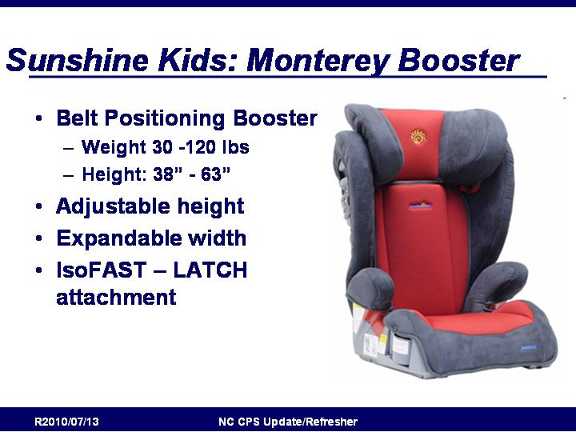
Sunshine Kids: Monterey Booster
- Belt Positioning Booster
- Weight 30 -120 lbs
- Height: 38” - 63”
- Adjustable height
- Expandable width
- IsoFAST – LATCH attachment

From Sunshine Kids website:
The Sunshine Kids Monterey Booster Seat is a high-back booster seat designed to fit a growing child up to 120 lbs. Deep, reinforced sides lined with energy-absorbing EPS foam help the Monterey Booster Seat absorb side-impact protection. A dial on the back adjusts the width of the expandable seatback to fit a child’s shoulders up to 20” wide. The Monterey Booster Seat is even more adjustable with its 11-position headrest that moves up to 6.5" in height with one hand for an easy, precise fit. As a fixed-position booster, the Monterey Booster Seat's integrated LATCH connectors and a front adjuster allow for a safe and secure installation in seconds. The seat bottom has extra length for leg support and features thick AirTek™ foam and tapered sides for total comfort. Dual cup holders are extra-deep and angled to keep drinks upright. The Sunshine Kids Monterey Booster Seat packs flat for convenience and can also be used as a backless booster.

- Full child size range- Fits children 30 lbs to 120 lbs and 38" to 63" in height
- Provides easy and secure LATCH attachment to vehicle even when not occupied
- Prevents submarining through angled and reinforced seat bottom
- Tapered seat shape- Properly fits a growing child at every stage
- Longer seat bottom- Proper leg support with cushioned comfort
- Can also be used as a backless booster, packs flat
- Retractable cup holders- Extra deep to keep drinks upright
- 2 recline positions- For comfort and to fit all vehicle seat shapes
- Bottom rubber pads- Better grip and helps protect vehicle upholstery

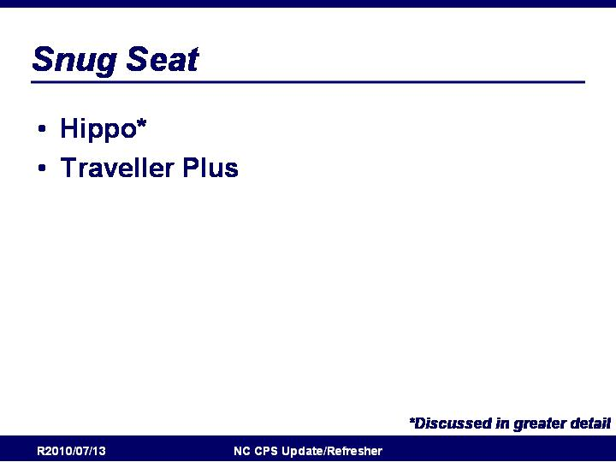
Slide 231

Snug Seat: Overview
- Hippo*
- Traveller Plus

http://www.snugseat.com

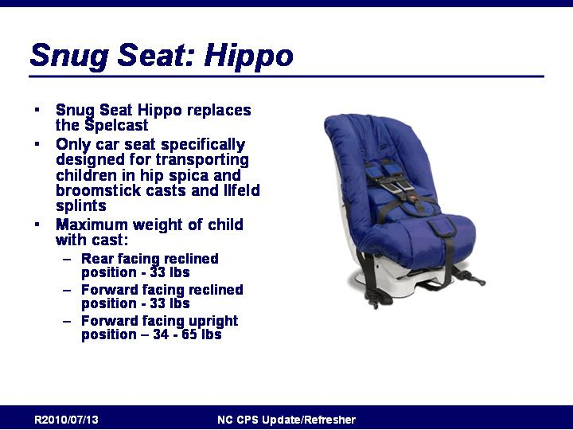
Slide 232

Snug Seat: Hippo
- Snug Seat Hippo replaces the Spelcast
- Only car seat specifically designed for transporting children in hip spica and broomstick casts and Ilfeld splints
- Maximum Casted Child Weight
- Rear facing reclined position - 33 lbs
- Forward facing reclined position - 33 lbs
- Forward facing upright position - 34-65 lbs.

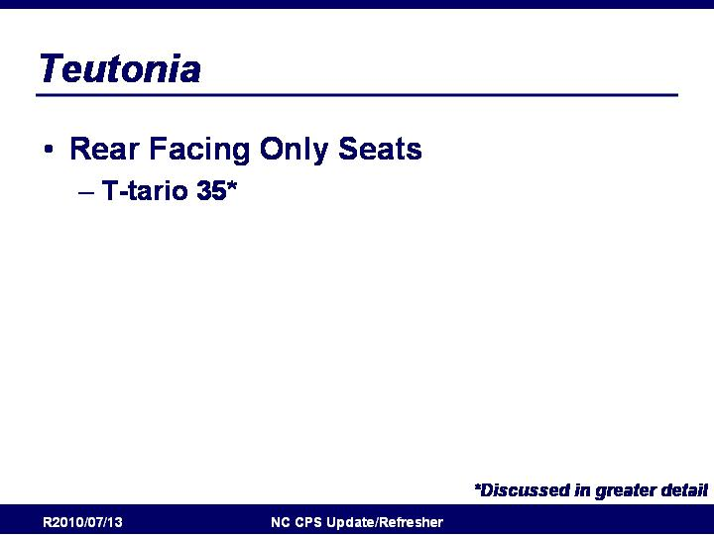
Slide 233

Teutonia: Overview
- Rear Facing Only Seats
- T-tario 35*

http://www.teutoniausa.com/

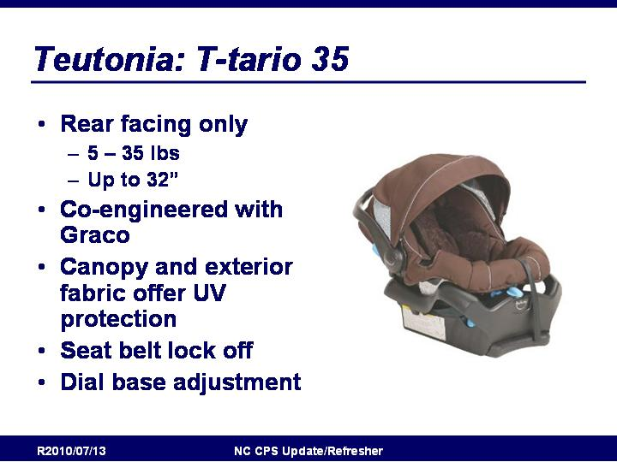
Slide 234

Teutonia: T-tario 35
- Rear facing only
- 5 – 35 lbs
- Up to 32”
- Co-engineered with Graco
- Canopy and exterior fabric offer UV protection
- Seat belt lock off
- Dial base adjustment

From Teutonia Website:
Co-engineered with Graco, the t-tario 35 has been thoughtfully constructed and rigourously tested for safety, including side impact testing to keep your baby secure from 5 to 35 lbs and 32 inches. Its LATCH equipped, stay-in-car base has a one hand dial adjustment to ensure the proper installation angle and integrated belt lock off to further simplify installation. Seat includes a removable infant head support, privacy shade and the EPS, energy absorbing foam.

- european styling
- canopy and exterior fabric offer UV 50+ protection and are water resistant
- 5 pt, front adjust harness helps you get your baby in and out
- snaps onto all stroller chassis using car seat adapter (sold seperately) engineered to fit t-tario 35
- side impact tested for occupant retention
- eps, energy absorbing foam for effective impact energy management
- luxury foam included for the ultimate in comfort for your child
- industry-leading, three-year manufacturer's warranty

Module 8: Fact or Fiction

